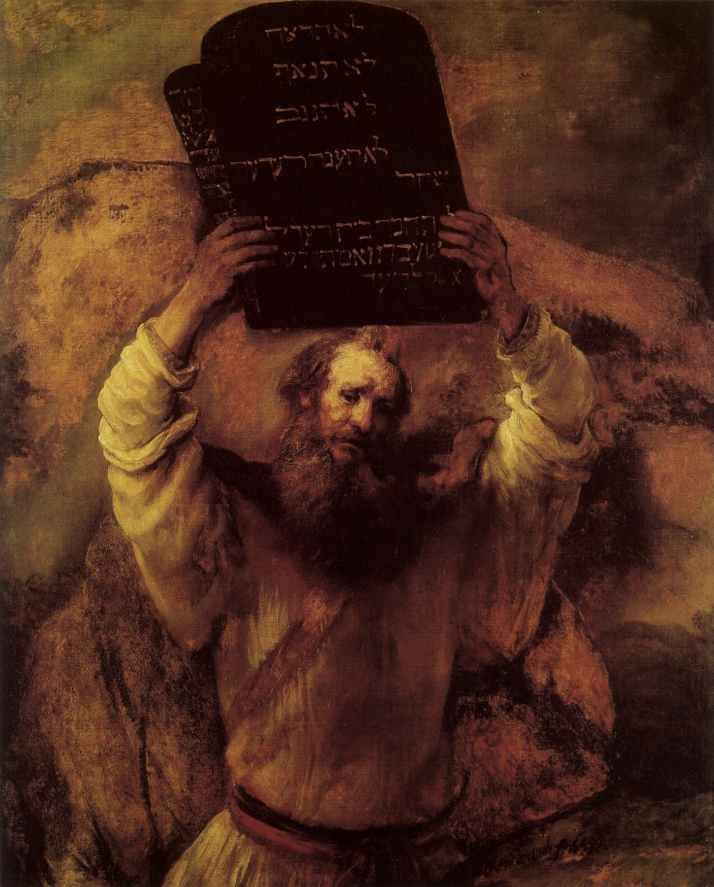
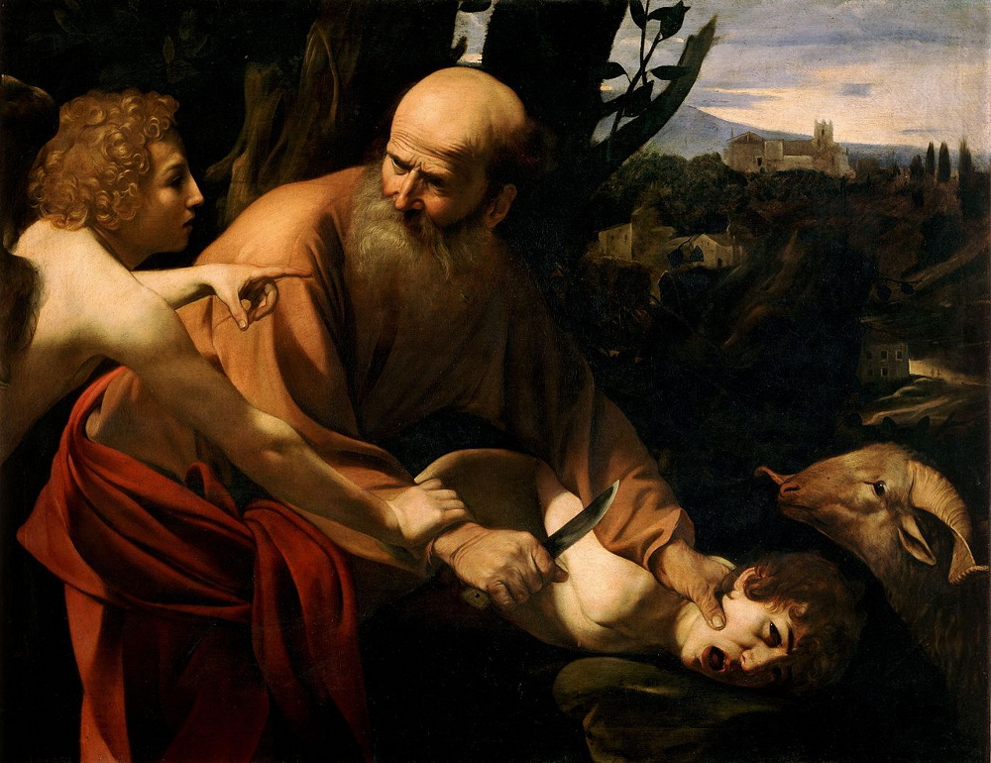
Abraham Through Moses

Review and Catch-up:
- Fall: Sin and Death. (Gen 3-4)
  - Looking for the seed (Gen 3:15)
  - approx. 4,000 B.C.
Caravaggio “Sacrifice of Isaac”
Rembrandt “Moses Breaking the Tablets of the Law”

- Flood: (Gen 6-9)
  - “The intent of man’s heart was constantly on evil”
  - Is Noah the seed?
    - Sin (9:20-24)
    - Death (9:29)
    - approx. 2341 B.C. (1659 years after creation)

- Babel: (Gen 11)
  - “Nothing will be impossible for them.”
  - approx. 2440 B.C. (about 100 years after flood)
- Abraham introduced (11:27-32)
  - Born approx. 2165 B.C.

- Chapters 5, 10, 11: Genealogies
  - Why genealogies?
    - Looking for the seed.
    - “and then he died.”
  - Enoch? (5:21-24) “and he was not, for God took him.”

Abraham
- Call of Abraham (Gen 12)
  - 12:1-3
    - “Make you a great nation.”
    - “Bless those who bless you, curse those who dishonor you.”
    - “In you, all the families of the earth will be blessed.”

  - 12:6-8
    - land of Canaanites
    - “To your offspring (seed) I will give this land.”
    - Built an altar to the Lord at Bethel

- The Land and the Spoils (Gen 13-14)
  - 13:14-18
    - “all the land you see I will give to you and to your offspring forever.”
    - “I will make your offspring as the dust” innumerable
    - Built an altar to the Lord at Hebron

  - 14:18-20
    - Melchizedek “priest of God Most High”
    - Blesses Abraham and God
    - Abraham gives him a 10th of his spoils

- Abrahamic Covenant (Gen 15)
  - 15:1-6
    - reiteration of promise “So shall your offspring be.”
    - “And he believed the Lord, and he counted it to him as righteousness.
  - 15:13-16
    - prediction of Egypt captivity
  - 15:18-20
    - To your offspring (seed) I give this land, from the river of Egypt to the great river Euphrates…”

- Abrahamic Lack of Faith (Gen 16-17)
  - 16:3-4
    - Abraham went into Hagar and conceived.
  - 16:10
    - Hagar’s offspring will be multiplied…
    - Is this the fulfillment of the promise? (see 17:15-22)
  - 17:9-11ff
    - circumcision will be the sign that you are an offspring of Abraham
  - 17:15-22
    - Isaac will be born from Sarah
    - Isaac will be the child of promise

- Sacrifice of Isaac (Gen 22)
  - 22:1-2
    - Sacrifice your only son, Isaac
    - Land of Moriah
    - v.4 on the third day…

  - 22:9-18
    - Mt. Moriah is named: “the Lord will provide” or “see”
    - “I will surely multiply your offspring.”
    - “And your offspring shall possess the gate of his enemies, and in your offspring shall all the nations of the earth be blessed, because you have obeyed my voice.”
    - Cf. Gal 3:8, 16.

- Is Abraham the seed?
  - Gen 25:8
  - So what about Isaac?...

Isaac and Jacob
- Promise repeated – Isaac (Gen 26)
  - 26:3-5
    - sojourn in the land
    - I will multiply your offspring (seed) as the stars
    - …and give your offspring (seed) all these lands
    - In your offspring (seed) all the nations of the earth shall be blessed.

  - Is Isaac the seed?
    - 35:28-29
    - So what about Jacob or Esau?...

- Jacob and Sons (Gen 28-50)
  - 28:1-5
    - Isaac tells Jacob not to marry Canaanites, instead go to Laban
    - “May he give the blessing of Abraham to you”
  - 28:13-15
    - The land you’re lying on I will give your offspring
    - Offspring shall be like the dust
    - “In your offspring (seed) all the families of the earth will be blessed.”
  - 29-30
    - Jacob has 12 sons by four women…
Story of Joseph
The story of…
- how God’s prophecy to Abraham in 15:13-16 came to pass
- how the line of the seed was preserved through famine
- how Israel became a nation
- how Moses was born
- God’s providence.

Prophecy for Judah (Gen 49:8-12)
- “your brothers shall praise you”
- “The scepter shall not depart from Judah”

