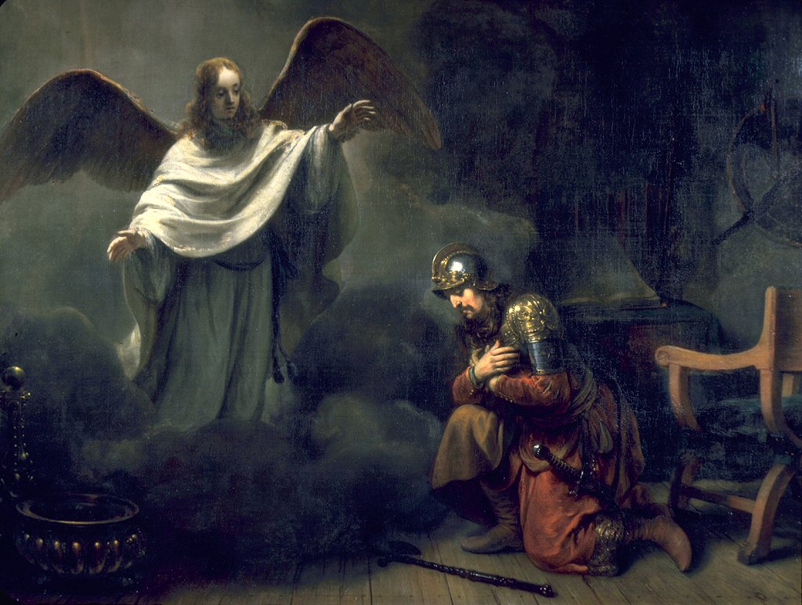
Acts 10:24-11:26
“Cornelius the Centurion”
by Gerbrand van den Eeckhout 1664

Peter and Cornelius: Part 2 – Meet and
Preach (10:24-48)
- Peter and Cornelius Meet (v24-33)
  - “Cornelius was expecting them and
had called together his relatives and
close friends.” (v24)
  - “Stand up; I too am a man.” (v26)

  - “you yourselves know how unlawful it is for a Jew to associate with or to visit anyone of another nation” (v28)
  - “I should not call any person common or unclean.” (v28)

  - “So I sent for you at once and you have been kind enough to come.” (v33)

- Peter Preaches the Gospel (v34-43)
  - “in every nation anyone who fears him and does what is right is acceptable to him.” (v36)
  - What parts of the gospel narrative does Peter mention? (v36-41)

  - “To him, all the prophets bear witness that everyone who believes in him receives forgiveness of sins through his name.” (v43)

- The Holy Spirit Confirms Belief (v44-48)
  - “The Holy Spirit fell on all who heard the word” (v44)
  - “were amazed because the gift of the Holy Spirit was poured out even on the Gentiles.” (v45)

  - “they were hearing them speaking in tongues and extolling God.” (v46)
  - “Who have received the Holy Spirit, just as we have?” (v47)

Peter Confronted (11:1-18)
- “heard that the Gentiles also had received the word of God.” (v1)
- “The circumcision party”: anyone who was circumcised. (cf. Gal 2, Titus 1:10-11, Acts 15) Likely a group within the church arguing that the Mosaic Law must continue to be followed in order to be Christian.

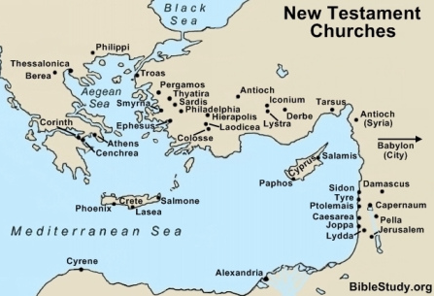

- “The Holy Spirit fell on them…” (v15)

- “…just as on us at the beginning.” (v15)

- “John Baptized with water…” (v16)
(cf. Luke 3:16, Acts 1:5)

- “If then God gave the same gift to them as he gave to use when we believed in the Lord Jesus Christ, who was I that I could stand in God’s way?” (v17)

- “to the gentiles also God has granted repentance that leads to life.” (v18)
  - Who says this?

Reforming… pun intended (11:19-26)
- And a great many people were added (v19-24)

  - “those scattered… speaking to only Jews.” (v19)
  - “But some… spoke to Hellenists in Antioch.” (v20)
  - “a great number believing, turned to the Lord.” (v21)

- They were called the Christians (v25-26)
  - Why does Barnabas bring Saul to Antioch and how long do they stay?

  - “And in Antioch the disciples were first called Christians” (v26)

