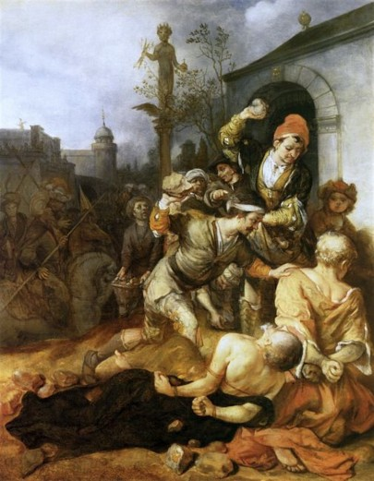
Acts 13:4-14:28

Barnabas, Paul, and John in Cyprus (13:4-12)
- “They proclaimed the word of God
in the synagogues” (v5)
- “a magician, a Jewish false prophet
named Bar-Jesus.” (v6)
  - Bar-jesus = Elymas
  - Saul=Paul

- “You son of the devil, you enemy of all righteousness,
full of all deceit and villainy, will you not stop making
crooked the straight paths of the Lord?” (v10)
  - What happened to Christian love?

“The Stoning of St Paul and St Barnabas at Lystra”
by Barent Fabritius 1672, Amsterdam
- Elymas struck blind… “Then the proconsul believed” (v12)
- “For he was astonished at the teaching of the Lord.” (v12)

Barnabas and Paul in Antioch Pisidia (13:13-50)
- Paul gives the background for the Messiah (v13-25)

  - “on the Sabbath, they went to the synagogue and sat” (v14)
  - “If you have any word of encouragement for the people, say it” (v15)
    - the synagogue rulers invite them to speak!

  - “Men of Israel and you who fear God, listen” (v16)
    - Who’s the audience?

  - Paul summarizes the story of the old testament (v17-22)
    - Would you be able to do that? Why or why not?

  - “Of this man’s offspring, God has brought to Israel a Savior, Jesus, as he promised.” (v23)
    - Where did he promise that? (cf. Acts 13:33-35; Ps 2; Is 55; Ps 16; Sam 7)

- Paul supports the resurrection with Scripture (v26-37)
  - “because they did not recognize him or understand the utterances of the prophets, which are read every Sabbath, fulfilled them by condemning him.” (v27)
  - “for David… fell asleep… and saw corruption, But he whom God raised up did not see corruption.” (v36-37)
- Paul gives an application (v38-41)
  - “Forgiveness of sins is proclaimed to you.” (v38)
  - “Everyone who believes is justified…” the way you couldn’t be with the law. (v39) (cf. Galatians, Romans arguments)

- The people want more, but the leaders don’t (v42-50)
  - “Many jews and devout converts to Judaism followed” (v430
  - “It was necessary for the word of God to be spoken first to you. Since you thrust it aside and judge yourselves unworthy of eternal life, behold, we are turning to the Gentiles.”(v46)
    - Why do they go to the Gentiles? (2 reasons)

  - Gentiles believe… “and as many as were appointed to eternal life believed. (v48)

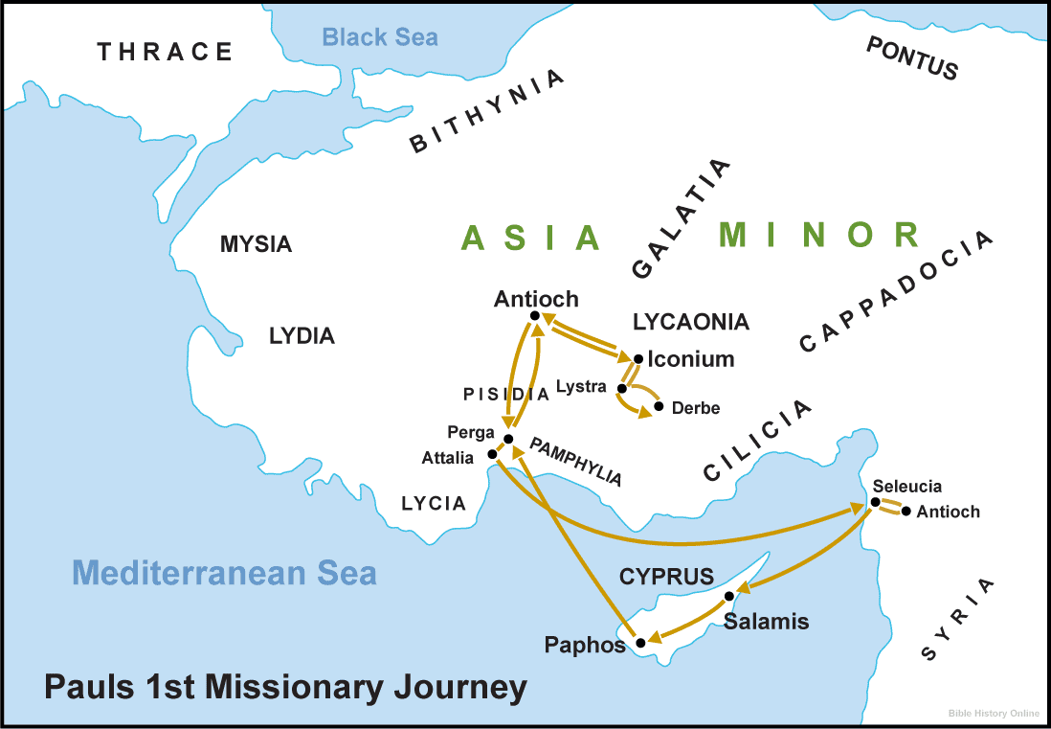
Barnabas and Paul in Iconium (13:51-14:7)
- “But they shook off the dust from their feet
against them and went to Iconium” (v13:51)
- “they remained a long time speaking boldly
for the Lord... grace… wonders” (v14:3)
- they fled to Lystra because they heard of an
attempted stoning. (v14:5-6)

Barnabas and Paul in Lystra (14:8-28)
- Paul heals a cripple (v8-10)
  - “seeing that he had faith to be saved” (v9)
  - he sprang up! (v10)

- The people praise them (v11-18)
  - “Barnabas they called Zeus and Paul Hermes” (v12)
  - “We also are men, of like nature with you… turn to a living God” (v15)
    - What “supports” do they give to persuade the people not to sacrifice to them?

- Paul stoned by previously-seen Jews (v19-23)
  - “Jews from Antioch and Iconium” (v19)
  - “he rose up and entered the city” (v20)
  - Went to Derbe, and then retraced their steps doing discipleship.
  - “through many tribulations we must enter the kingdom of God.” (v22)
  - they appointed elders in every church (v23)

- Paul and Barnabas return to Antioch (v24-28)
  - “They declared all that God had done with them and how he had opened a door of faith to the Gentiles.” (v27)
  - “And they remained no little time with the disciples.” (v28)

