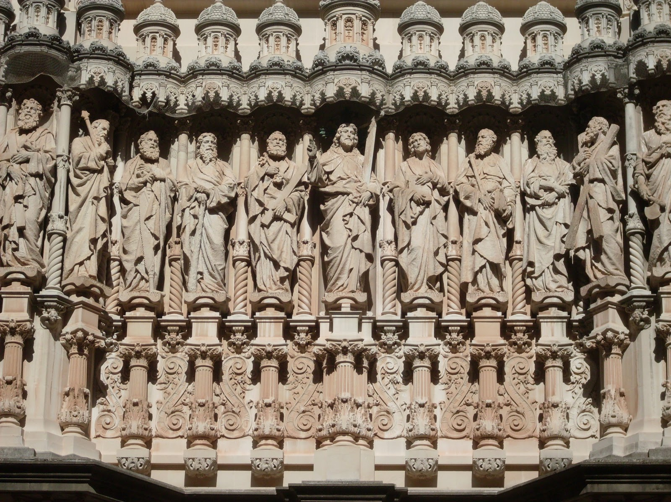
Acts 15:1-35

The Problem Arises (v1-6)
- “came down from Judea” (v1)

- “unless you are circumcised…” (v1)

- “…you cannot be saved.” (v1)

Atrium façade at the Basilica at the Montserrat Monastery. Barcelona, Spain. By Venanci and Agapit Vallmitjana 1900-1901.
- “no small debate with them” (v2)

- “appointed to go up to Jerusalem to the apostles and elders about this question.” (v2)

- “describing in detail the conversion of the gentiles” (v3)

- “some believers who were Pharisees rose up saying, ‘It is necessary to circumcise them and to order them to keep the law of Moses.’” (v5)

Peter’s Address (v7-11)
- “After there had been much debate” (v7)

- “In the early days God chose among you by my mouth that the gentiles would hear the word of the gospel and believe.” (v7)

- “God bore witness to them” … how? (v8)
  - “By giving them the Holy Spirit, just as he did to us.” (v8)

- “Why do you test God?” …how?(v10)
  - “By placing a yoke” .. that we can’t even bear.
  - What yoke? (cf. Gal 3:17-28; Rom 3:19-31; Mishnah, berakot 2.2)
    - Jewish custom of reciting the law and Shema.

- “But we believe we will be saved through the grace of the Lord Jesus, just as they will.” (v11)
  - GOSPEL!

Barnabas, Paul, and James’s Address (v8-21)
- Barnabas and Paul tell what’s happening among the gentiles. (v12)
- “Simeon has related how God first visited the Gentiles” (v14)
  - Simeon=Peter (cf. 2 Pet 1:1 Συμεων Πετρος)
- “With this word the prophets agree” (v15)
  - Amos 9:11ff

  - What is the context and the meaning of Amos 9?

  - “That the remnant of mankind may seek the Lord” (LXX) or “That they may possess the remnant of Edom” (MT)?

- “Therefore my judgment is that…” (v19)
  - Not trouble the gentile believers (19)
  - Abstain from idolatry (20)
  - Abstain from sexual immorality (20)
  - Abstain from what has been strangled (20)
  - Abstain from blood. (20)

- “For from ancient generations, Moses has had in every city, those who proclaim him, for he is read every Sabbath in the synagogues.” (v21)
  - Idolatry, fornication, and murder are considered the 3 cardinal sins to the Jews, for which the whole world would be accountable.

Four are sent to Antioch with a Letter (v22-35)
- “They sent Judas called Barsabbas and Silas…” with a letter. (v22)

- “Some persons have gone out… and troubled you” (v24)
  - Who? (cf. v1)

- “And Judas and Silas encouraged and strengthened the brothers.” (v32)

- “Paul and Barnabas remained in Antioch teaching and preaching the word of the Lord” (v35)

