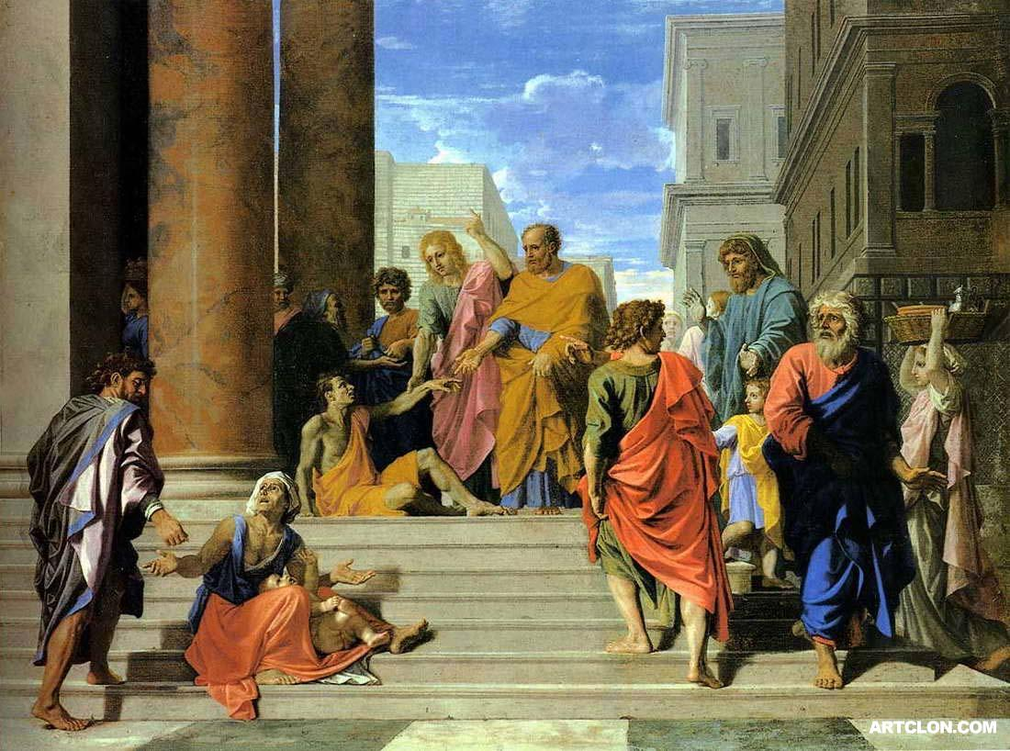
Acts 3:1-4:22

Peter and John Heal (3:1-11)
- “at the hour of prayer” : 3pm
- “The gate called beautiful”
  - Horaian: beautiful, or timely, or seasonal

- “In the name of Jesus, get up and walk.”
Nicholas Poussin “Saint Peter and John Healing The Lame Man” 1655
  - How was Peter able to perform this miracle?
  - Why does Luke include this miracle?

- “and entered the temple with them”
- “walking and leaping and praising God.”

Peter Preaches (3:12-4:4)
- “ran together to them in the portico called Solomon’s.”
  - on the way out of the Temple

- “Men of Israel”

- v.13-15
  - What is Peter summarizing?
  - Is this sermon for us or not?

- “v.17-18
  - Where does Peter turn for support for his argument?

- “repent therefore and turn back”
  - What is repentance?

  - Is our repentance the same as these hearers’ repentance?

- “times of refreshing” “send the Christ appointed for you” “the time of restoring all things”

- Deuteronomy 18:15ff
  - Who does Peter say Moses was talking about?
  - Who was Moses talking about?

- “God first resurrected His servant and sent him speaking to you on turning each from your eviling.”

- Why were the Sadducees greatly annoyed?

- How many believed now?

Peter and John before Council (4:5-22)
- “By what power or by what name did you do this? (echo Luke 20:2-8)

- v.11 – Luke 20:16-18, Psalm 118:22

- v.12: Saved from what?

- v.14-17 – Luke 20:9-16

- “for all were praising God for what had happened.”

