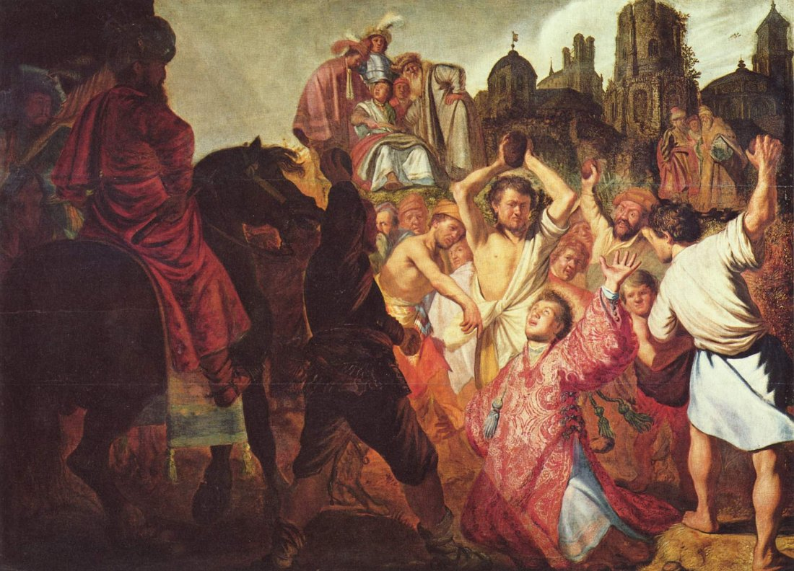
Acts 6:1-8:1a

Establishing Deacons (6:1-7)
- Hellenists: Jews who had taken on Greek
customs as a result of Alexander the Great’s
Hellenization (greek-etizing) of the world.
- Hebrews: Jews who rejected Greek culture

- What was the problem?
“The Stoning of St. Stephen” by Rembrandt (1625) (His first known work)

- Why didn’t the Apostles do it themselves?

- What was the result? (v.7)

Stephen Seized (6:8-7:1)
- The synagogue of the Freedmen: likely a Hellenistic synagogue where the service was conducted in Greek. (the cities listed are all Greek cities)

- “They could not withstand the wisdom and Spirit…” (v.10)

- “This man never ceases to speak words against this holy place and the law,” (v. 13)

- “His face was like the face of an angel.” (v.15)

- “Are these things so?” (7:1)
  - what things?

Stephen Speaks (7:2-53)

- What common theme is Stephen emphasizing in his speech? Why?

- Abraham Isaac and Jacob (v. 2-16)
  - “in Mesopotamia”
  - Gen 12:1 quote
  - “yet he gave him no inheritance in it” (v.5)
  - What period of Israel’s history is verses 6-8 referencing?

  - “sold him into Egypt, but God was with him…” (v.9)
  - “and Jacob went down into Egypt” (v.15)

- Moses (v.17-41)
  - “He supposed that his brothers would understand that God was giving them salvation by his hand… but they did not” (v.25)
  - “became an exile in the land of Midian” (v.29)
  - “for the place where you are standing is holy ground.” (v.33)
  - “I have come down to deliver them” (v.34)
  - “God will raise up for you a prophet like me from your brothers.” (v.37)
  - “and in their hearts they turned to Egypt…” (v. 39)

- Prophets (v.42-43)
  - “gave them over to worship the host of heaven…” (v. 42)
    - i.e. worship the stars and false gods (see Deut 4:19; 2 Kngs 17:16; 21:3; 23:5; Zeph 1:5)

  - “I will send you into exile beyond Babylon”

- Thesis (v. 44-50)
  - “Our fathers had a tent…” (v.44)
  - …same with Joshua…
  - …same with David… and he asked to build a temple…
  - “But it was Solomon who built a house for him. (v.47)
  - “Yet the most High does not dwell in houses made by hands” (v.48)
  - Isa 66:1,2

- Accusation (v. 51-53)
  - “uncircumcised in heart and ears” (v.51)
  - “as your fathers did, so do you.” (v. 51)
    - explanation (v.52-53)

Stephen Stoned (7:54-8:1a)
- “but he, full of the Holy Spirit, gazed into heaven and saw the Glory of God and Jesus standing at the right hand of God.” (v.55)
- “And the witnesses laid down their garments at the feet of a young man named Saul.” (v. 58)

- What do Stephen’s final two phrases remind you of?
  - See Luke 23:34, 46; 2 Chron 24:22)

- “And Saul approved of his execution” (8:1)

