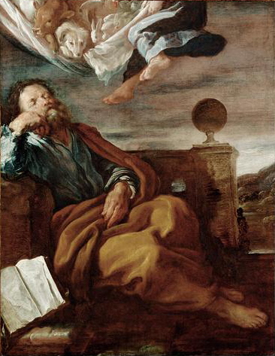
Acts 9:32-10:23
“Peter’s Vision of a Sheet with Animals”
by Domenico Fetti in 1619

Peter in Lydda and Joppa (9:32-43)
- Healing Aeneas (v32-35)
  - “Aeneas, Jesus Christ heals you; rise and
make your bed?” (v34)
  - “And immediately he rose.” (v34)
  - “..and they turned to the Lord.” (v35)
  - Compare and Contrast Luke 5:24-26

  - What point is Luke still making with this healing?

- Healing Dorcas (v36-43)
  - “when they had washed her, they laid her in an upper room.” (v37)
    - Is that unusual?

  - Who sent for Peter?

  - “But Peter put them all outside, knelt down and prayed” (v40)
  - “Tabitha, arise” (v40)
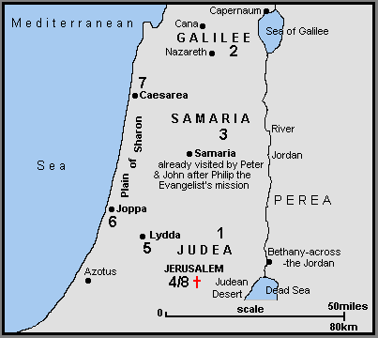
  - “…and many believed in the Lord” (v42)

  - Compare and Contrast Luke 8:40-56

Peter and Cornelius: Part 1 – Two Visions (10:1-23)
- Cornelius’s Vision (v1-8)
  - “a devout man who feared God” (v2)
    - evidence?

  - “he saw clearly in a vision” (v3)
  - “Your prayers and your alms have ascended as a memorial before God” (v4)

- Peter’s Vision (v9-23)
  - “he fell into a trance and saw the heavens opened and something like a great sheet descending” (v11)

  - “for I have never eaten anything that is common or unclean” (v14)

  - “What God has made clean, do not call common.” (v15)

  - “While Peter was pondering the vision, the Spirit said to him… go and accompany them without hesitation” (v19-20)

  - “… and some of the brothers from Joppa accompanied him.” (v23)

