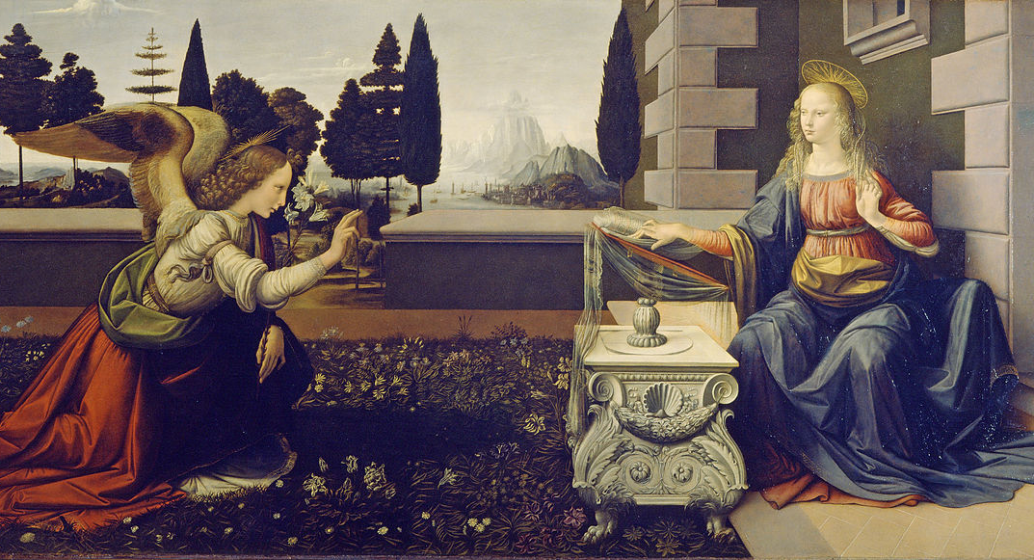
Angelology – Handout

Introduction:
- Definition:
  - Angel: heavenly messenger
αγγελος angelos – messenger, angel
מלך malak – messenger, angel
- Purpose/Role:
  - Convey messages from God to humans?
  - Unknown

Creation:
- When were angels created?
  - Day 4? (Gen 1:15-19)
  - the “gap”? (Gen 1:1-3)
  - in “the beginning”? (Gen 1:1)
  - Between day 6 and 7?
- If it’s true that Satan is a fallen angel, then angels must have been created before the events of Genesis 3. (cf. Job 38:4-7)

Nature:
- Wholly different from humans (Heb 1:14)
- They study humans (1 Pet 1:10-12; Eph 3:10-11)
- Various “types” or classes (Isaiah 6:2; Gen 3:24)
  - e.g. seraph, cherub
  - Archangels? (7 in Catholic Doctrine)
  - The Angel of the Lord? (Gen 16:7-12; 21:17-18; 22:11-18; Ex 3:2; Judg 2:1-4; 6:11-24; Zech 1:12; 3:1)

Facts:
- Created by Christ (Ps 148:1-7, Col 1:16)
- Do Not Marry (Matt 22:30)
- Some rebelled (1/3?) (Matt 25:41; Rev 12:1-9)
- Carry messages (Luke 1-2; meaning of word)
- Two named in Bible:
  - Michael (Rev 12; Jude)
  - Gabriel (Dan 8-9; Lk 1)

Perceived Actions:
- Worship God (Isaiah 6)
- War (Rev 12; Jude 9; Dan 10:13)
- Can take human forms (Gen 19; Gen 6?)
- Don’t accept worship (Rev 22:8-9) (cf. Josh 5:13-15?)
- Take human form? (Gen 18-19; Gen 6?)
- Sin? (Jude 6-9)

Satan:
- satan and devil mean “adversary” or “enemy”
- Personal being or impersonal force? (Gen 3; Matt 4:1-11; Luke 4:1-13; Job 1-3; Rev 12:9; 20:2)
- Not an equal opposite to God.

- Isaiah 14:(12-17)

- Ezekiel 28:(1-15)

- When did he fall?
- Why did he fall?
- Where is he headed? (Matt 25:41; Rev 19-20)

Demons:
- Genesis 6
- Jude 6-9
- 1 Peter 3:17-20
- Seen primarily in Gospels (e.g. Lk 4:33; Mark 5:1-20)

