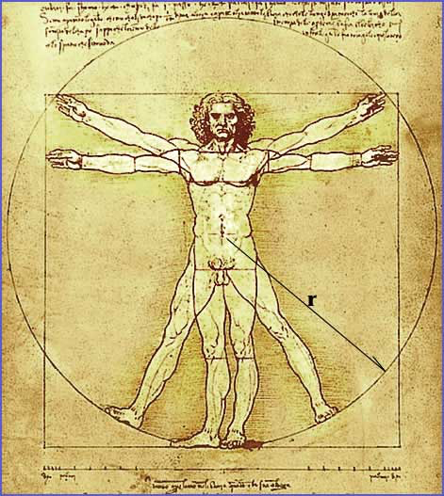
Anthropology and Hamartiology Handout

ANTHROPOLOGY:

Imago-Dei:

Genesis 1:26-27:

- Is there a difference between “image” and “likeness”?
  - heb. tselem and demuth, grk. imago and similitude

- What is included in the “image and likeness of God”?

Facets:

- Material
  - Current (2 Cor 4:5-12)

  - Resurrection 1 Cor 15:20-26 (context v1-26)

- Immaterial
  - Soul/Spirit (Gen 2:7; Matt 10:28)

  - Conscience (Rom 2:14-16)

  - Mind (Rom 12:2)

  - Will (Rom 7:15-25)

- Do Humans have free will?
  - Yes. All creatures are free to act according to their nature.

- “The will always chooses according to its strongest inclination at the moment.” Jonathan Edwards
- “Man has free will but lacks liberty.” Augustine

Kitty cat kitty can where have you been?
I’ve been to England to see the queen.
Kitty cat kitty cat, what saw you there?
I saw a mouse under the her chair.

Fall:
- Genesis 3

- What were the causes of the fall?

- What were the results of the fall?

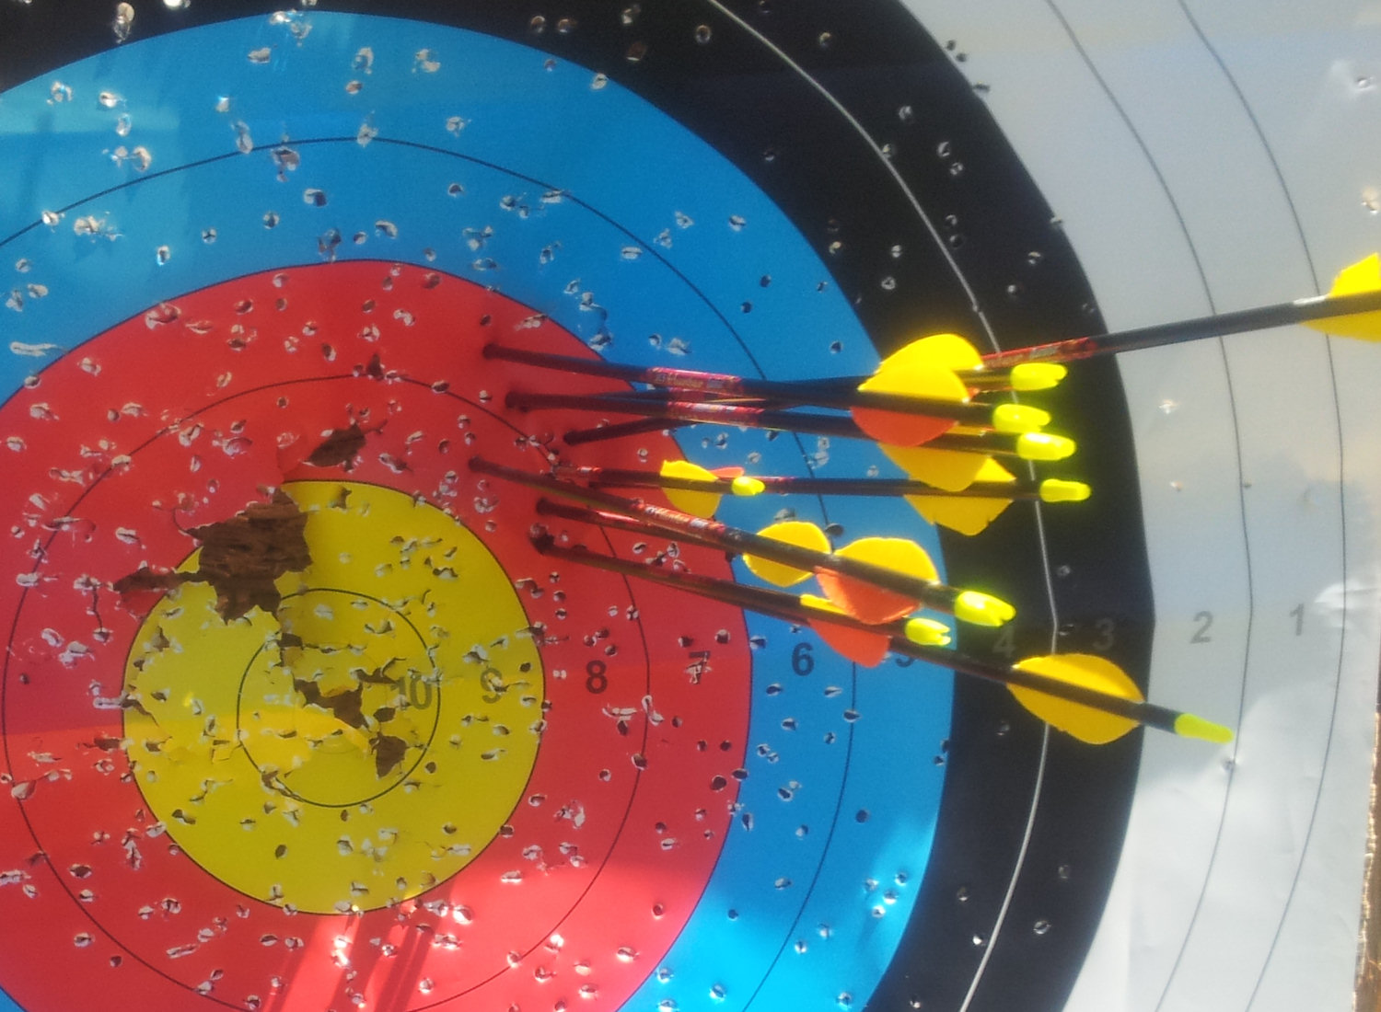
HAMARTIOLOGY

Definition:
- Sin is any fed desire in a human that is contrary to
the prescriptive will of God. -Stephen’s Definition

- “Sin may be defined ultimately as anything in the creature which does not express, or which is contrary to, the holy character of the Creator.” Oliver Buswell

- Missing the mark and hitting another

- Rebellion against God

- Other Synonyms?

Inheritance:
- What is the consequence of what Adam did relative to us?
  - Gen 5:3

- In what sense did Adam represent us?
  - 1 Cor 15:22

- Manner of Participation:
  - Represntationalism (non-participatory)

  - Seminalism (Participatory)

- Pelagianism:
  - sin does not corrupt man’s mind, emotion, will.
  - Man is spiritually alive.
  - Basic Justification: God will not ask us to do what we cannot do.
  - Basic Theology: total ability, denial of depravity/original sin
  - You become a sinner when you commit your first sin.

- Augustinianism:
  - sin corrupts every facet of man.
  - Man is spiritually dead.
  - Basic Justification: Biblical texts. (Rom 3:23, Jer 17:9)
  - Basic Theology: total inability
  - You are born a sinner.

“What’s the difference between a believers sin and an unbelievers sin? The answer is habituality, perpetuality, and remorse. Not the kind of action.” John Hannah

Penalty:

- Death

- Genesis 2:16-17

- Romans 6:23

- What is meant by “death”?

