Biblical View of Government and Immigration

Outline:
- Government
- Immigration
- Political Parties and USA Gov Involvement

- Government – Civil Disobedience
3 Logical Options:
- Civil Disobedience is NEVER Right
  - “Radical Patriotism”
- Civil Disobedience is SOMETIMES Right
  - “Willful Submission”
- Civil Disobedience is ALWAYS Right
  - “Anarchism”

Anarchism
- No biblical support
- Gen 9 – God ordains Human Government after the Flood
- Various instructions to “submit” to the Government (Rom 13:1-7; 1 Pet 2:13-17; Titus 3:1)

Radical Patriotism
- Biblical Support:
  - Rom 13:1-7 – Submit to the governing authorities.
  - Matthew 22:17-22 – Render to Caesar
  - Examples of submission even to Evil Governments (Daniel to Babylon, Nehemiah to Persia, Israel to Egypt)

- Biblical Refutation:
  - Examples of OT Saints (Moses, Judges, Prophets, midwives in Ex 1)
  - Example of Jesus (Jn 2:15)
  - Example of the Apostles (Acts 4:18-29 5:28-29)
  - Example in Revelation (14:9-10 [cf 13:15])

Willful Submission
- Biblical Support:
  - Render to Caesar (Matt 22:17-22)
  - Appeal to Conscience/Morality (James 4:17; Rom 13:1-7)
  - Obey God’s laws first, man’s laws second (Acts 5:29; Dan 3; John 19:11, Reformation)
  - Accept human punishment for disobedience? (E.g. Jesus vs E.g. Paul vs E.g. Paul at other times)
    - Refer back to conscience.

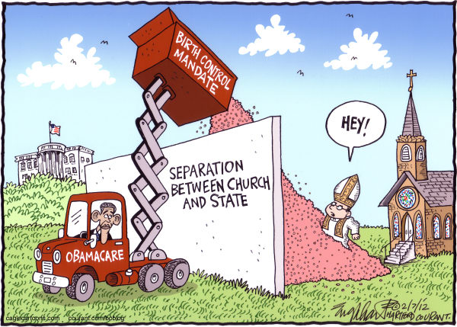
Government – Separation of Church and State
- NOT separation of God and State, or Morality and State
- Church History examples
  - Early Church (Fully separate)
    - Persecution and holiness, lack of uniformity
  - Constantine (co-operation)
    - Creeds and clarity, lack of complete sincerity
  - Holy Roman Empire/Dark Ages (Fully integrated)
    - Unity and clarity, lack of purity

- Immigration

Popular Views
- Illegal immigrants are law-breakers and should be punished accordingly.
- Illegal immigrants are more like refugees and should be treated mercifully.

Biblical Insights
- Mosaic Law (Lev 19:9-17, 33-34)
- Heb 13:2 – Welcome Christians you don’t know
- Lk 13:29, Rev 7:9 – Every tribe and tongue will have Christians
- 2 Thess 3:11-12 – He who does not work…
- 1 Cor 6:9-11; Gal 5:19-21; Eph 5:3-6 – Paul’s sin lists that include thieves and swindlers.
  - Could illegal immigration be considered theft?
- Paul’s recognition and use of Roman citizenship to his own advantage (Acts 22:25; 25:10-11)

My View
- Institutionally: respective of laws and supportive of strict enforcement on citizenship and immigration.
- Personally: helpful, humble, and forgiving to illegal immigrants recognizing their struggles.
- Policy: A form of path to citizenship while increasing border security and decreasing illegal immigration.

- Political Parties and USA Government Involvement
- Conservative vs. Liberal and Republican vs. Democrat
  - They’re not the same
  - Political ideology vs Political party
- Democratic Republic of the USA
  - We live in a republic
  - We have a say in our government
  - We have a responsibility to stay involved

Always remember… Phil 3:20-21 – “Our citizenship is in heaven…

