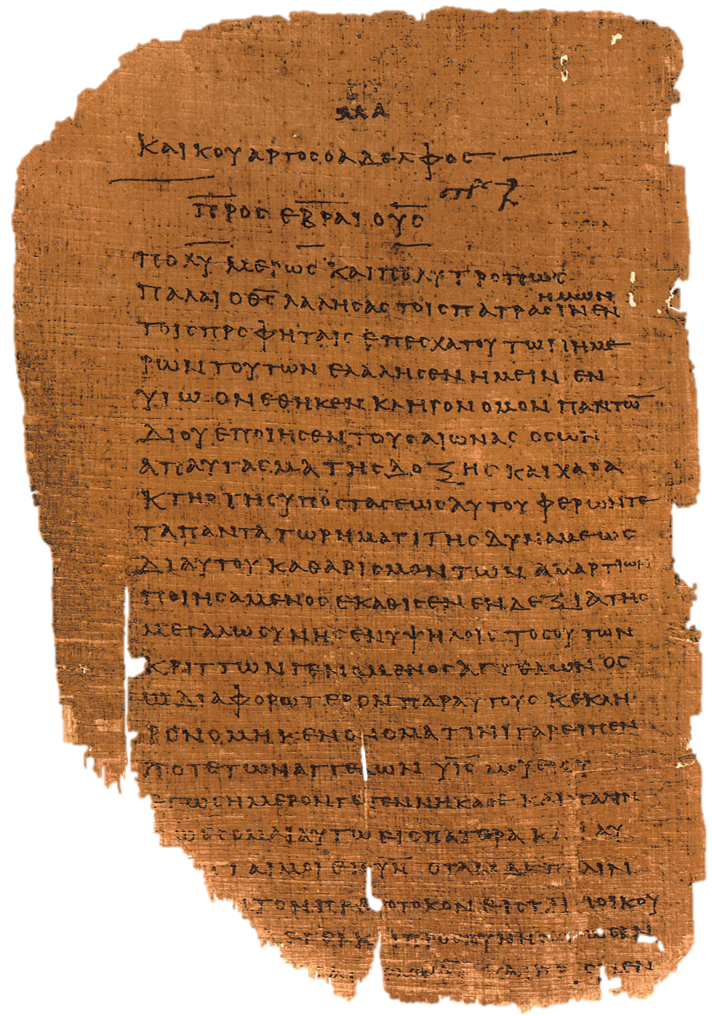
Bibliology “Words About the Book” – Handout

INTRODUCTION
Revelation:
- the process of making something known that was previously unknown
- to “reveal”

How Should I Live?
- Does God Exist? Yes: go to 2. No: Oh well, do what you want.
- Can He reveal himself to us? Yes: go to 3. No: Oh well, do what you want.
- Has he Revealed himself to us? Yes: go to 4. No: Oh well, do what you want.
- Find and follow that revelation.

Special and General Revelation:
- General Revelation – secondary or indirect communications from God
  - Creation – Psalm 19:1-4; Romans 1:18-20; Acts 14:17

  - Conscience – Romans 2:14-16

  - Providence – Matt 5:45

- Special Revelation – Primary or direct revelations from God

Types of Special Revelation:
- The Lot – Lev 16:8; Prov 16:33; Acts 1:21-26
- The Urim and Thummin – Exod 28:30; Num 27:21; Deut 33:8
- Visions (Dreams) – Gen 20:3; 31:11-13, 24; 40-41; Isa 1:1; 6:1; Joel 2:28

- Theophanies – Gen 18:1-2; 32:24-30; *Josh 5:13-15

  - “the angel of the Lord”? – Gen 16:7-14; Exod 3:2; 2 Sam 24:16; Zech 1:12

- Angels (messengers)- Dan 9:20-21; Luke 2:10-11; Rev 1:1

- Prophets – Deut 18:18-22; 2 Sam 23:2; Verse 1 of most prophets (e.g. Zech 1:1); Eph 3:5; Rev 11:4-6

- Jesus – John 1:1; 8:19ff; 10:30; 12:44-50; Matt 1:21-23; Phil 2:6; Heb 1:1

- Bible – John 17:17; 2 Tim 3:16-17; 2 Pet 1:21
The Bible as the Sole Authority:
- All authentic revelation is equally authoritative
- Not all revelation is equally available
- Not all revelation is equally understandable
- The Bible is the only verifiable, authentic special revelation available to all Christians in this Dispensation.

- What about the authority of the Church?
  - “Unless I am convinced by the testimony of the Holy Scriptures or by evident reason-for I can believe neither pope nor councils alone, as it is clear that they have erred repeatedly and contradicted themselves-I consider myself convicted by the testimony of Holy Scripture, which is my basis; my conscience is captive to the Word of God. Thus I cannot and will not recant, because acting against one's conscience is neither safe nor sound. God help me. Amen.” - Luther

INSPIRATION
Definition (Stephen’s View):
- Verbal Plenary Inspiration
  - Verbal – the specific words are inspired

  - Plenary – all of the words are inspired

  - Inspiration – God breathed the words through the men
    - latin: in- “into”; spirare- “breath”

- “God superintended the human authors of the Bible so that they composed and recorded without error His message to mankind in the words of their original writings.”-Ryrie

- “In the sense in which the works of a man are his words, revealing his thoughts, will, purposes, the Scriptures are the word of God. He is their author. Their contents rest on his authority. They are not merely his as written by pious men, not a human form of divine truth, but God’s own exhibition of truth. “ – Hodge

- “A supernatural influence exerted on the sacred writers by the Spirit of God, by virtue of which their writings are given Divine trustworthiness.”- Warfield

- “Every word of scripture is inspired by God, and done so in such a way that the author is both truly God and truly man. Every word correctly conveys God’s intended meaning, while the man acting as God’s instrument does not surrender his mind, will, or style therein.” – Curto

Internal Evidence:
- Verbal – 1 Cor 2:2-13
  - “which we also speak in words, not in teachings of men’s wisdom…”

- Plenary – 2 Tim 3:16-17
  - “All scripture is God-breathed…” θεοπνευστος theopneustos

- Inspiration – 2 Pet 1:21 (and 2 Tim 3:16)
  - “For no prophecy was ever brought by the will of men, but men spoke from God, being brought by the Holy Spirit.”

Opposing Views:
- Natural Inspiration

- Mystical Inspiration (Trance Theory)

- Mechanical Inspiration (Dictation Theory)

- Partial Inspiration

INERRANCY
Definition:
- “The Scriptures possess the quality of freedom from error. They are exempt from the liability to mistake, incapable of error. In all their teachings they are in perfect accord with the truth.” – Young⁴

- “The Scriptures have never erred” –Luther⁵

- “the inerrancy of the Bible means simply that the Bible tells the truth.” – Ryrie⁶

- Figures of speech are acceptable

- differing but true accounts are acceptable
  - One angel or two?

- approximations are acceptable
  - ”I make 100k a year.” Salary: $100,240

- free quotations are acceptable
  - “He said, ‘Take a bath.’” Actual quote: “You must bathe now.”

- Extends only to original manuscripts

- “What was literally intended by the original authors in their original manuscripts is without error in any way and such intention can be communicated with the words chosen by the author in a reasonable way so as to be called ‘true’ for every single word or phrase therein.” – Curto

Chicago Statement 1978:
1. God, who is Himself Truth and speaks truth only, has inspired Holy Scripture in order thereby to reveal Himself to lost mankind through Jesus Christ as Creator and Lord, Redeemer and Judge. Holy Scripture is God’s witness to Himself.
2. Holy Scripture, being God’s own Word, written by men prepared and superintended by His Spirit, is of infallible divine authority in all matters upon which it touches: it is to be believed, as God’s instruction, in all that it affirms: obeyed, as God’s command, in all that it requires; embraced, as God’s pledge, in all that it promises.
3. The Holy Spirit, Scripture’s divine Author, both authenticates it to us by His inward witness and opens our minds to understand its meaning.
4. Being wholly and verbally God-given, Scripture is without error or fault in all its teaching, no less in what it states about God’s acts in creation, about the events of world history, and about its own literary origins under God, than in its witness to God’s saving grace in individual lives.
5. The authority of Scripture is inescapably impaired if this total divine inerrancy is in any way limited or disregarded, or made relative to a view of truth contrary to the Bible’s own; and such lapses bring serious loss to both the individual and the Church.

Internal Evidence:
- Jesus’s confidence in the Scriptures - Matt 4:1-11; 5:17-18; 10:15; 12:17,40; 17:11-12; 19:3-5; ch 22; 24:15
- Matt 22:29-32
  - Jesus bases an entire argument for resurrection on a verb tense.
- An appeal for inerrancy from within the document is circular reasoning.

External Evidence:
- Its lack of demonstrable errors give credence
- Illustration: a man trusts his wife
- Syllogism:
  - God always tells the truth.
  - The Bible is God’s word.
  - Therefore, the Bible is always true.

Problem Passages?:
- e.g. Matt 20:29-34 vs Mark 10:46-52 vs Luke 18:35-43

- How many were there?
  - Where there is 2 there is also 1.
  - No author says there was “only one” man, just that there was “a man”

- Was Jesus entering or leaving Jericho?
  - There were actually two Jericho’s (at least!) at the time: Old Jericho and New Jericho
  - It may be that Jesus was going between the two

CANON
Definition:
- κανον kanon “rod, ruler”
- The ruler, or measuring stick, for Christians
- Those books which an author actually wrote.
- canonization: the process of recognizing those books actually written by God.

History:
- Questions to consider:
  - Why didn’t they collect books until the 2nd and 3rd centuries?
    - The Apostles’ deaths
    - persecution means scarcity (less ability)
    - persecution means unanimity (no need)

  - Why didn’t they offer lists of scriptures until the 3rd and 4th centuries?
    - Development of tests
    - massive argumentation

  - When was the issue actually settled?
    - Council of Carthage, 397 and 419 (Sort of)
    - Reformation, Council of Trent 1545-1563 (Finally)
Tests:
- Apostleship
  - Was it written during the age of the Apostles?

- Acceptance
  - Would you die for this book?

- Authority
  - Does it have any demonstrated errors?

Formation – OT:
- Septuagint (Greek Translation of OT) (400’s BC)
  - Includes entire 15 book Apocrypha

- Josephus’s Listing (approx AD 50-100)
  - Matches our list of 39 books

- Council of Jamnia (approx AD 90) (Jews in Rome)
  - Matches our list of 39 books

- Council of Trent (AD 1545-1563) (Roman Catholic Council)
  - Included 7 more books and extra sections of Daniel and Esther

Formation – NT:
- Muratorian Fragment (approx AD 170)
  - Omits: Hebrews, 1 and 2 Peter, James, and 3 John;
  - Includes: Wisdom of Solomon

- Athanasius’s 39th Festal Letter (AD 367)
  - Omits Esther; Includes Baruch

- Council of Hippo (AD 393)
  - matches our list of 27 books

- Councils of Carthage 1 and 2 (397, 419)
  - matches our list of 27 books

RC vs Protestant:
- Jerome translates Latin Vulgate (AD 405)
  - Includes 15 apocryphal books in appendix
  - “Not to be read in churches”

- The Roman Catholic and Protestants agree on 66 books

- They disagree about 7 “OT” books and some additional sections of two more

-RC Canon, Differences from Protestants Highlighted-

- Genesis
- Exodus
- Leviticus
- Numbers
- Deuteronomy
- Joshua
- Judges
- Ruth
- 1 Samuel
- 2 Samuel
- 1 Kings
- 2 Kings
- 1 Chronicles
- 2 Chronicles
- Ezra
- Nehemiah
- Tobit
- Judith
- Esther
- 1 Maccabees
- 2 Maccabees
- Job
- Psalms
- Proverbs
- Ecclesiastes
- Song of Songs
- Wisdom
- Sirach
- Isaiah
- Jeremiah
- Lamentations
- Baruch
- Ezekiel
- Daniel
- Hosea
- Joel
- Amos
- Obadiah
- Jonah
- Micah
- Nahum
- Habakkuk
- Zephaniah
- Haggai
- Zechariah
- Malachi

INTERPRETATION
Literal Grammatical Historical Hermeneutics:
- Literal – take the words the way they were literally intended (search for the literal referent of FoS)

- Grammatical – interpret based on the grammar of the original language, not solely on a translation

- Historical – interpret in light of the historical setting of author and reader

SUPPLEMENTAL BIBLIOGRAPHY

Bibliology in General
- The Bible by God, compiled by others
- Basic Theology by Charles Ryrie
- Systematic Theology Volume 1 by Lewis Sperry Chafer
- The Moody Handbook of Theology by Paul Enns
- Holy Scripture by Donald G. Bloesch
On Inspiration
- Inspiration by A.A. Hodge and B.B. Warfield
- Biblical Inspiration by I. Howard Marshall
- Inspiration and Interpretation by John F. Walvoord

On Inerrancy
- Inerrancy by Norman Geisler
- Five Views on Biblical Inerrancy by Peter Enns (and others)
- Inerrancy and the Church by John Hannah
- Does Inerrancy Matter by James M. Boice
- Explaining Inerrancy: A Commentary by R.C. Sproul
On Canonicity
- The Canon of Scripture by F.F. Bruce
- The Canon Debate by Lee Martin McDonald
- Chronological and Background Charts of the New Testament by Wayne House
- Canon Revisited by Michael J. Kruger

