CHURCH HISTORY: Catholic Christianity

Characteristics of the Age:
- persecution from Rome

- massive expansion and evangelism

- rumors in the republic

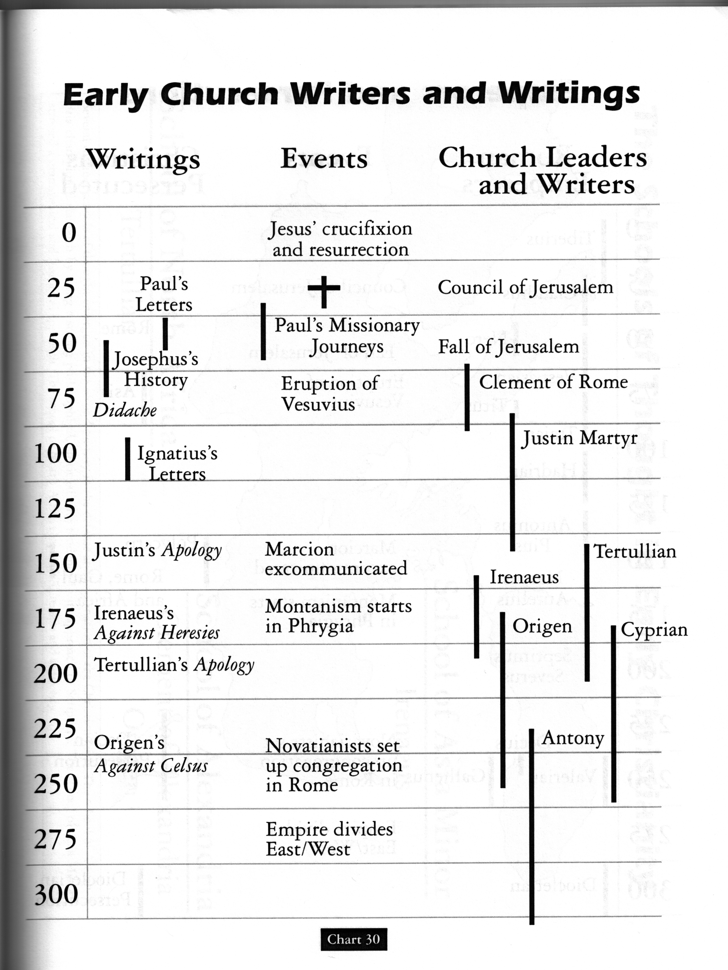

- two schools

Major Players
Clement of Rome
Ignatius of Antioch
Polycarp
Justin Martyr
Tertullian
Irenaeus
Clement of Alexandria
Origen

Doctrines:
- Gospel

- Jesus

- Scriptures

Apostle’s Creed
“I believe in God almighty
And in Christ Jesus, his only Son, our Lord
Who was born of the Holy Spirit and the Virgin Mary
Who was Crucified under Pontius Pilate and was buried
And the third day rose from the dead
Who ascended into heaven
And sits on the right hand of the Father
Whence he comes to judge the living and the dead
And in the Holy Ghost
The holy church
The remission of sins
The resurrection of the flesh
The life everlasting.”

