CREATION VIEWS

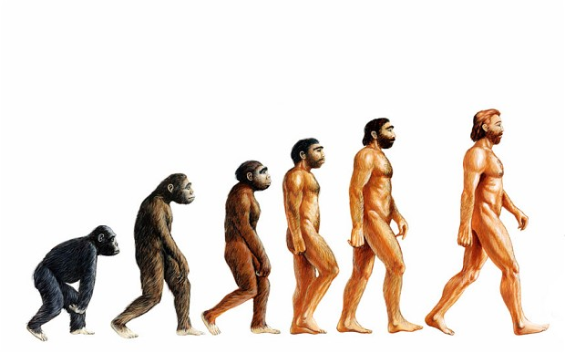
Outline:
- Introductory Matters
- The Views

I. Introductory Matters
a. Genesis 1-2
- Two successive accounts

b. To be scientifically proven…
- Observable
- Testable
- Repeatable

c. “Historical Science” vs “Science” (*see Bill Nye/Ken Ham debate)

d. “Macro” vs “Micro” Evolution

II. The Views: (Ordered from least to most biblical)
- Evolution
- Creative Evolution
- Literary Approach
- Day-Age
- 2 Phase
- Gap Theory (aka. Prior Creation)
- Literal Six-Day

1. Evolution
Basics:
- Says that earth randomly evolved over an enormous period of time to create life
- Earth is however old Modern Scientists now claim (currently 5 Billion yrs)
- Uses Radiometric dating of meteoric material and volumetric/luminosity of sun compared to other stars. Oldest material=minimum age of earth, age of sun=maximum age of earth (because no sun means no solar system)

Pros/Arguments For:
- Explains calculated age of earth

Cons/Arguments Against:
- Radiometric dating inaccurate after 2,000 years (hour glass example)
- Assumes unchanging conditions throughout earth’s existence
- Is not scientifically proven
- Contradicts two scientific Laws: (1) Biogenesis (i.e. life comes from life) (2) 2nd Law of Thermodynamics (i.e. things, if left to themselves, progress toward chaos, not order)
- Assumes death prior to sin
- Ignores God’s involvement

2. Creative Evolution
Basics:
- Says that God used the evolutionary process to create earth
- *see Basics of Evolution

Pros/Arguments For:
- Tries to account for God’s involvement
- Explains calculated age of earth

Cons/Arguments Against
- *see arguments a-d on Evolution
- Evolution and Genesis have different orders of creation (evolution puts light and stars before the earth, and the land before the ocean)
- Assumes uniformitarianism (i.e. everything is the same as it always was)

3. Literary Approach
Basics:
- God created, but the Genesis account is purely poetic/literary
- Most who take literary approach adhere to Creative Evolution

Pros/Arguments For:
- Attempts to explain the differences between biblical texts and Evolutionary theory
- Explains calculated age of earth
- Usually adheres to Mosaic Authorship

Cons/Arguments Against:
- *see arguments a-c on Creative Evolution
- Does not use literal hermeneutic
- Assumes higher view of science than the Bible

4. Day-Age Theory
Basics:
- God created in six phases of history but they weren’t literal days. A “day” in Genesis is a much longer period of time.
- May or may not have followed evolutionary process

Pros/Arguments For:
- Attempts to hold higher view of Biblical texts
- Explains calculated age of earth
- Adheres to mosaic Authorship
- Some linguistic support for yom as “time” instead of “day”

Cons/Arguments Against:
- Abandons literal Hermeneutic
- Uses verses out of context to support theory
- Fossil record does not support gradual creation
- Assumes death prior to sin

5. 2 Phase
Basics:
- God created the earth in two phases, one recorded in Genesis 1, the other in Genesis 2 with a great length of time in between
- Often uses pieces of other views in the first phase.

Pros/Arguments For:
- *See arguments a-c on Day-Age
- Explains the repeat account in Genesis 2
- Can be held while holding to a literal hermeneutic
- Explains calculated age of earth

Cons/Arguments Against:
- no evidence for break of time between 2:3 and 2:4
- Unnecessary to explain biblical text
- Assumes death prior to sin

6. Gap Theory
Basics:
- God created everything in 1:1 and began refashioning it in verse 2 with a large gap of time in between
- Uses mostly linguistic theological necessity arguments for support.
- Age of earth is indeterminate, but age since refashioning is identical to LSD

Pros/Arguments For:
- Accounts for change in word “made.” Bara- v.1 Asa-v.7ff
- Explains calculated age of earth
- Can be held while holding literal hermeneutic
- Explains when Satan fell
- Attempts to Hold Higher-view of Biblical text

Cons/Arguments Against:
- Hyper-literal interpretation of Hebrew words
- Unnecessary to explain biblical text
- Assumes death prior to sin (reasonable counter-arguments available)
- Adds a lot to the text that isn’t explicit

7. Literal Six Day
Basics:
- God created everything in 6 literal days just as the Bible describes.
- The Chapter 2 retelling is a more detailed/particularized account
- Holds that the earth is between 6 and 10,000 years old

Pros/Arguments For:
- Best use of literal hermeneutic
- Holds Biblical text as highest standard of truth
- Explains Genesis 2 account
- Adheres to Mosaic authorship
- No death prior to sin
- Does not add to or take away from the text
Cons/Arguments Against:
- Does not explain calculated age of earth
  - “Apparent Age” argument
- Minority View
- Overly Simplistic

Resources for Further Study on LSD (both sides):
www.answersingenesis.org
www.creation.com
“In Six Days” ed. John F Ashton
“The Genesis Flood” by Henry Morris and John Whitcomb
“Mount St. Helens: Modern Day Evidence for the World Wide Flood” by Steve Austin
http://www.thegospelcoalition.org/blogs/justintaylor/2015/01/28/biblical-reasons-to-doubt-the-creation-days-were-24-hour-periods/

Discussion Notes:

Other Notes:

