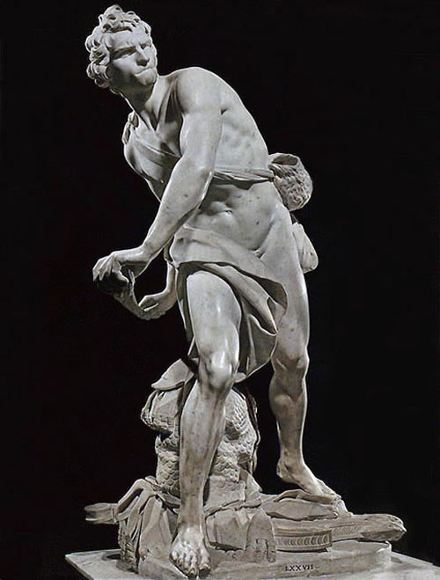
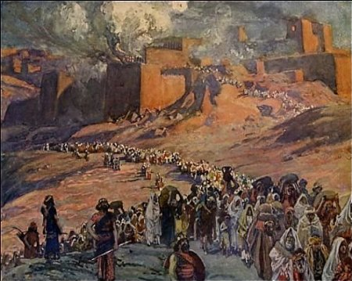
David Through Exile:
A Survey of Kings and Prophets

Saul, David, and Solomon
- Saul (1 Samuel 9-31; 1 Chron 8; 10)
  - Chosen by God, anointed by Samuel (1 Sam 9-10)
  - Successful Leader (1 Sam 11-13)
  - Unsuccessful Leader (1 Sam 13-31)

- David (1 Sam 16 – 1 Kings 2; 1 Chron 11-29)
  - Chosen by God, anointed by Samuel (1 Sam 16)
  - Saul’s servant and constant conflict with Saul (1 Sam 16-31)
  - Transition from Saul to David (2 Sam 1-4)
  - Successful leader (2 Sam 5-10)
  - Unsuccessful father (2 Sam 11-24)
  - Davidic Covenant (2 Sam 7)

- Solomon (1 Kings 1-11; 2 Chron 1-9)
  - Wise king, foolish lover (1 Kings 1-11)
  - Builder of the temple (1 Kings 5-8)
  - Last ruler of the United Kingdom

Divided Kingdom (1 Kings 12 - 2 Kings 25; 2 Chron 10-36)
- Rehoboam (Judah/South) and Jeroboam (Israel/North) Conflict (*see Supplement #3)
- All the kings of Israel and Judah (*see Supplement #1)

- Israel
  - No good kings
  - They all “followed the sins of Jeroboam” (Idol worship)
  - Destroyed by Assyria in 722 B.C. (2 Kings 17)

- Judah
  - 6 good kings, 2 mixed results
  - Deported/defeated in 3 waves by Babylon (605 B.C., 597 B.C., 586 B.C.)
  - Temple destroyed by Babylon (586 B.C.)

Prophets (Isaiah-Malachi)
- ministered during the reigns of the kings
- Writings Prophets (*see Supplement #2) vs Non-Writing Prophets
- Common themes in Prophets Writings (*see Supplement #4)
  - God’s judgment
  - God’s sovereignty
  - God’s steadfast love for Israel
  - God’s graceful restoration of Israel after judgment

One of Stephen’s Favorite Prophets: Habakkuk
- Outline
  - Cry for Just Judgment on Wicked in Israel (1:2-4)

  - God’s Promise of Judgment on All in Israel (1:5-11)

  - Habakkuk’s Question of God’s Judgment (1:12-2:1)

  - God’s Response to Habakkuk’s Question (2:2-20)

  - Habakkuk’s Resolve to Trust God (3:1-19)

- Message
  - God is sovereign and merciful, and the righteous (those who have faith in him) will be resurrected in the end.

Review of the History Exodus to Exile (1 America = 240yrs)
- Exodus – 1446 BC
- Law/Wandering – 1446-1406 BC (40 yrs)
- Conquest – ~1406-1399 BC (~5-7 yrs)
- Judges – ~1390-1050 BC (340yrs)
- Saul – 1050-1010 BC (40 yrs) [Ish-Bosheth reigned 2 yrs]
- David – 1010-970 BC (40 yrs)
- Solomon – 970-930 BC (40 yrs)
- Divided Kingdom – 930-722 BC (Israel, 208 yrs) 930-586 BC (Judah, 344 yrs)
- The Kings *see Supplement #1
Supplement #1

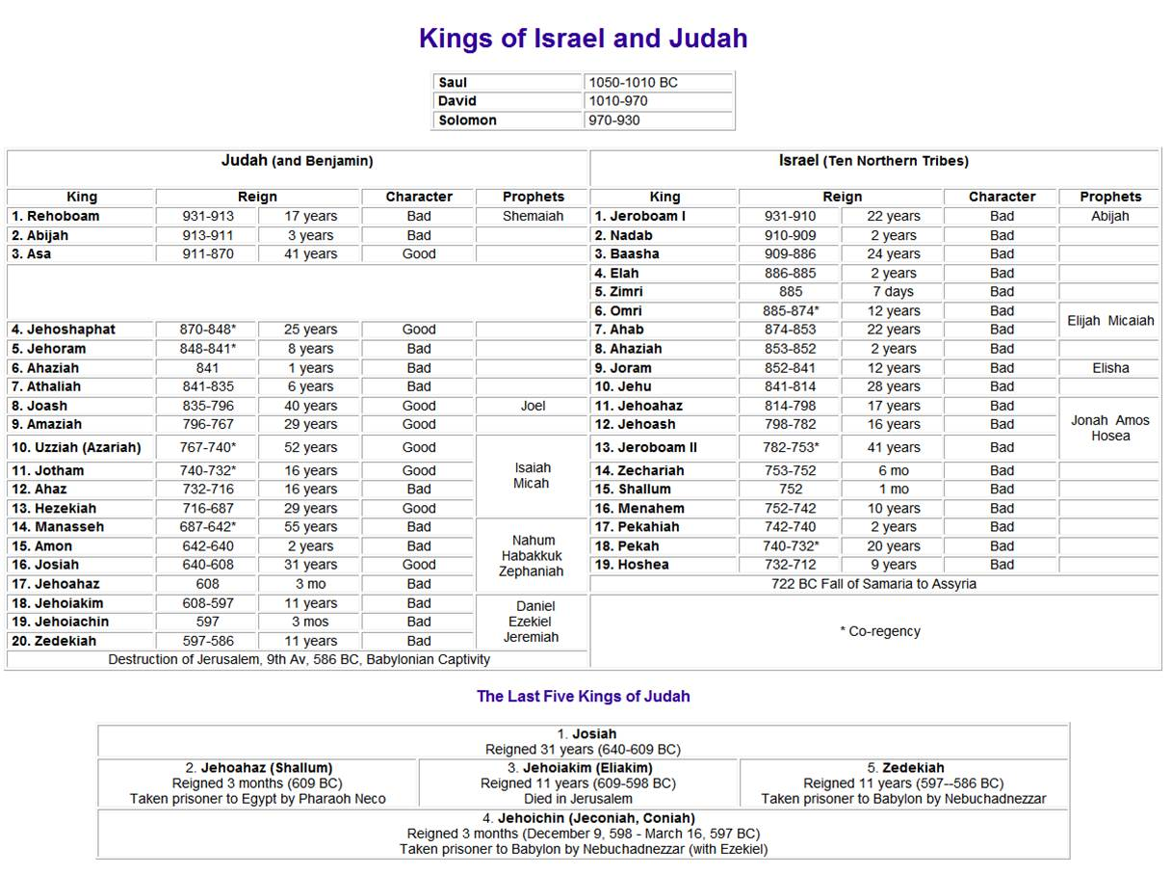

Supplement #4
Supplement #2

Prophet | Purpose of Book
Isaiah | A plea to Judah and Jerusalem to Trust Yahweh as his Servant nation, in the face of a gentile-run world.
Jeremiah | A call for Judah to repent and then to submit to punishment for refusing to repent.
Ezekiel | A reminder of God's faithfulness to Israel even when they were unfaithful, and predictions of his continued faithfulness.
Daniel | A show of God's sovereignty over all nations and all history.
Hosea | A call for Israel to repent, and a reminder of God's love for Israel, even when they were unfaithful.
Joel | A warning to Jerusalem of judgment day: the Day of the Lord.
Amos | A stern warning of judgment for Israel's idolatry.
Obadiah | A message of judgment on Edom.
Jonah | A message of judgment on Nineveh, and God's mercy.
Micah | A message to the people of Judah to repent.
Nahum | The announcing of Nineveh's fall.
Habakkuk | A cry to God for justice, and submission to his sovereignty.
Zephaniah | A call to be silent and fear Yahweh.
Haggai | An encouragement to the remnant to rebuild the temple.
Zachariah | A call for the remnant to hope in the messiah and his kingdom.
Malachi | a call for the remnant to pursue holiness.

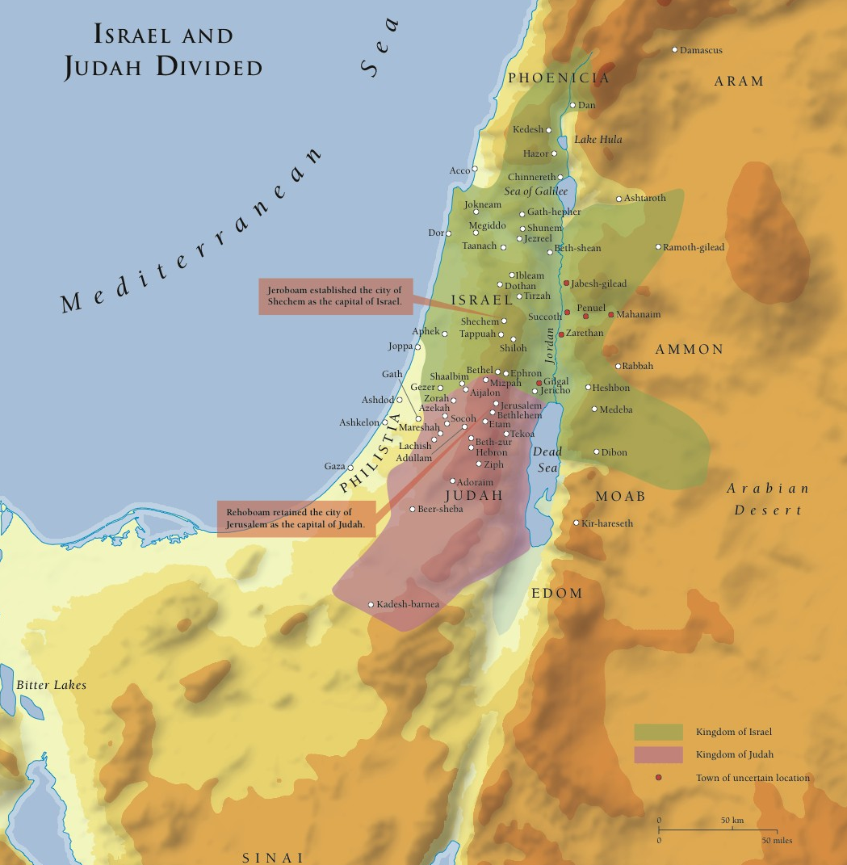
Supplement #3

