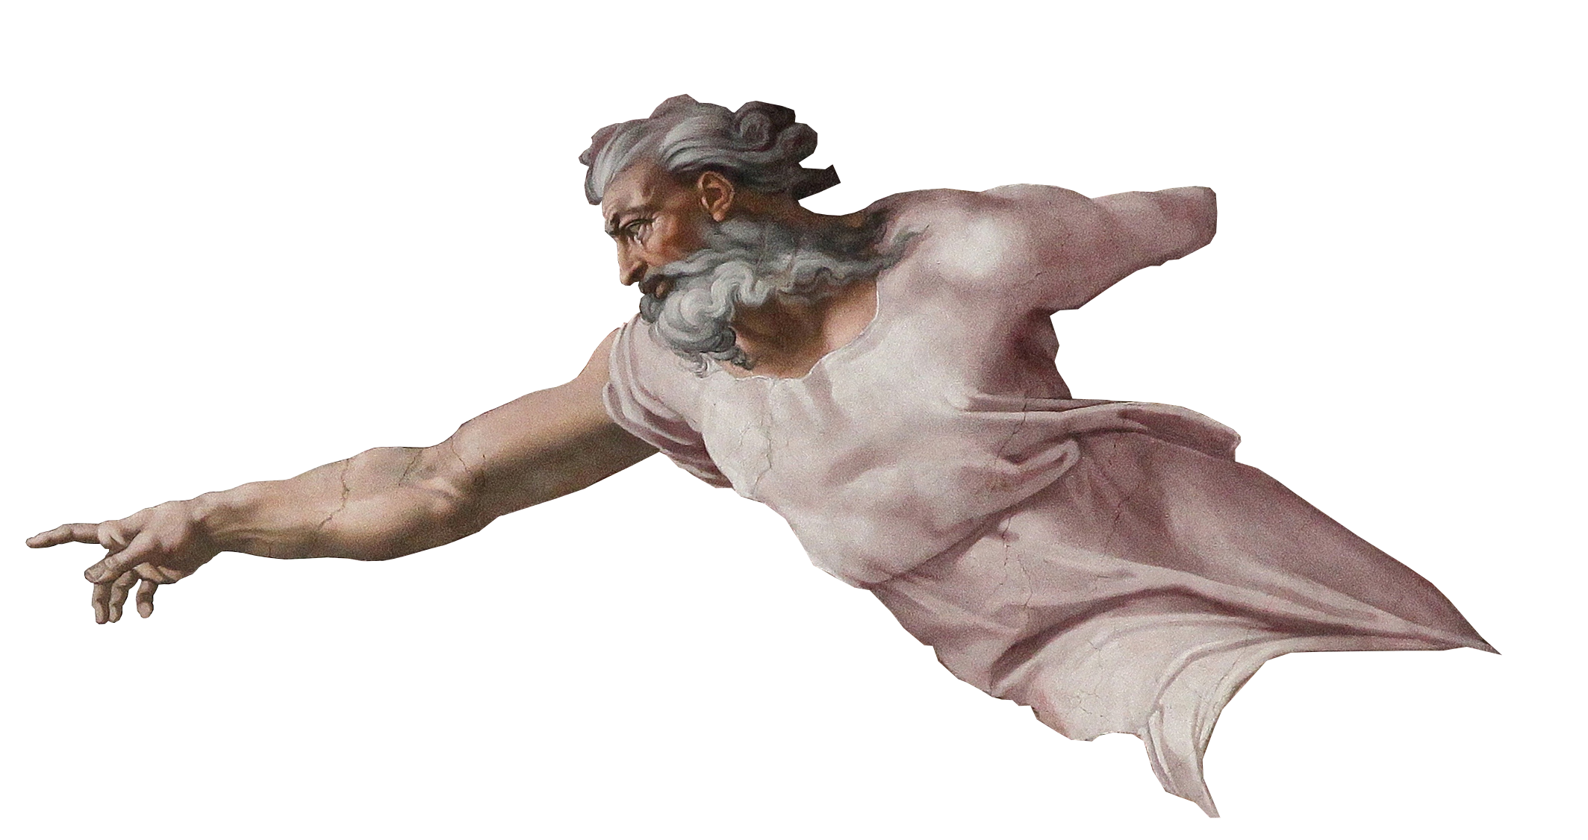
Theology Proper – Handout

ATTRIBUTES OF GOD
Definitions of God(?):
- “Spirit, infinite, eternal, unchangeable, in His being, power, holiness, justice, goodness, and truth.” – Westminster Shorter Catechism
- “God is the sum total of his infinite perfections.” – Dr. Paul Shockley
- “He is ens perfectissimum… the word ens designates Him as a being, not an idea, but as that which has real, objective existence; and absolute perfection distinguishes Him from all other beings.” - Charles Hodge

Defining God:
- Ultimately fruitless
- sub-ultimately helpful
- defining by description is best

In-Communicable Attributes
Aseity (Self-existence)
- “From Self” (lat.)
- God is the un-caused causer.
- Name: Yahweh “I am” יהוה
- Genesis 1:1

Infinity/Eternity
- God is not limited by anything but Himself (including time).
- Name: El Olam “God Everlasting” אל עולמ
- 1 Kings 8:27

Immutability
- God doesn’t change.
- Name: Yahweh “I am” יהוה
- Malachi 3:6
- Can God change his mind?
  - (Gen 6:6; Jonah 3:10)
  - Anthropomorphisms

The Three Omnis
- Omnipotence
  - God is all powerful.
  - Name: El Shaddai “God Almighty” אל שדי
  - Genesis 17:1

- Omniscience
  - God knows everything.
  - Name: El Roi “God who sees” אל ראי

- Omnipresence (?)
  - God is not excluded from anywhere in his creation.
  - Name: none
  - Psalm 139:7-11

Sovereignty/Autonomy
- God is in control.
- Name: Adonia “Lord/Master” אדני
- Psalm 135:5-6

- Non-exhaustive list
- other possible In-communicable attributes
  - Simplicity
  - Spirituality
  - Perfection
  - Unity

Communicable Attributes
- Attributes which God shares
- Primarily shared with humans
- Primarily shared through “Imago Dei”
- All seen lessened/imperfect in humans

Justice
- God always does what is right.
- “justify”
- Name: Yahweh Tsidkenu “The Lord is our Righteousness” יהוה צדקנו
- 1 John 1:9
- “At no point is divine justice more observable than in the plan of redemption.” – Chafer, 1:203

Goodness/Holiness
- God always does what is good.
- Name: Yahweh Shalom “GOD is Peace” יהוה שלום
- Leviticus 19:1-2; Romans 8:28

Love
- God always “commits his will to the true good of another.”
- Name: Yahweh Roi “God is my Shepherd” יהוה ראי
- 1 John 4:7-8

Grace
- God always provides beyond what is required/expected.
- Name: Yahweh Jireh “God will Provide” יהוה יראה
- Ephesians 2:8

- other possible communicable attributes
  - Truth
  - Righteousness
  - Knowledge
  - Will

TRIUNITY OF GOD

One-ness
- Deuteronomy 6:4

- Exodus 20:3
- Isaiah 45:14

- 1 Corinthians 8:4-6

- Ephesians 4:3-6
- James 2:19
Three-ness
- Deity of “the Father”
  - Jhn 6:27; 1 Pet 1:2; 1 Cor 8:6

- Deity of “the Son”
  - Heb 1:3-4; Matt 1:21-23;

Jhn 1:1; 8:58; 10:30; Col 1:15

- Deity of “the Spirit”
  - Acts 5:3-4; 1 Cor 2:10; 6:19

Other Contributing Passages
- Matthew 28:19

- Matthew 3:16-17

- 2 Corinthians 13:14

- ***1 John 5:7***

History
Early Church Fathers (100-150AD)
- Weren’t concerned with the doctrine
- Fighting Gnosticism
- Affirmed “Jesus is Lord.”
- Followed Apostles Creed
  - “Creed” credo (lat) “I believe”

Gnosticism
- Secret knowledge
- Matter is evil, spirit is good
- Dualistic philosophy
- Jesus wasn’t really a historical human
The Apologists (150-300AD)
- Development of language, but not concepts
  - Tertullian coins “trinity” “person” “substance”
- Fighting Modalism
- Setting the stage for the theologians

Modalism
- God is only one person
- The one person of god appears in three forms
- When God is the Father, he’s not the son or the Spirit, etc.

The Theologians (300-600AD)
- Nailing down concepts
- Fighting Arianism and Tri-theism
- Council of Nicaea (325AD)
- Nicene Creed

Arianism
- Jesus wasn’t always the son of God
- Jesus didn’t have full divinity
- Jesus was “God-like”
- Jesus was the first thing God created (Col 1:15)
Tri-theism
- There are three different Gods, with three different essences

The Theologians (cont.) (300-600AD)
- Weaknesses of Nicene council
- Creed of Constantinople (381AD)
- The three Cappadocians work
- Athansius’s Creed

Conclusion:

- 3 qualities to affirm
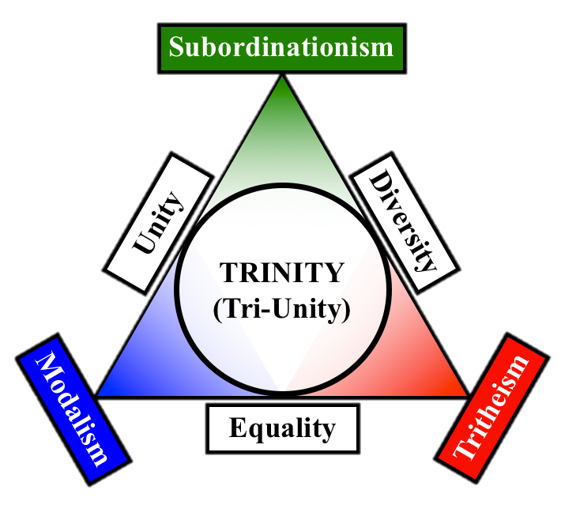
- 3 heresies to deny

- 3 persons
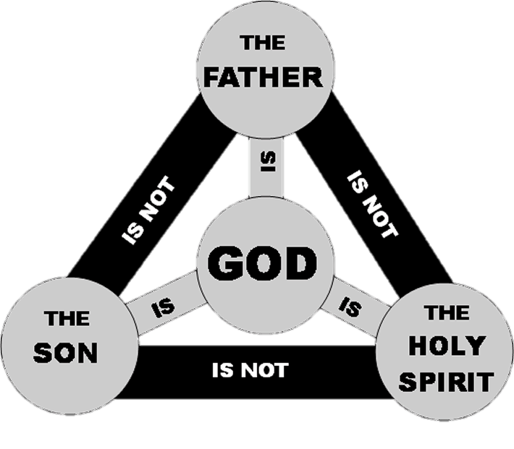
- 1 essence

