Worldview: An Introduction

What is a Worldview?

Definitions:
- “A worldview is simply the total of our beliefs about the world, the ‘big picture’ that directs our daily decisions and actions.”-Chuck Colson & Nancy Pearcey, How Now Shall We Live?
- “A habituated way of seeing and doing.” -Paul Shockley
- Core beliefs which determine how we live
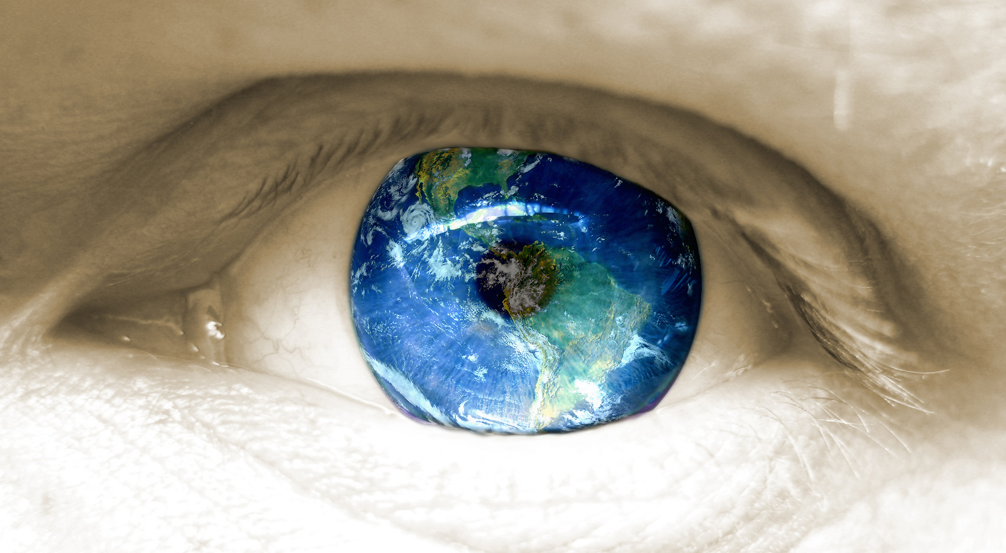
- Everyone has one. No exceptions.

A Person’s worldview tells you:
- What they truly believe
- How they live on a daily basis
- What sort of pains they’ve had in life
- Where you should start in your apologetics

How are worldviews formed?
- ________________________________
- ________________________________
- ________________________________
- ________________________________
- ________________________________
- ________________________________

The 7 Components of any Worldview:
- View of God

- View of Truth

- View of Reality

- View of Knowledge

- View of Ethics

- View of Humanity

- View of Evil
What Are The Common Worldiviews?
- Naturalistic

- Postmodern

- Pantheistic

- Polytheistic

- Monotheistic

- Biblical

Naturalistic :
View of God | View of Man | View of Truth | View of Values
ATHEISM: There is no God  AGNOSTICISM: There’s not enough evidence to say there is a God  SECULAR EXISTENTIALISM:  God does not exist so humanity must learn to live without Him. | Chance product of evolution  Entirely material “Biological Machine”  “Meat sacks”  There is no afterlife  There is no such thing as “sin” | Truth is determined by:  “Science”  Knowledge gained by the five senses | No objective  Prescriptive values  Morals are individual preference or products of society  Conscience is a product of evolution.

Postmodern:
View of God | View of Man | View of Truth | View of Values
NEW AGE SPIRITUALISM:  God is all of us.  NON-THEISM:  I believe there’s a God… but I don’t really at the same time. | Humans are pawns in cultural reality  They are products of their culture  Could be a product of evolution | Truth is what you want it to be  There are no universal  truths.  Truth is what you personally hold as meaningful | No moral objectives  Anti- Authoritarian  Values are social constructs and mental organizers with no source  Tolerance is a prized virtue
Why study it/How to use it?
Reasons to Study Worldviews:
- It answers ethical/moral questions
  - What should I believe about this issue?
  - How should I respond to this event?

- It answers philosophic questions
  - What is truth and reality?
  - How do different people answer the big questions of life?

- It answers practical questions
  - What will I do next because of my worldview?
  - How will so-and-so act because of his worldview?

Questions for Determining Someone’s Worldview:
  - “Where do you think we came from?” “What are we humans?”
  - “What do you think happens when we die?”
  - “What has gone wrong with this world?” “Can you believe the evil stuff happening?”
  - “What do you think we should do to fix this world?”

What’s my Worldview:

Questions to ask yourself about your worldview:
  - What is real?

  - What are the nature and limits of knowledge?

  - What is good? How do I live a good life?

  - What is a “good person”?

  - How does one become a “good person”?

  - What do I believe about the 7 components of a worldview?

My worldview:
View of God | View of Man | View of Truth | View of Values
View of Reality | Knowledge | Evil

