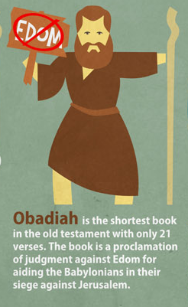
Obadiah Handout

Introductory Issues:
- Author: Obadiah (v1)
  - Theophoric name “servant of Yahweh”
  - common name in OT
  - 1 Kings 18:3-6?
- Date: approx 845 BC (Reign of Jehoram)
- Audience: Edom (v1)
- Purpose/Message: To contrast the eternal states of
Judah and Edom, and pronounce judgment on those
who oppose the Lord.

Background:
- 2 Kings 8:16-22, 2 Chronicles 21
- Jehoram (Son of Good King Jehosaphat)
  - King at 32, reigns 8 years
  - Kills all his younger brothers, married
to Athaliah (Ahab’s daughter)
  - “Walks in the ways of the kings of Israel” (2 Chron 21:6)
  - warred with Edom, but did not subdue them
  - Allowed Philistines and Arabs to ransack Jerusalem (2 Chron 21:16-17)
  - Had Ahaziah (his youngest son) when he was 18
  - died by a prophecy of Elijah, intestinal sickness

- History of Edom
  - Descendants of Esau (Isaac’s first-born son)
  - “Edom” means “Red” Famous for their geographic region with red-colored sand, and their pater’s red hair
  - Warred with Israel and Judah repeatedly (Num 20:14-21; 1 Sam 14:47; 2 Sam 8:14; 1 Kings 11:14; 2 Chron 21:8-10)

I. Edom’s Doom (1-14)
A. The coming destruction (1-9)

- “I will make you small among the nations” (v2)
- “The pride of your heart deceives you” (v3)

- “Will I not on that day destroy the wise men out of Edom and understanding out of Mount Esau?” (v8)

B. The sins that brought it (10-14)

- “Because of the violence you have done to your brother Jacob…” (v10)

- “On the day that you stood aloof... and strangers carried off his wealth...” (v11)
  - What day is being described? (cf. 2 Chron 21:16-17)

- Do not gloat/rejoice/loot... (v12-14)

II. The Day of the Lord (15-21)
A. Judgment on the nations (15-16)

- “The Day of the Lord is coming on all the nations, as you have done it will be done to you” (v15)

- “Just as you drank on the holy mountain, all the nations will drink continually…” (v16)
  - What is meant by this metaphor/pun?

B. Restoration of Israel (17-21)

- “But on Mount Zion there will be those who escape and it will be Holy.” (v17)

- Jacob a fire… Esau a stubble? (v18)

- What all does he promise will happen in vs. 19-21?

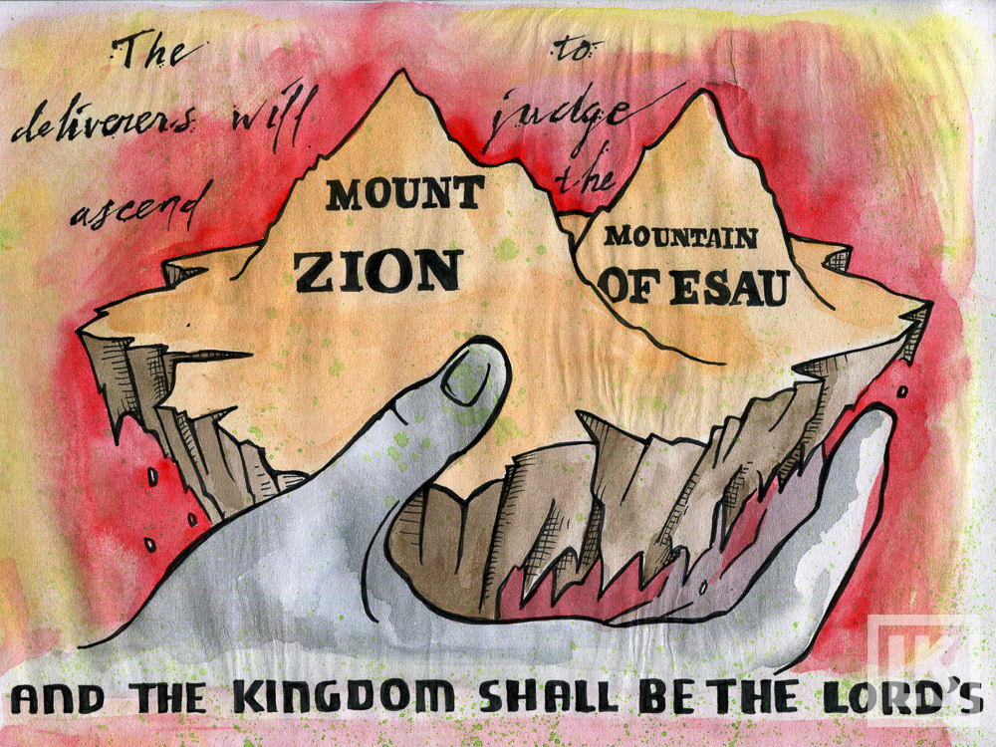

- Have those things happened?

- What period of time is being described?

