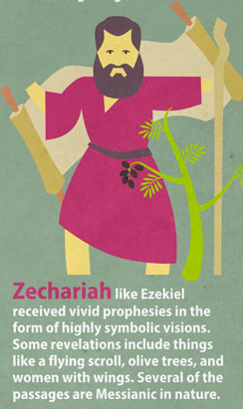
Zechariah Handout 2

Introductory Issues:
- Author: Zechariah (1:1) “YHWH Remembers”
  - “Son of Iddo” cf. Neh 12:4, 16
  - Priest who returned with Zerubbabel
  - Zechariah is both prophet and priest
  - Liberal scholars began claiming multiple
authors to Zechariah in the 17th century
citing style and historical differences
between 1-8 and 9-14

- Date: First 8 visions- February 15, 519 BC (1:1-6)

- Audience: Post-exilic Jews who are rebuilding the
temple under his, and Haggai’s, prophetic encouragement.

- Purpose/Message: To encourage the rebuilding of the temple and give hope concerning future domination of Israel over world powers.

Background:
** See “Background section of “Haggai Handout.”

Text:
- 8 Symbolic Visions (Ch 1-6) (On Handout 1)
- 4 Explanatory Messages (Ch 7-8)
- 2 Oracles (Ch 9-14)

II. 4 Explanatory Messages (Ch 7-8)
Intro (7:1-3)
- “The people of Bethel sent… ‘Should I weep and fast in the fifth month as I have done for so many years?’”
  - 5th month: month of temple destruction in 586BC (2 Kngs 25:8)
  - Bethel:
    - Place of Jacob’s vision of the stairway to heaven (Gen 28)
    - Center of heavy idolatry in north during divided kingdom (cf. 1 Kngs 12:29-33)

Rebuke (7:4-7)
- “When you fasted… was it for me?” (v5)
- When you ate and drank... wasn’t it for yourselves?” (v6)

Recall (7:8-14)
- Instruction on action: v9-10
- “They refused to pay attention… stopped their ears... made their hearts hard...” (v11-12)

- “Lest they should hear the law and the words that YHWH of armies had sent by his Spirit through the former prophets.” (v12)
  - Who did what in this verse?

- “As he called, and they would not turn, so they called and I would not hear” (v12)
  - Who is the “He” the “They” and the “I”?

- “And I scattered them among the nations... and the pleasant land was made desolate.” (v14)

Restoration (8:1-17)
- “I am very jealous for Zion... with great wrath” (v2)
  - cf. 1:14 (argument for unity)

- A picture of the future of Jerusalem: v3-8. Summarize what it will be like.

- “And they shall be my people and I shall be their God.” (v8)
  - cf. Gen 17:7-8; Ex 29:45; Jer 31:31-33 (Heb 8:10); 32:28 Rev 21:7

- I will deal differently with you now, than I have in the former days: v9-17
  - What are the general commands God gives to the people (v16-17)

Rejoicing (8:18-23)
- “The fast of the fourth, fifth, seventh, and tenth month shall be to the house of Judah, seasons of Joy and gladness and cheerful feasts.” (v19)
  - Fasts change to feasts. When does this happen?

- During this time, season of feasts, inhabitants of all nations will come and go into Jerusalem. (v20-23) What time period is being described?

