Revelation Millennial Kingdom (2nd Pass) and Eternal State Handout
Interpretive Systems
- Premillennialism
  - Christ’s return will be before (pre) a literal 1,000 year reign (Millennium)
  - Usually views Revelation ch 4ff as entirely future
    - “Historical Premillennialism” views the events in 4-19 as symbols of church/world history leading up to a future millennium

- Amillennialism
  - There is no literal millennium, but we are living in the non-literal millennium right now: the church age. The millennial kingdom is a purely spiritual one, and Christ’s return to earth is the consummation of the millennium.
  - Usually views ch 4-18 and 20:1-10 of Revelation as past tense (Preterism)

- Postmillennialism
  - Quite similar to amillennialism, but stipulating that the world will undergo a progressive Christianization (building the Kingdom on earth), which ushers in the return of Christ and the eternal state.
  - “We believe Scripture promises the advance and victory of Christ's Kingdom in this age, leading to the final judgement. Like leaven working through the dough till all is leavened. For He must reign until all His enemies are made a footstool for His feet, up to the last enemy, death.” Johnny Simmons (Postmil friend)

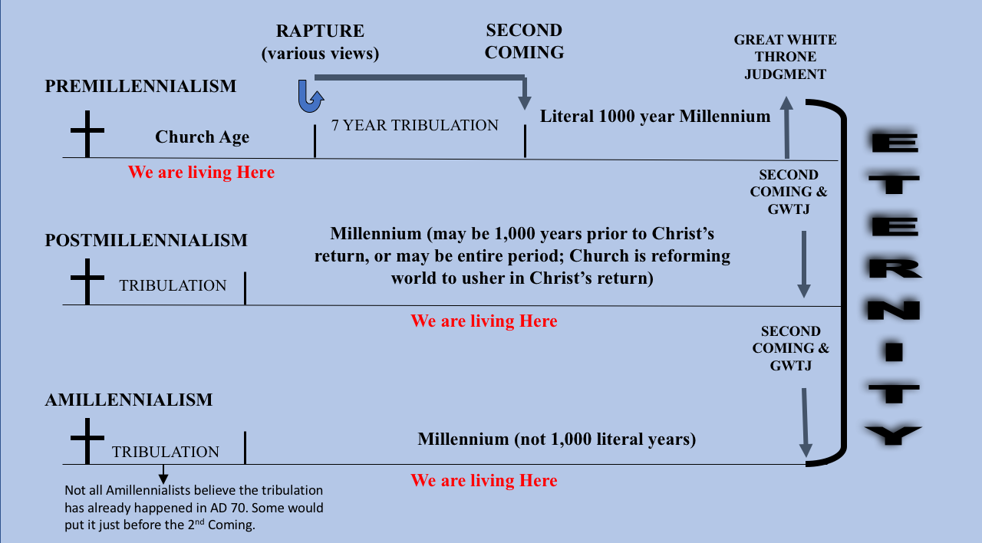

Why the Differences?
- Hermeneutical practices/priorities
  - “Apocalyptic Literature” is often viewed as a separate genre which must be interpreted according to different hermeneutical principles
  - Many interpreters view the book of Revelation as “separate” from the canon instead of part of the singular story

- Historical events
  - Licentious Premill theology (300’s)
  - Augustine – “City of God” popularized Amillennialism as an alternative (400’s)
  - Middle Ages – development of Postmill theology with the evangelization of the European tribes (500-1500)
  - Return of Premill Theology with smaller late-reformation movements, strengthened by WWI and WWII decreasing Postmil popularity

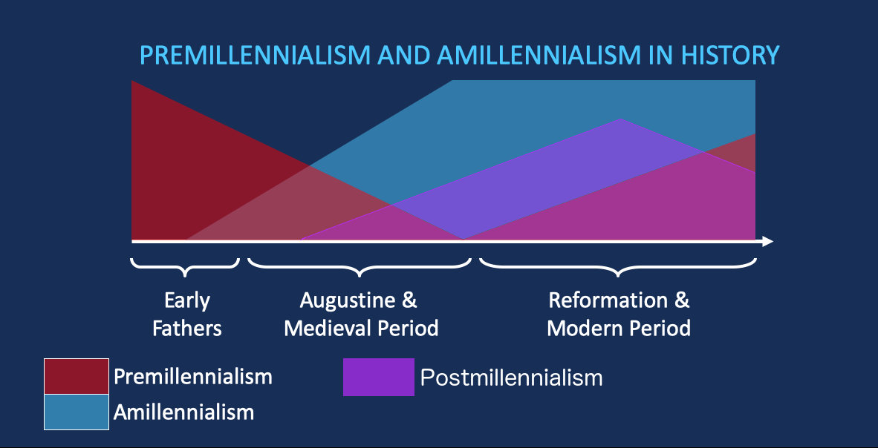

Eternal State
- “Then I saw a new heaven and a new earth; for the first heaven and earth passed away, the sea is yet no longer.” (21:1)

  - “New” καινος kainos has wide semantic domain: ”unused,” “strange or noteworthy,” “not old” “refurbished”
  - νεος neos more narrowly means ”brand new” “just made”
  - καινος is used for the “new earth” and “new heaven” and “new Jerusalem”
  - What kind of a new heaven and earth does John see?

- “And I saw the holy city, new Jerusalem, coming down out of heaven from God, made ready as a bride adorned for her husband.” (21:2)
  - Who is the bride?

- “The tabernacle of God is among men and he will tabernacle among them, and they shall be His people, and God Himself will be among them” (21:3)
  - What part of the story should this bring to mind?

- “He who overcomes will inherit these things” (21:7)
- “Come I will show you the bride, the wife of the lamb” (21:9)

- New Jerusalem: (21:10-23)
  - Coming from heaven (v10)
  - Brilliance like jasper (v11)
  - 72 yard high walls, 12 pearl gates, names of tribes, 3 on each wall, guarded by angels (v12-13, 17, 21)
  - 12 foundation stones, names of apostles (v14)
  - 12,000x12,000 stadia cube (approx. 1500 miles) (v16)
  - City: gold; wall: jasper (v18)
  - 12 foundation stones = stones of garden, stones of ephod (Ex 28; Ezek 28:13; Gen 2:12)
  - No temple, sun, or moon because God is there (v 22-23)

- Measuring of the temple (21:15)(cf. Ezek 40)
  - Different measurements?

- “The nations will walk by its light, and the kings of the earth will bring their glory into it” (v24)
  - What is “it”?

  - Who are these kings and nations and where are they living?

- “Then he showed me a river of the water of life coming from the throne of God and of the lamb… tree of life yielding its fruit” (22:1-2)
  - Cf. “River of life” Ezek 47; “Tree of Life” Gen 3:22-24

- “The leaves of the tree were for the healing of the nations.” (22:2)
  - What does this mean? (cf Gen 3:7; 8:11; Gen 22:18; Deut 32:43; Ps 86:9; 106; Is 11-12; 66; Zech 8:23)
  - “nations” ἐθνος ethnos often translated “gentiles”

- “And behold, I am coming quickly. Blessed is he who heeds the words of the prophecy of this book.” (22:7)

- “Do not [worship me] I am a fellow servant of yours and your brethren the prophets and those who heed the words of this book.” (22:9)
- Are verses 22:11-12 surprising?

- “Blessed are those who wash their robes so that they may have the right to…” (22:14)
  - Who washes their robes?

- To what is verse 15 referring?

- If anyone adds to or takes away from the words of the book of this prophecy, different results. What are they? (22:18-19)

- “Yes I am coming quickly.” (22:20)

