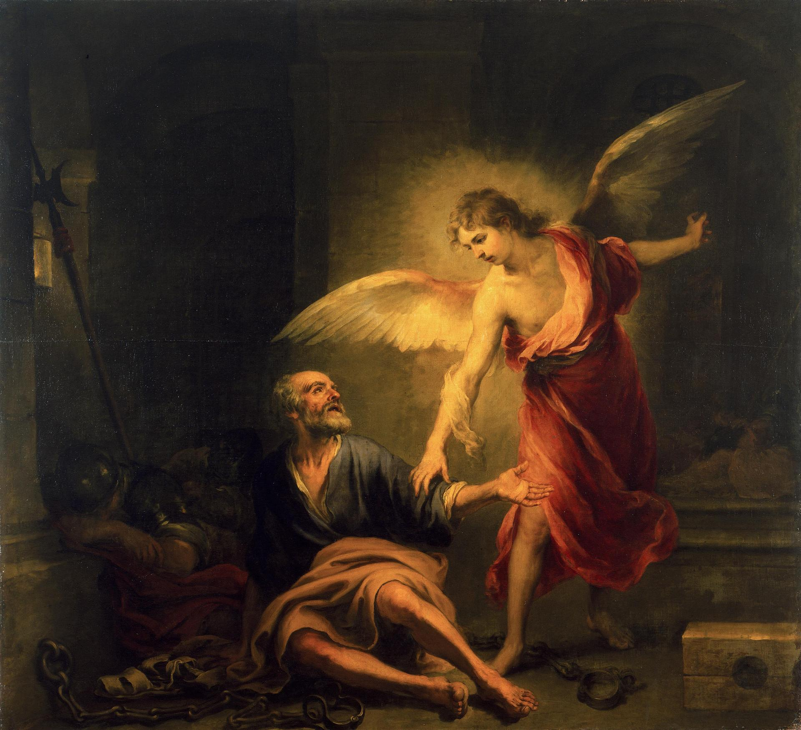
Acts 11:27-13:3
“The Liberation of St Peter”
Bartolome Esteban Murillo 1665-1667

Problems in Jerusalem (11:27-12:5)
- “Prophets came from Jerusalem
to Antioch” (v11:27)
  - What is a Prophet?

- “This took place in the days of Claudius” (v11:28)
  - This took place between 41and 54 AD.
  - Josephus attests Herod’s death in 44AD, the third year of Claudius’s reign. (Antiquities, 19.8.2)

- “”the disciples…sent relief to the brothers in Judea” (v11:29)

- “Herod the king… killed James the brother of John” (v12:1-2)

  - The 4 Herods in the Bible:

- Herod the Great
  - Matthew 2
  - Tried to kill Jesus at birth
  - Went insane
  - Ordered death of all 2yr olds in Bethlehem
  - Ruled from 37-4BC

- Herod Antipas I
  - Ruled from 4BC-39 AD
  - Luke 9&23
  - Killed JtheB
  - Tried Jesus Illegally
  - Ruled during Jesus life and ministry

- Herod Agrippa I
  - Ruled from 41-44 AD
  - Acts 12
  - Killed the Apostle James
  - Imprisoned Peter
  - Killed By an Angel

- Herod Agrippa II
  - Ruled during Apostle Paul’s ministry
  - Married his sister Bernice
  - Acts 25-26
  - Tried the Apostle Paul
  - Sent the Apostle Paul to Caesar at Paul’s request
- “When he saw that it pleased the Jews…” (v12:3)

- What are the days of Unleavened Bread? (Ex 12:14-20)

- “So Peter was kept in prison, but earnest prayer for him was made to God by the Church.” (v12:5)
The Effects of Prayer (12:6-17)
- “And behold, an angel of the Lord stood next to him…” (v7)
- “And he went out and followed him. He did not know that what was being done by the angel was real…” (v9)
- “When Peter came to himself…” (v11)
- “from all that the Jewish people were expecting.” (v11)

- “many were gathered together praying” (v12)
- “you are out of your mind!”… “It is his angel” (v15)
  - What views of prayer are displayed here and by whom?

- And he said, “Tell these things to James and the brothers” (v17)
  - Which James? (cf. 15:13)

The Word of the Lord Increasing (12:18-13:3)
- “Herod was angry with the people of Tyre and Sidon… [but] they asked for peace because their country depended on the King’s for food.” (v12:20)
- “The voice of a God and not of a man. Immediately an angel of the Lord struck him down.” (v12:23)
  - Why did the Lord strike him down?

- “But the word of God increased and multiplied.” (v.12:24)

- “And Barnabas and Saul returned (to Antioch) bringing John Mark.” (v12:25)

- “Now there were in the Church at Antioch, prophets and teachers.” (v13:1)
  - What’s the difference between a prophet and a teacher?

  - Can someone be both?

- “while worshipping and fasting, the Holy Spirit said…” (v13:2)
- “they sent them off.” (13:3)
  - Who now?

