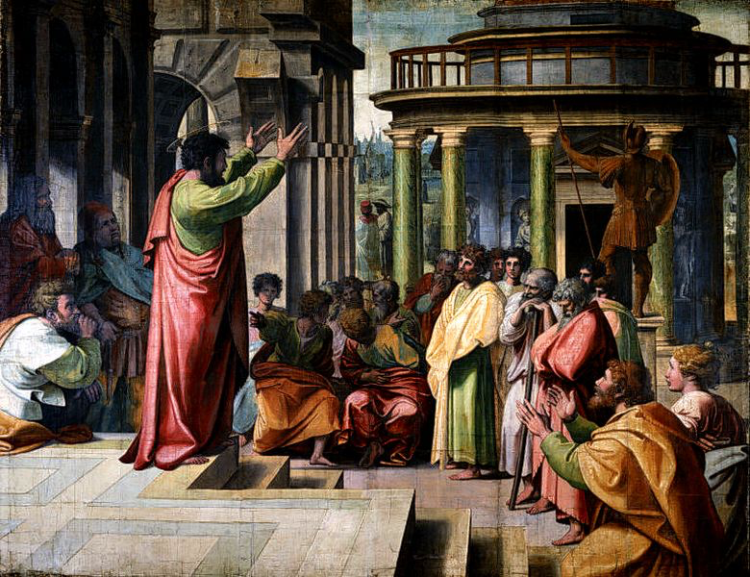
Acts 17:15-18:22

Paul in Athens (17:15-34)
- What is Paul doing while in Athens?
  - Waiting for Timothy and Silas. (v15-16)
  - Reasoning in the synagogue and
marketplace (v17)
- Epicurean Philosophers: the purpose of life is
to seek pleasure.
- Stoic Philosophers: self-control, self-denial,
and fortitude are the keys to good living.
“Areopagus Sermon” by Raphael 1515. Cartoon for tapestries in Sistine Chapel.

- What was Paul preaching?
  - “Jesus and the resurrection.” (v18)

- “And taking him, they led him to the Areopagus.” (v19)
- Paul’s message:
  - “You are very religious.” (v22)
  - “You have an alter to an unknown God.” (v23)

  - That God is the uncreated creator of everything. (v24-25)
  - “He gives life and breath and everything to men.” (v25)

  - and from one man… “appointing and commanding the times and boundaries of their dwelling places to seek God, if then indeed they would only reach out and grasp for him, and indeed he is not far from each of us…” (v27)

  - Your own poets see some of this truth. (v28-29)
  - “The times of ignorance God overlooked, but now…” (v30)

  - “repent because...” a man is going to judge the world, and that man came back from the dead. (v31)

- 2 Reactions: mocking and curiosity. (v32)
  - What point solicited those reactions?

- “Some men joined and believed.” (v34)

Paul in Corinth (18:1-17)
- Paul meets Aquila and Priscilla. (v2)
- Paul stays with them in Corinth (v3)
- “he reasoned in the synagogue every Sabbath… Jews and Greeks.” (v4)
- “witnessing to Jews the Christ to be Jesus.” (v5)

- “From now on, I will go to the Gentiles.” (v6)

- “Do not be afraid but go on speaking.” (v9)
- “no one will attach you to harm you.” (v10)
- “He stayed a year and 6 months teaching the word of God among them.” (v11)

- The Jews attempt to have Paul taken out by Gallio. (v12-15)

- “…see to it yourselves. I refuse to be a judge of these things.” (v15)
- “he drove them from the tribunal.” (v16)

- “They seized Sosthenes… and beat him in front of the tribunal. But Gallio paid no attention.”(v17)
  - Why are they beating Sosthenes? (cf. 1 Cor 1:1)

Return to Antioch (18:18-22)
- Paul went to Syria with Priscilla and Aquila. (v18)
- “He cut his hair, for he was under a vow.” (v18)

- “They came to Ephesus and he left them there, but he went into the synagogue and reasoned with the Jews.” (v19)

- He set sail from Ephesus, greeted the church in Caesarea, and went down to Antioch. (v22)

