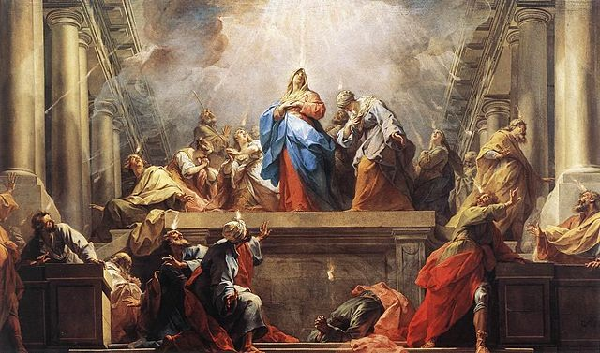
Acts Week 2: 2:1-47

Review
- Descriptive vs. Prescriptive
- Jew/Gentile Interplay
- 40 Days teaching on the Kingdom of God
- Ascension
- Choosing Matthias to replace Judas

- The Coming of the Spirit (2:1-13)
Jean II Restout’s “Pentecost” 1732
- Peter’s Sermon(2:14-40)
  - Joel’s Prophecy (2:14-21)
  - Jesus’s Fulfillment (2:22-24)
  - David’s Promise (2:25-31)
  - Jesus’s Fulfillment (2:32-36)
  - Application (2:37-40)
- The Church Has Begun (2:41-47)

The Coming of the Spirit (2:1-13)
- Day of Pentecost: (aka: Feast of Weeks) Fifty days after Passover, one of the major Jewish celebrations that commemorated the end of the grain harvest season.

- “divided tongues as of fire… rested on them”
  - The Holy Spirit’s (Yahweh’s) presence frequently takes form of fire (Gen 15:17; Ex 3:2-6; 13:21-22; 19:18)
  - Luke 3:16? (Was it a reference to a single future event, or two separate events?)

- (Systematic Theology) Filling¹ vs. Filling² vs. Indwelling
  - Filling¹: temporary empowerment for specific purposes (1 Sam 16:14; Ps 51:11; Lk 1:15, 41; Acts 2:4; 4:8; 9:17; 13:9)
  - Filling²: Progressively becoming more Christ-like and thus “filled” with the Spirit to a state of fullness. (Lk 4:1; Acts 13:52; Eph 5:18; Gal 5:22-23)
  - indwelling: permanent residence/seal for believers in the church age. (Rom 8:9; Eph 1:13; 2 Cor 1:22)

- “we hear them telling in our own tongues the mighty works of God”
  - Who is hearing this?

  - What are they hearing/hearing about?

  - What are the two reactions?
Peter’s Sermon (2:14-40)
Joel’s Prophecy (2:14-21):
- Who is Peter’s audience?

- “But this is what was uttered through the prophet Joel…”
  - What is the context of Joel 2:28-32?
    - “Day of the Lord”
    - Kingdom of God
    - Destruction and restoration of Jerusalem/Judah
    - V. 32

  - Did everything Peter quoted happen at Pentecost? Did any of it?

  - Why is Peter quoting this passage?

Jesus’s Fulfillment (2:22-24):
- Which Jesus? (v.22-23)
- What did the “men of Israel” do to him?
- What did God do to him? Why?

David’s Promise (2:25-31):
- Based on Psalm 16, what does David understand God promised him? (v.27-28) (v.31)

- v.29 (paraphrase) “I’m confident David’s dead.”
- v.30 (paraphrase) “since David was a prophet and God made the Davidic covenant with him…” (2 Sam 7)
- v.31 (paraphrase) “he saw the resurrection coming!”
Jesus’s Fulfillment (2:32-36):
- v.32 (paraphrase) “It’s come, and we saw it!”
- “He has poured out this that you yourselves are seeing,” i.e. “This event (speaking in tongues in front of you) is Jesus’s doing… he poured the Holy Spirit on us!”

- “The Lord said to my Lord…”
  - Where is he sitting?

  - Until when?

- So… (v.36) what?

Application (2:37-40):
- What does Peter tell them to do?

- Is this the prescription for all believers? Why or why not?

- “Save yourselves from this crooked generation.”
  - Who is the crooked generation?

The Church has Begun (2:41-47)
- How many were added?

- What all were they doing? (v.42, 44-47)

- “day by day” (v.46, 47)

