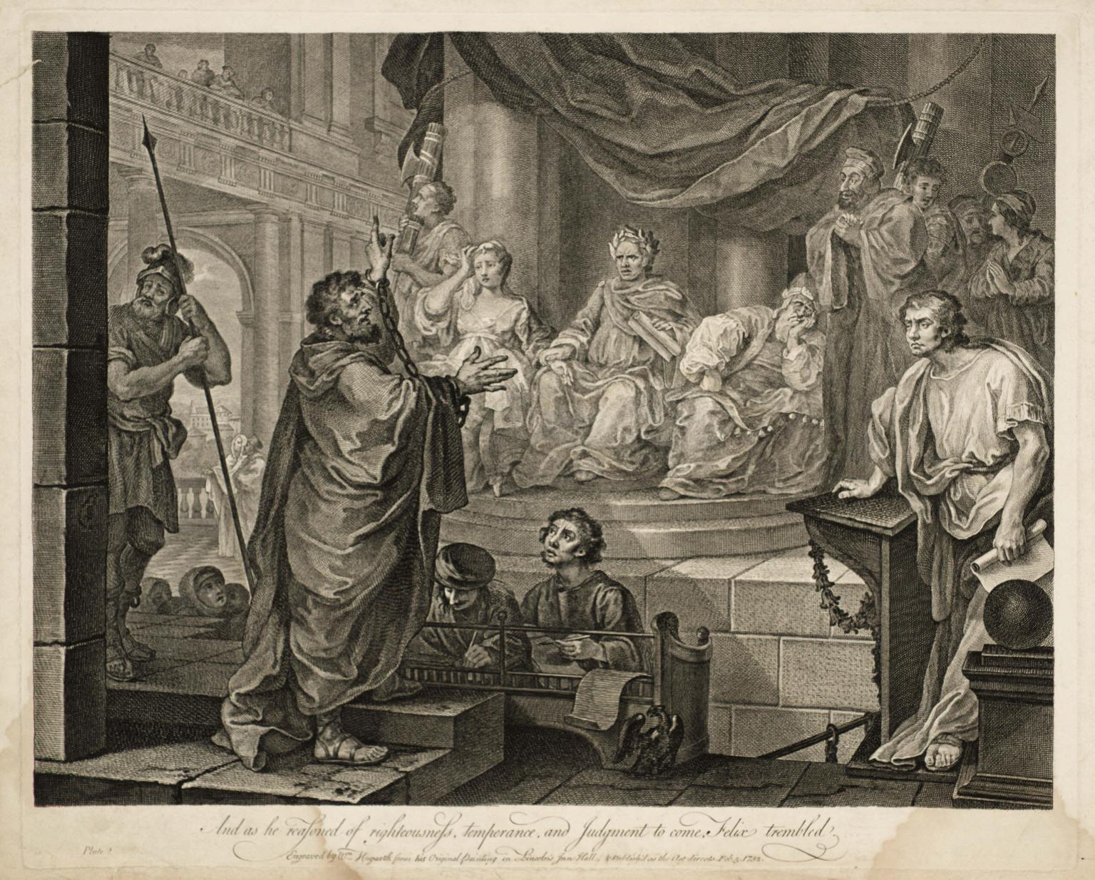
Acts 21:40b-24:27

Paul Speaks as He is being Arrested (21:40b-22:22)
- “I am a Jew” (v3)
- “Brought up in this city” (v3)
- “educated at the feet of Gamaliel” (v3)
- “I persecuted this Way to the death” (v4)
- Tells his conversion story (cf. Ch9)

- “I fell into a trance” (v17)
- “Go, for I will send you far away to the
“Paul Before Felix” etching by William Hogarth 1752
Gentiles.” (v21)

- “Away with such a fellow from the earth for he should not be allowed to live.” (v22)
  - What statement caused this reaction?

  - Why such a strong reaction?

Paul Before the Tribune and Council (22:23-23:11)
- “the tribune (Claudius Lysias [cf. 23:26])… said he should be examined by flogging to find out why they were shouting against him like this.” (v24)
- “Is it lawful for you to flog” an un-condemned Roman citizen? (v25)
- “The tribune answered, ‘I bought this citizenship for a large sum.’” (v28)
  - What does he mean by saying this?

- “I am a citizen by birth.” (v28)
- “the tribune (and centurions) were afraid” (v29)
  - Why?

- The tribune calls in a council.
  - Who all is here? (hint: 23:2, 6)

- After being struck, does Paul apologize or justify himself? (v23:1-5)
  - “I do not doubt that this is a taunting excuse [….] Paul purges himself of this crime; yet so, that he denies that Ananias is to be counted a priest of God, who has corrupted and perverted all the order of the Church.” –John Calvin

- How does Paul stir up the council? (v6-9)
- some Pharisee scribes stood and said “we find nothing wrong in this man.” (v9)
- “Take courage for as you have testified to the facts about me in Jerusalem, so you must testify also in Rome.” (v11)
An Unsuccessful Assassination Attempt (23:12-24:27)
- The Plot and its Undoing (23:12-22)
- “The Jews made a plot and bound themselves by an oath neither to eat nor drink till they had killed Paul.” (v12)
- Paul’s nephew goes to the tribune. “Do not be persuaded by them for more than forty of their men are lying in ambush for him.” (v21)

- The Escort to Caesarea (23:23-35)
- “Get two hundred soldiers with seventy horsemen and two hundred spearmen to go as far as Caesarea.” (v23)

- The Letter to Felix
  - “I found that he was being accused about questions of their law, but charged with nothing deserving death or imprisonment.” (v29)
- Felix: “I will give you a hearing when your accusers arrive.” (v35)

- The Defense in Caesarea (24:1-27)
- Tertullus (a ῥητορος rhetoros – rhetorician)
- Felix – a governor who was a slave, won his freedom, and was known for his violent self-advancement. “He exercised royal power with the mind of a slave.” – Tacitus

- Tertullus’s Address:
  - Flattery for 3 verses (v2-4)
  - accusations: (v5-8)
    - stirs up riots throughout the world (v5) (cf. Ch19 Riot in Ephesus)
    - ringleader of Nazarene sect (v5) (Jesus of Nazareth. cf. v14)
    - tried to profane the temple (v6)
    - Is there a verse 7?

- Paul’s Reply:
  - I’ve been in Jerusalem for only 12 days (v11)
  - I wasn’t found starting a riot (v12)
  - They have no proof of any of this (v13)
  - I haven’t even broken their law! (v14-16)
  - I was presenting offerings when some jews from Asia (started the riot) (v17-20)
  - The only thing that I did was proclaim the resurrection of the dead. (v21)
- Felix hears Paul speak for two years about Christ, but leaves him in prison. (v24-27)

