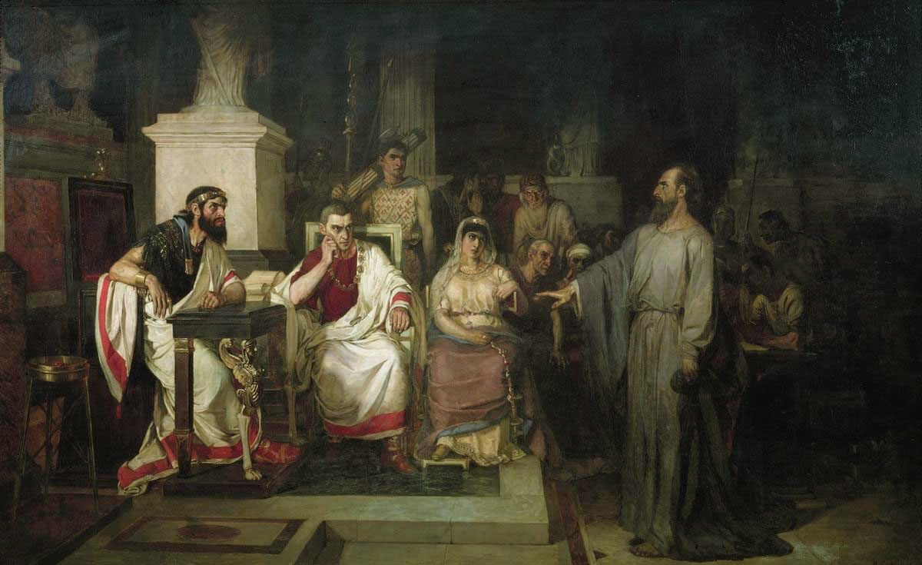
Acts 25:1-26:32

Paul Before Festus (25:1-12)
- Festus Goes to Jerusalem (v1)
- the chief priests plan to kill
Paul in Jerusalem (v3)
- “let the men of authority among
you go down with me… and bring
charges against him.” (v5)

“The Apostle Paul Explains The Tenets Of Faith In The Presence Of King Agrippa, His Sister Berenice, And The Proconsul Festus” by Vasily Surikoz 1875

- “the Jews also [brought] many
serious charges against him that they could not prove.” (v7)

- “Neither against the law of the Jews, nor against the temple, nor against Caesar have I committed any offense.” (8)
- “Festus, wishing to do the Jews a favor…” (v9)

- “I appeal to Caesar.” (v11)

Agrippa Comes to Town (25:13-22)
- The 4 Herods in the Bible:

- Herod the Great
  - Matthew 2
  - Tried to kill Jesus at birth
  - Went insane
  - Ordered death of all 2yr olds in Bethlehem
  - Ruled from 37-4BC

- Herod Antipas I
  - Ruled from 4BC-39 AD
  - Luke 9&23
  - Killed JtheB
  - Tried Jesus Illegally
  - Ruled during Jesus life and ministry

- Herod Agrippa I
  - Ruled from 41-44 AD
  - Acts 12
  - Killed the Apostle James
  - Imprisoned Peter
  - Killed By an Angel

- Herod Agrippa II
  - Ruled during Apostle Paul’s ministry
  - Married his sister Bernice
  - Acts 25-26
  - Tried the Apostle Paul
  - Sent the Apostle Paul to Caesar at Paul’s request

- “Festus laid Paul’s case before the king” (v14)
  - a man left by Felix (v14)
  - Jews are accusing him (v15)
  - They only have points about their own religion and a certain Jesus (v19)
  - He appealed to Caesar and I’m holding him til I can send him (v21)

Paul Before Agrippa (25:23-26:32)
- Festus’s Problem (25:23-27)
  - “I found that he had done nothing deserving of death.” (v25)
  - “I have brought him before you… that I may have something to write!” (v26)

- Paul’s Testimony (26:1-18)
  - “…because you are familiar with all the customs and controversies of the Jews.” (v3)
    - Agrippa may have been a practicing Jew (cf. 26:27) an appointed many high priests.

  - “they have known for a long time… that I have lived as a Pharisee.” (v5)
  - “And now I stand here on trial because of my hope in the promise made by God to our fathers”
    - What Promise? (cf. Gen 3:15; Job 19:25-27; Ps 16:9-11; Is 25:8; Ez 16; 37:1-14; Hos 6:2; Dan 12:2; Amos 9:11-15; Hab 2:4; Jonah 2:5-9; Acts 22:6; 24:21)

  - He again tells his conversion story (v9-18)
    - Compare this to his story before crowd in 22:3-21. What’s different this time?

- Paul’s Defense (26:19-23)
  - “… that they should repent and turn to God, practicing works worthy of repentance.”(v20)
    - Repentance literally means “change of mind.” What about this idea do you think made the Jews seize and try to kill Paul?

  - “That the Christ must suffer and that by being the first to rise from the dead, he would proclaim light both to our people and to the Gentiles.” (v23)

- The Final Deliberations (26:24-32)
  - “I am speaking true and rational words.” (25)
  - “King Agrippa, do you believe the prophets? I know that you believe.” (27)

  - “This man is doing nothing to deserve death or imprisonment…. This man could have been set free if he had not appealed to Caesar.” (v31-32)
    - Something to ponder: could this have happened any other way? Consider 19:21 and 23:11.

