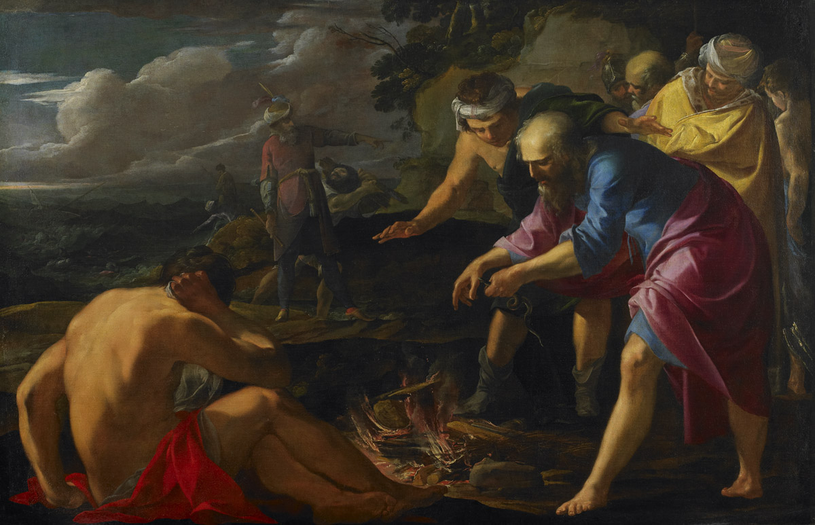
Acts 27:1-28:31

Departure for Rome (27:1-12)
- “They delivered Paul to… Julius” (v1)
  - centurion of Augustan Cohort

- “accompanied by Aristarchus” (v2)
  - cf. Acts 19:29; 20:4; Phm 24;
Col 4:10-11
  - according to tradition, martyred
“Saint Paul Shipwrecked on Malta” by Laurent de La Hyre, 1629
in Rome under Nero

- “we put in at Sidon and Julius treated Paul kindly…” (v3)
- difficult journey up the Asia minor coast (v4-8)

- “the voyage was now dangerous because even the Fast was already over” (v9)
  - “The Fast”=Yom Kippur = Day of Atonement= End of September
  - Sea traffic stops between October and February

- “Paul advised them… but the centurion paid more attention to the captain and ship owner.” (v10-11)

Stormy Seas (27:13-26)
- “but soon a tempestuous wind called the northeaster struck” (v14)
- “we gave way to it and were driven along” (v15)
- “we managed with difficulty to secure the ship’s boat” (v16)
  - a life boat was often dragged behind Mediterranean ships in the 1st century

- “They used supports to undergird the ship” (v17)
  - They ran ropes under the ship to keep it from breaking apart

- “All hope of our being saved was abandoned.” (20)

- “Paul stood up saying ‘…take heard for there will be no loss of life among you.’” (v21-22)
- “Do not be afraid, Paul; you must stand before Caesar.” (v24)

Paul Preserves Life (27:27-38)
- “Fearing that we might run on the rocks, they let down four anchors.” (v29)
- Some sailors try to escape, and Paul gets the soldiers to stop them. (v30-32)
- “I urge you to take some food… not a hair is to perish from the head of any of you.” (v34)
- “he took bread, and giving thanks to God in the presence of all, he broke it and began to eat.” (v35)
- “They lightened the ship, throwing out the wheat into the sea.” (v38)
Shipwreck (27:39-44)
- “they ran the vessel aground.” (v41)
- “the soldiers’ plan was to kill the prisoners, lest any should swim away and escape, but the centurion wishing to save Paul, kept them from carrying out their plan.” (v43)
- “all were brought safely to land.”(v44) (cf. v22)

Paul on Malta (28:1-10)
- “The natives showed us unusual kindness” (v2)
- “a viper came out because of the heat and fastened on his hand.” (v3)
- “No doubt this man is a murderer. Though he has escaped from the sea, Justice has not allowed him to live.” (v4)
- “He suffered no harm” (v5)
- Paul heals many on the island and they supply their needs for the voyage in gratitude. (v6-10)

Paul in Rome 28:11-31)
- “We set sail… in a ship with twin gods as figureheads”(v11)
  - Castor and Pollux, said to give good fortune to mariners in Greek mythology
  - Why might Luke include this?

- They stop at Syracuse and Rhegium before coming to Rome. (v12-14)

- “Paul was allowed to stay by himself, with the soldier guarding him.” (v16)
  - Possibly Julius?

- “After three days he called together the local leaders of the Jews.” (v17)
- Paul explains how he got to Rome (v18-20)

- “For this reason, I have asked to see you and speak with you since it is because of the hope of Israel that I am wearing this chain.” (v20)

- “But we desire to hear from you what your views are, for with regard to this sect we know that everywhere it is spoken against.” (v22)
- “he expounded to them testifying:
  - to the kingdom of God and
  - trying to convince them about Jesus
  - both from the Law of Moses and the prophets.” (v23)

- “The Holy Spirit was right in saying…” (v25)
  - Isaiah 6

- “Therefore let it be known that this salvation of God has been sent to the Gentiles.” (v28)

- “preaching the kingdom of God and teaching about the Lord Jesus Christ with all boldness and unhindered.” (v31)



