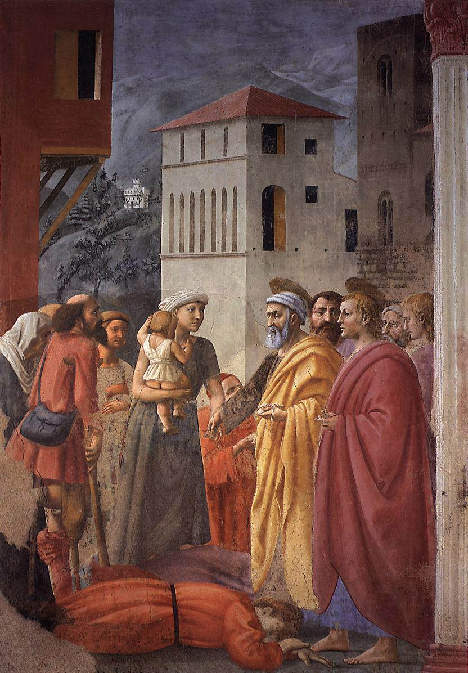
Acts 4:23-5:42
“The Distribution of Alms and Death of Ananias” by Masaccio 1425

The Believer’s Pray (4:23-31)
- What 3 descriptors do they ascribe to God?

- Psalm 2:1-2
  - What was this psalm about in its original context?
  - Do the believers quote it in that context?
  - Who is the Lord’s “anointed”? (gk: χριστος christos)

- v.27 – why do they list these specific people? (hint: read the Psalm again)
- v.28 – “to do whatever… your plan had predestined to occur”
- v.30 – “to speak your word with all confidence in you to extend your hand in healings and signs occurring through the name of your holy servant Jesus.”

  - What did they pray for?
  - Why?

  - What happened as a result?

Anannias and Sapphira (4:32-5:12a)
- “now the full number…”
- “all things in common” (cf. 2:44)
- Particularization: 34-35>36-37
- “Lay it at the apostle’s feet” ? Why? (Exod 4:25? Josh 4:3,9? Ruth 3?)

- “With his wife’s knowledge”
- “You have not lied to men but to God”
  - “great fear came upon all who heard of it.”

- “Tell me if you sold the land for this much?”
- “She said, ‘Exactly, (nai) this much!’”
- “she fell down at his feet and breathed her last.”

  - “And great fear came upon the whole church and all who heard of these things.”

Apostle’s Arrested and Set Free (5:12b-25)
- All the apostles are back in Solomon’s portico
- “None of the rest dared join them” who are “the rest”?

- v.16 Remind you of anything? (Luke 4:40 and others)
- “Go stand and speak to the people in the temple all the words of this life (zoe).”
- The High Priest isn’t looking in the temple.
- v.26 “they were afraid of being stoned by the people” (cf. Luke 22:2)

The Apostles the Council and Gamaliel (5:26-5:42)
- “We strictly charged you…” (4:18)

- “You intend to bring this man’s blood upon us.” Whose blood?

- “and so is the Holy Spirit, whom God has given to those who obey him.”

- Gamaliel presents a hypothesis:

- “rejoicing that they were counted worthy to be shamed for the name”
- What would they not stop doing? (v.42)

