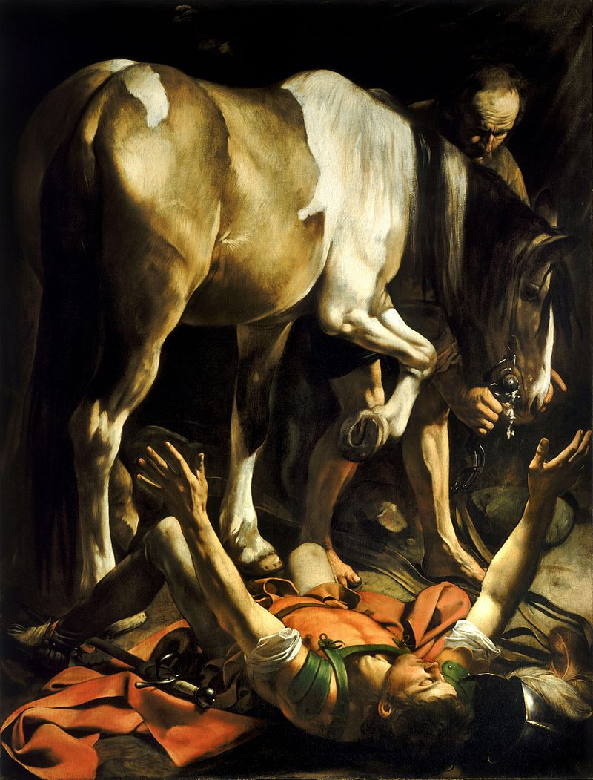
Acts 8:1b-9:31
“The Conversion on the Way to Damascus”
by Caravaggio 1601

The Church Scattered (8:1b-3)
- “were scattered throughout the regions
of Judea and Samaria, except the apostles” (v2)
- Where were they now going and why?

- What was Saul doing?

The Gospel in Samaria (8:4-25)
- “Philip went down to Samaria and proclaimed
to them the Christ.” (v5)
- “the signs that he did.” (v6)
  - what signs? (v7)

- “This man is the power of God that is called great.” Or “This man is what is called the great power of God.”
- Why do they pay attention to him?

- “prayed for them that they might receive the Holy Spirit, for he had not yet fallen on any of them, but they had only been baptized in the name of the Lord Jesus.” (v15-16)

- “Then they laid their hands on them and they received the Holy Spirit.” (v17)

- “he offered them money” (v18)
- “you have neither part nor lot in this matter, for your heart is not right before God.” (v21)
  - Was Simon’s “first conversion” (in verse 13) real?

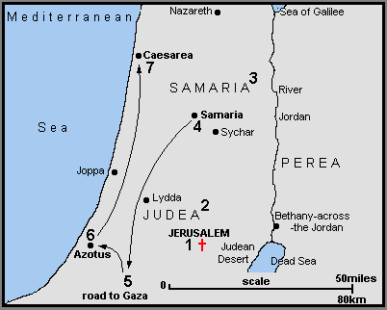

Philip and the Ethiopian (8:26-40)
- “to the road that goes from Jerusalem to Gaza.” (v26)
- What was he reading?

- “About whom does the prophet say this,
about himself or someone else?” (v34)
- “beginning with this scripture he told him
the good news about Jesus.” (v35)
  - Was this man at all Jewish?

- “What prevents me from being baptized?” (v36)
  - *manuscript additions?

- “The Spirit of the Lord carried Philip away” (v39)

Saul’s Conversion (9:1-19)
- “if he found any belonging to the way” (v2)

- “suddenly a light from heaven shone around him.” (v3)

- “Who are you lord?” “I am, Jesus, Whom you are persecuting.” (v5) ego eimi
- “though his eyes were opened, he saw nothing.” (v8)
  - Ex 4:11; Lev 21:18-19; Is 42

- “Go for he is a chosen instrument of mine to carry my name before the gentiles and kings and children of Israel. I will show him how much he must suffer for the sake of my name.” (v15-16)
- “then he rose and was baptized” (v18)

“Saul’s New Faith (9:20-31)
- Immediately he proclaimed Jesus in the synagogues, saying, “He is the Son of God.” (v20)

- “confounded the Jews who lived in Damascus by proving that Jesus was the Christ.” (v22)

- “the Jews plotted to kill him.” (v23)
  - Ring any bells?
- “Lowering him in a basket” (v25)

- “he attempted to join the disciples, but they were all afraid of him” (v26)
- “but Barnabas” (27)
  - Where did we meet Barnabas? What is he like?

- “So he went… preaching boldly in the name of the Lord” (v28)

- “so the church throughout all Judea and Galilee and Samaria had peace and was being built up, and waling in the fear of the Lord and in the comfort of the holy Spirit, it multiplied.” (v31)

