
Acts Week 1: Introduction and 1.1-1:26

Acts Outline
- The Birth of the church 1:1-5:42
  - 1:1-2:47 (40 days, Pentecost)
  - 3:1-5:42 (healing cripple, Peter and John before
Sanhedrin, All things in Common, Ananias and Sapphira)
- Persecution and expansion 6:1-9:31
Salvador Dali’s “The Ascension of Christ”
  - 6:1-8:1a (Deacons, Stephen, Stoning of Stephen)
  - 8:1b-9:31 (Philip, Road to Damascus)
- The Acts of Peter and Beginnings of Gentile Christianity 9:32-12:24
  - 9:32-10:48 (Peter at Lydda and Joppa, Cornelius’s Vision, Peter’s vision, Gentiles receive good news)
  - 11:1-12:24 (Peter defends himself to Apostles, Peter escapes Jail, Herod’s death)
- Church Extension from Antioch and Apostolic Decree at Jerusalem 12:25-15:35
  - 12:25-14:28 (Mission Journey 1: Barnabas and Saul in… Cyprus, Pisidian Antioch, Iconium, Lystra, and Derbe)
  - 15:1-35 (Jerusalem Council)
- Paul Leaves Antioch and Moves to the Aegean World 15:36-19:20
  - 15:36-17:34 (Mission Journey 2: Revisiting churches, Asia Minor, Paul and Silas imprisoned, Thessalonica, Berea, Athens)
  - 18:1-19:20 (Mission Journey 3: Corinth, Ephesus)
- Paul Plans to Visit Rome and Gets There by an Unforeseen Route 19:21-28:31
  - 19:21-21:16 (Mission Journey 3: Riot at Ephesus, Paul heads toward Jerusalem)
  - 21:17-23:30 (Paul in Jerusalem)
  - 23:31-26:32 (Paul at Caesarea)
  - 27:1-28:31 (Voyage to Rome)

Introduction

Author: Luke
Audience: Most Excellent Theophilus, Christians, and a larger gentile audience
Purpose: The purpose is continued from Luke, to present an orderly account to Theophilus of the things that have been accomplished among the Christians. (Lk 1:1-4) A second purpose might be to present the Son of Man who was rejected by Israel and the consequent going out of the gospel to the gentiles.
Key Verse: 12:24 “But the Word of God increased and multiplied.”

Important notes:
- A second volume to the first book
- Descriptive as opposed to Prescriptive
- Acts of the Apostles
- Jew – Gentile interplay
Text
- The 40 days (1:1-11)
  - How did Jesus give commands to the apostles after he was taken up? (1:2)

  - “appearing to them for forty days and speaking about the kingdom of God.” (1:3)
  - “will you at this time restore the kingdom to Israel?” (1:6)
    - what are they expecting the kingdom to be?

    - Are they right?

    - How does Jesus respond?

  - What will the apostles be for Jesus and where?
  - “will come in the same way as you saw him go into heaven.”

- Matthias Chosen (1:12-26)
  - “with the Women, Mary the mother of Jesus, and his brothers.” (1:14)
  - 120 followers at time of ascension

  - “and was allotted his share in this ministry” (1:17ff)
    - Is the account of Judas’s death accurate?
    - How do we deal with seeming contradictions in the Bible?

  - Requirements to replace Judas:
    - ____________________
    - ____________________
    - ____________________

  - What is casting lots?
  - So, Is Matthias the twelfth apostle, or is Paul? (PvD)
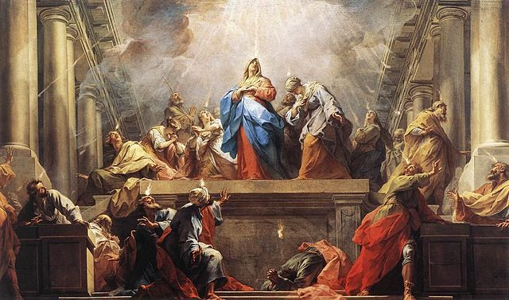
Acts Week 2: 2:1-47

Review
- Descriptive vs. Prescriptive
- Jew/Gentile Interplay
- 40 Days teaching on the Kingdom of God
- Ascension
- Choosing Matthias to replace Judas

- The Coming of the Spirit (2:1-13)
Jean II Restout’s “Pentecost” 1732
- Peter’s Sermon(2:14-40)
  - Joel’s Prophecy (2:14-21)
  - Jesus’s Fulfillment (2:22-24)
  - David’s Promise (2:25-31)
  - Jesus’s Fulfillment (2:32-36)
  - Application (2:37-40)
- The Church Has Begun (2:41-47)

The Coming of the Spirit (2:1-13)
- Day of Pentecost: (aka: Feast of Weeks) Fifty days after Passover, one of the major Jewish celebrations that commemorated the end of the grain harvest season.

- “divided tongues as of fire… rested on them”
  - The Holy Spirit’s (Yahweh’s) presence frequently takes form of fire (Gen 15:17; Ex 3:2-6; 13:21-22; 19:18)
  - Luke 3:16? (Was it a reference to a single future event, or two separate events?)

- (Systematic Theology) Filling¹ vs. Filling² vs. Indwelling
  - Filling¹: temporary empowerment for specific purposes (1 Sam 16:14; Ps 51:11; Lk 1:15, 41; Acts 2:4; 4:8; 9:17; 13:9)
  - Filling²: Progressively becoming more Christ-like and thus “filled” with the Spirit to a state of fullness. (Lk 4:1; Acts 13:52; Eph 5:18; Gal 5:22-23)
  - indwelling: permanent residence/seal for believers in the church age. (Rom 8:9; Eph 1:13; 2 Cor 1:22)

- “we hear them telling in our own tongues the mighty works of God”
  - Who is hearing this?

  - What are they hearing/hearing about?

  - What are the two reactions?
Peter’s Sermon (2:14-40)
Joel’s Prophecy (2:14-21):
- Who is Peter’s audience?

- “But this is what was uttered through the prophet Joel…”
  - What is the context of Joel 2:28-32?
    - “Day of the Lord”
    - Kingdom of God
    - Destruction and restoration of Jerusalem/Judah
    - V. 32

  - Did everything Peter quoted happen at Pentecost? Did any of it?

  - Why is Peter quoting this passage?

Jesus’s Fulfillment (2:22-24):
- Which Jesus? (v.22-23)
- What did the “men of Israel” do to him?
- What did God do to him? Why?

David’s Promise (2:25-31):
- Based on Psalm 16, what does David understand God promised him? (v.27-28) (v.31)

- v.29 (paraphrase) “I’m confident David’s dead.”
- v.30 (paraphrase) “since David was a prophet and God made the Davidic covenant with him…” (2 Sam 7)
- v.31 (paraphrase) “he saw the resurrection coming!”
Jesus’s Fulfillment (2:32-36):
- v.32 (paraphrase) “It’s come, and we saw it!”
- “He has poured out this that you yourselves are seeing,” i.e. “This event (speaking in tongues in front of you) is Jesus’s doing… he poured the Holy Spirit on us!”

- “The Lord said to my Lord…”
  - Where is he sitting?

  - Until when?

- So… (v.36) what?

Application (2:37-40):
- What does Peter tell them to do?

- Is this the prescription for all believers? Why or why not?

- “Save yourselves from this crooked generation.”
  - Who is the crooked generation?

The Church has Begun (2:41-47)
- How many were added?

- What all were they doing? (v.42, 44-47)

- “day by day” (v.46, 47)

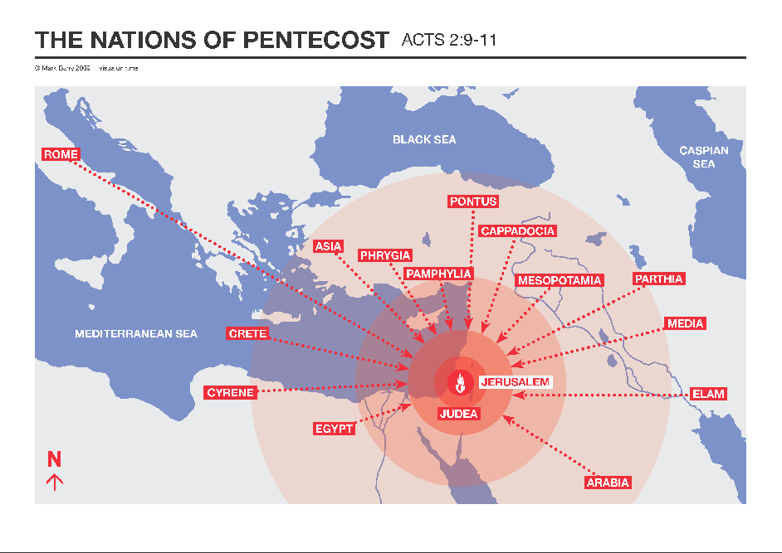

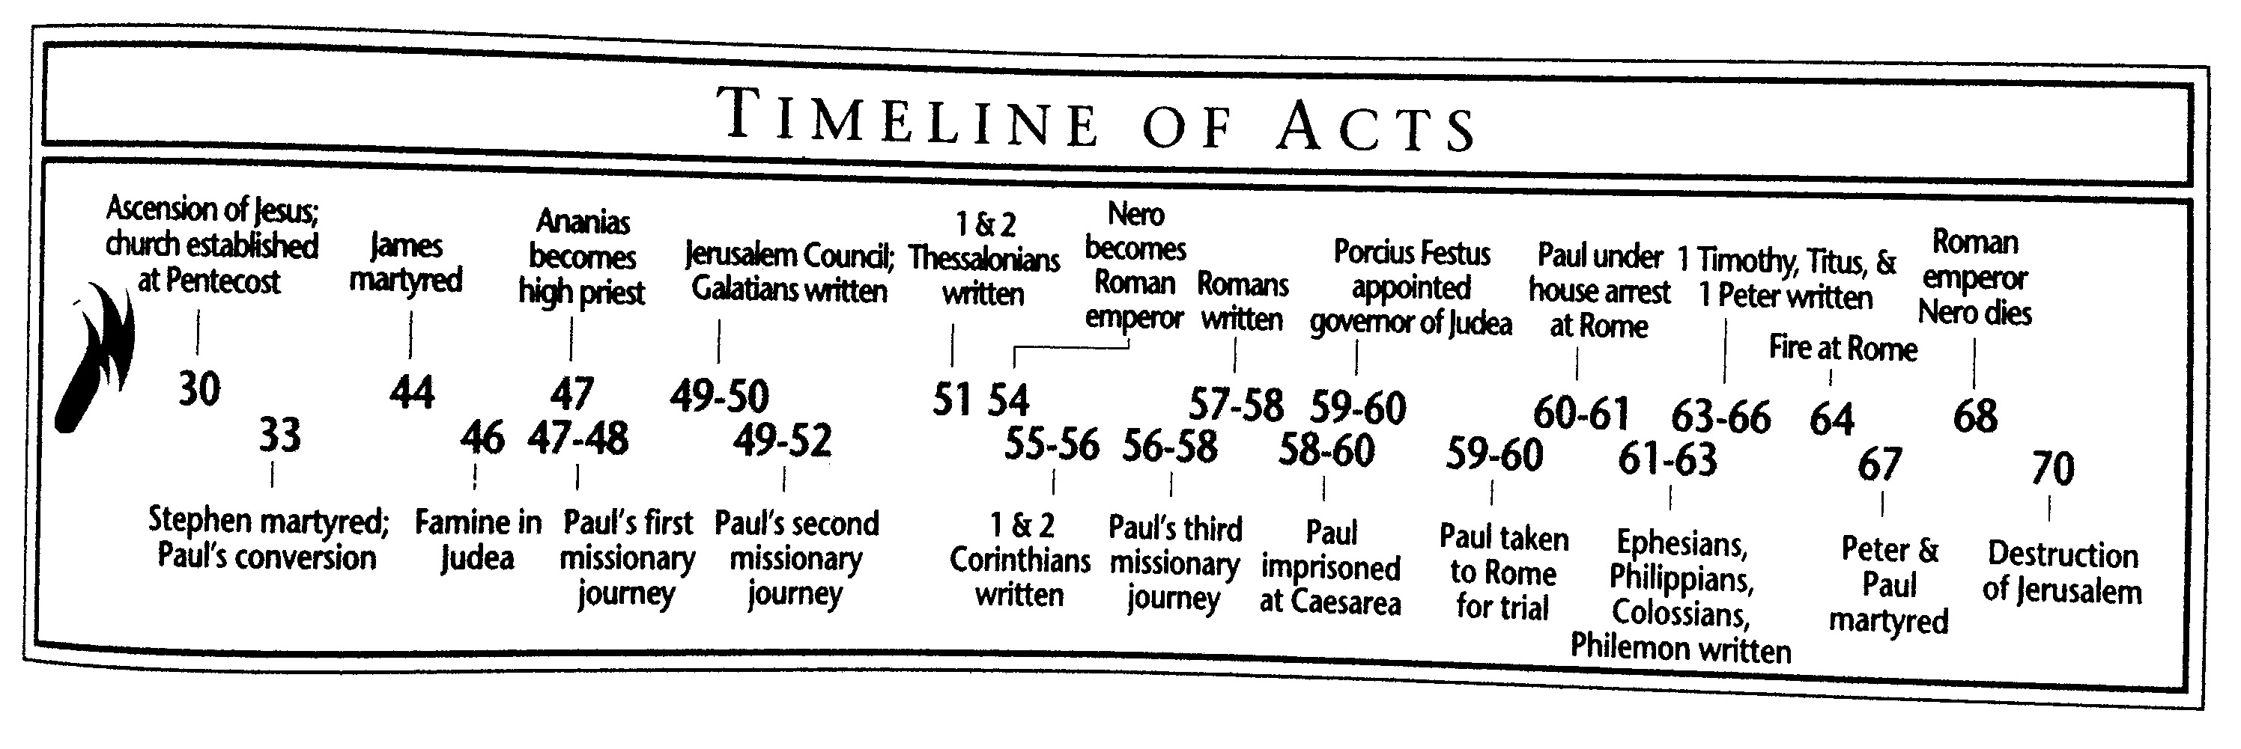

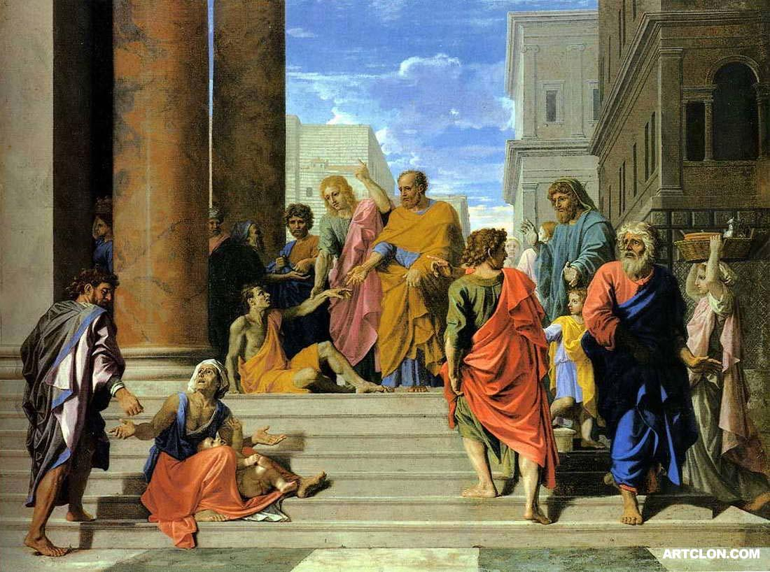
Acts 3:1-4:22

Peter and John Heal (3:1-11)
- “at the hour of prayer” : 3pm
- “The gate called beautiful”
  - Horaian: beautiful, or timely, or seasonal

- “In the name of Jesus, get up and walk.”
Nicholas Poussin “Saint Peter and John Healing The Lame Man” 1655
  - How was Peter able to perform this miracle?
  - Why does Luke include this miracle?

- “and entered the temple with them”
- “walking and leaping and praising God.”

Peter Preaches (3:12-4:4)
- “ran together to them in the portico called Solomon’s.”
  - on the way out of the Temple

- “Men of Israel”

- v.13-15
  - What is Peter summarizing?
  - Is this sermon for us or not?

- “v.17-18
  - Where does Peter turn for support for his argument?

- “repent therefore and turn back”
  - What is repentance?

  - Is our repentance the same as these hearers’ repentance?

- “times of refreshing” “send the Christ appointed for you” “the time of restoring all things”

- Deuteronomy 18:15ff
  - Who does Peter say Moses was talking about?
  - Who was Moses talking about?

- “God first resurrected His servant and sent him speaking to you on turning each from your eviling.”

- Why were the Sadducees greatly annoyed?

- How many believed now?

Peter and John before Council (4:5-22)
- “By what power or by what name did you do this? (echo Luke 20:2-8)

- v.11 – Luke 20:16-18, Psalm 118:22

- v.12: Saved from what?

- v.14-17 – Luke 20:9-16

- “for all were praising God for what had happened.”
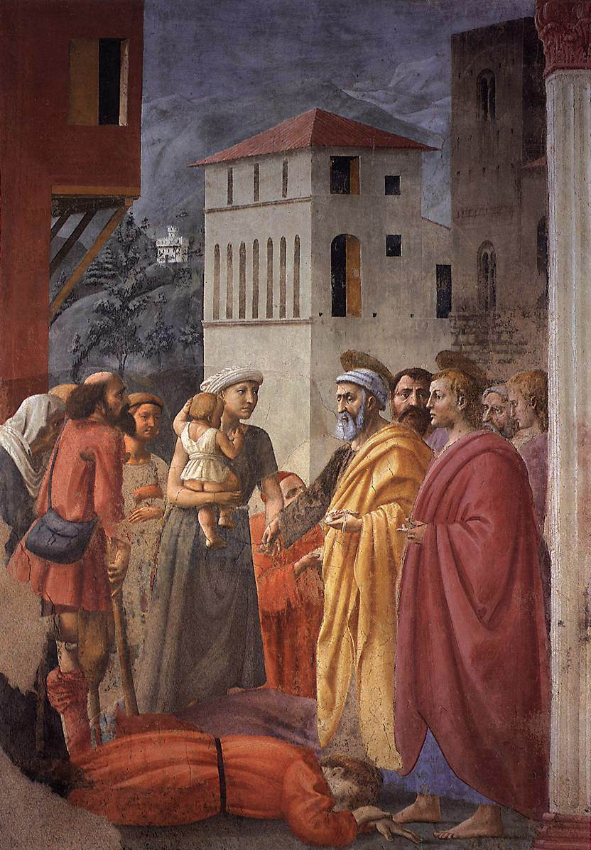
Acts 4:23-5:42
“The Distribution of Alms and Death of Ananias” by Masaccio 1425

The Believer’s Pray (4:23-31)
- What 3 descriptors do they ascribe to God?

- Psalm 2:1-2
  - What was this psalm about in its original context?
  - Do the believers quote it in that context?
  - Who is the Lord’s “anointed”? (gk: χριστος christos)

- v.27 – why do they list these specific people? (hint: read the Psalm again)
- v.28 – “to do whatever… your plan had predestined to occur”
- v.30 – “to speak your word with all confidence in you to extend your hand in healings and signs occurring through the name of your holy servant Jesus.”

  - What did they pray for?
  - Why?

  - What happened as a result?

Anannias and Sapphira (4:32-5:12a)
- “now the full number…”
- “all things in common” (cf. 2:44)
- Particularization: 34-35>36-37
- “Lay it at the apostle’s feet” ? Why? (Exod 4:25? Josh 4:3,9? Ruth 3?)

- “With his wife’s knowledge”
- “You have not lied to men but to God”
  - “great fear came upon all who heard of it.”

- “Tell me if you sold the land for this much?”
- “She said, ‘Exactly, (nai) this much!’”
- “she fell down at his feet and breathed her last.”

  - “And great fear came upon the whole church and all who heard of these things.”

Apostle’s Arrested and Set Free (5:12b-25)
- All the apostles are back in Solomon’s portico
- “None of the rest dared join them” who are “the rest”?

- v.16 Remind you of anything? (Luke 4:40 and others)
- “Go stand and speak to the people in the temple all the words of this life (zoe).”
- The High Priest isn’t looking in the temple.
- v.26 “they were afraid of being stoned by the people” (cf. Luke 22:2)

The Apostles the Council and Gamaliel (5:26-5:42)
- “We strictly charged you…” (4:18)

- “You intend to bring this man’s blood upon us.” Whose blood?

- “and so is the Holy Spirit, whom God has given to those who obey him.”

- Gamaliel presents a hypothesis:

- “rejoicing that they were counted worthy to be shamed for the name”
- What would they not stop doing? (v.42)

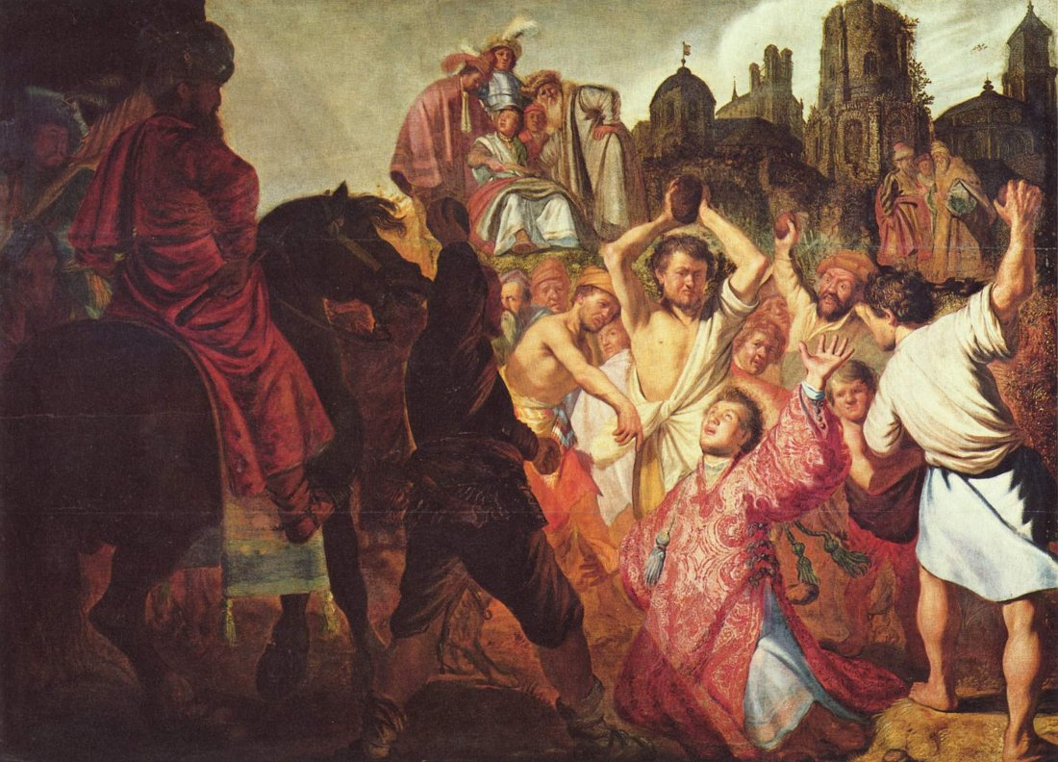
Acts 6:1-8:1a

Establishing Deacons (6:1-7)
- Hellenists: Jews who had taken on Greek
customs as a result of Alexander the Great’s
Hellenization (greek-etizing) of the world.
- Hebrews: Jews who rejected Greek culture

- What was the problem?
“The Stoning of St. Stephen” by Rembrandt (1625) (His first known work)

- Why didn’t the Apostles do it themselves?

- What was the result? (v.7)

Stephen Seized (6:8-7:1)
- The synagogue of the Freedmen: likely a Hellenistic synagogue where the service was conducted in Greek. (the cities listed are all Greek cities)

- “They could not withstand the wisdom and Spirit…” (v.10)

- “This man never ceases to speak words against this holy place and the law,” (v. 13)

- “His face was like the face of an angel.” (v.15)

- “Are these things so?” (7:1)
  - what things?

Stephen Speaks (7:2-53)

- What common theme is Stephen emphasizing in his speech? Why?

- Abraham Isaac and Jacob (v. 2-16)
  - “in Mesopotamia”
  - Gen 12:1 quote
  - “yet he gave him no inheritance in it” (v.5)
  - What period of Israel’s history is verses 6-8 referencing?
  - “sold him into Egypt, but God was with him…” (v.9)
  - “and Jacob went down into Egypt” (v.15)

- Moses (v.17-41)
  - “He supposed that his brothers would understand that God was giving them salvation by his hand… but they did not” (v.25)
  - “became an exile in the land of Midian” (v.29)
  - “for the place where you are standing is holy ground.” (v.33)
  - “I have come down to deliver them” (v.34)
  - “God will raise up for you a prophet like me from your brothers.” (v.37)
  - “and in their hearts they turned to Egypt…” (v. 39)

- Prophets (v.42-43)
  - “gave them over to worship the host of heaven…” (v. 42)
    - i.e. worship the stars and false gods (see Deut 4:19; 2 Kngs 17:16; 21:3; 23:5; Zeph 1:5)

  - “I will send you into exile beyond Babylon”

- Thesis (v. 44-50)
  - “Our fathers had a tent…” (v.44)
  - …same with Joshua…
  - …same with David… and he asked to build a temple…
  - “But it was Solomon who built a house for him. (v.47)
  - “Yet the most High does not dwell in houses made by hands” (v.48)
  - Isa 66:1,2

- Accusation (v. 51-53)
  - “uncircumcised in heart and ears” (v.51)
  - “as your fathers did, so do you.” (v. 51)
    - explanation (v.52-53)

Stephen Stoned (7:54-8:1a)
- “but he, full of the Holy Spirit, gazed into heaven and saw the Glory of God and Jesus standing at the right hand of God.” (v.55)
- “And the witnesses laid down their garments at the feet of a young man named Saul.” (v. 58)

- What do Stephen’s final two phrases remind you of?
  - See Luke 23:34, 46; 2 Chron 24:22)

- “And Saul approved of his execution” (8:1)

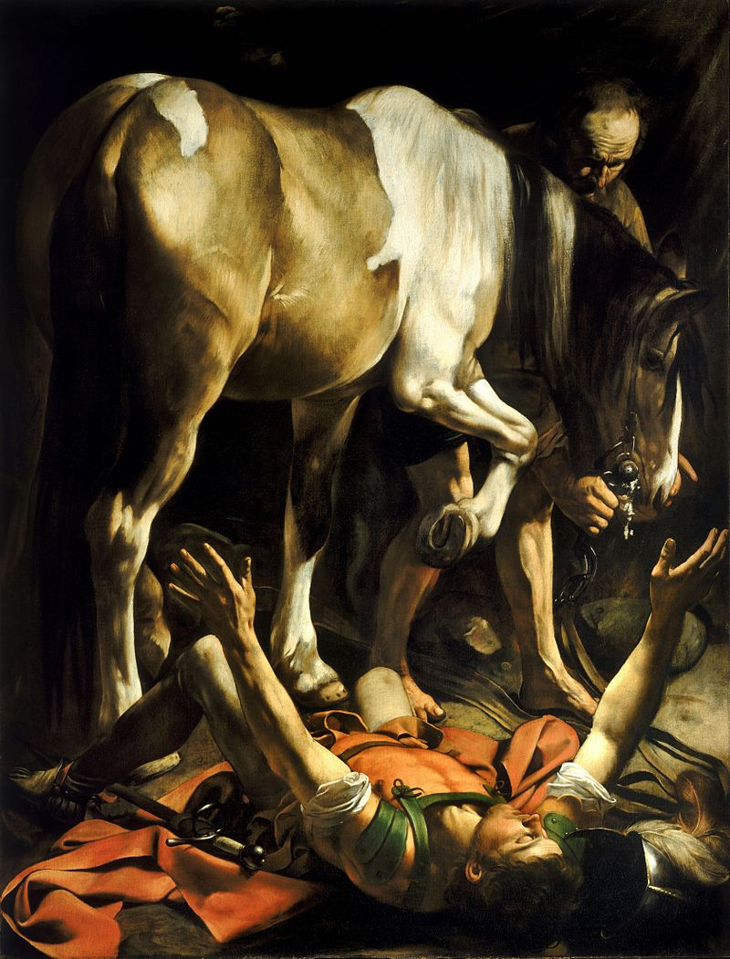
Acts 8:1b-9:31
“The Conversion on the Way to Damascus”
by Caravaggio 1601

The Church Scattered (8:1b-3)
- “were scattered throughout the regions
of Judea and Samaria, except the apostles” (v2)
- Where were they now going and why?

- What was Saul doing?

The Gospel in Samaria (8:4-25)
- “Philip went down to Samaria and proclaimed
to them the Christ.” (v5)
- “the signs that he did.” (v6)
  - what signs? (v7)

- “This man is the power of God that is called great.” Or “This man is what is called the great power of God.”
- Why do they pay attention to him?

- “prayed for them that they might receive the Holy Spirit, for he had not yet fallen on any of them, but they had only been baptized in the name of the Lord Jesus.” (v15-16)

- “Then they laid their hands on them and they received the Holy Spirit.” (v17)

- “he offered them money” (v18)
- “you have neither part nor lot in this matter, for your heart is not right before God.” (v21)
  - Was Simon’s “first conversion” (in verse 13) real?

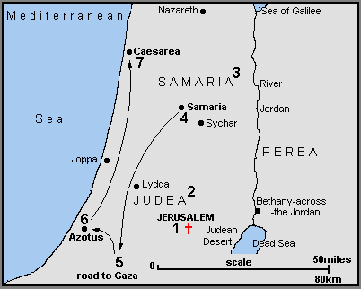

Philip and the Ethiopian (8:26-40)
- “to the road that goes from Jerusalem to Gaza.” (v26)
- What was he reading?

- “About whom does the prophet say this,
about himself or someone else?” (v34)
- “beginning with this scripture he told him
the good news about Jesus.” (v35)
  - Was this man at all Jewish?
- “What prevents me from being baptized?” (v36)
  - *manuscript additions?

- “The Spirit of the Lord carried Philip away” (v39)

Saul’s Conversion (9:1-19)
- “if he found any belonging to the way” (v2)

- “suddenly a light from heaven shone around him.” (v3)

- “Who are you lord?” “I am, Jesus, Whom you are persecuting.” (v5) ego eimi
- “though his eyes were opened, he saw nothing.” (v8)
  - Ex 4:11; Lev 21:18-19; Is 42

- “Go for he is a chosen instrument of mine to carry my name before the gentiles and kings and children of Israel. I will show him how much he must suffer for the sake of my name.” (v15-16)
- “then he rose and was baptized” (v18)

“Saul’s New Faith (9:20-31)
- Immediately he proclaimed Jesus in the synagogues, saying, “He is the Son of God.” (v20)

- “confounded the Jews who lived in Damascus by proving that Jesus was the Christ.” (v22)

- “the Jews plotted to kill him.” (v23)
  - Ring any bells?
- “Lowering him in a basket” (v25)

- “he attempted to join the disciples, but they were all afraid of him” (v26)
- “but Barnabas” (27)
  - Where did we meet Barnabas? What is he like?

- “So he went… preaching boldly in the name of the Lord” (v28)

- “so the church throughout all Judea and Galilee and Samaria had peace and was being built up, and waling in the fear of the Lord and in the comfort of the holy Spirit, it multiplied.” (v31)

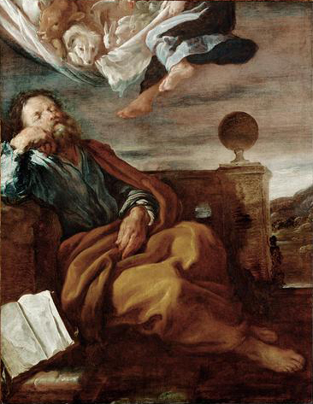
Acts 9:32-10:23
“Peter’s Vision of a Sheet with Animals”
by Domenico Fetti in 1619

Peter in Lydda and Joppa (9:32-43)
- Healing Aeneas (v32-35)
  - “Aeneas, Jesus Christ heals you; rise and
make your bed?” (v34)
  - “And immediately he rose.” (v34)
  - “..and they turned to the Lord.” (v35)
  - Compare and Contrast Luke 5:24-26

  - What point is Luke still making with this healing?

- Healing Dorcas (v36-43)
  - “when they had washed her, they laid her in an upper room.” (v37)
    - Is that unusual?

  - Who sent for Peter?

  - “But Peter put them all outside, knelt down and prayed” (v40)
  - “Tabitha, arise” (v40)
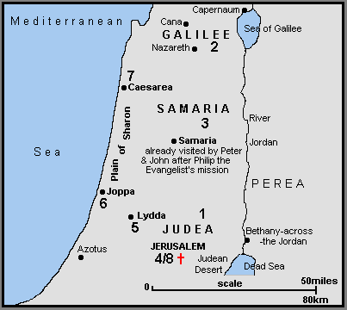
  - “…and many believed in the Lord” (v42)

  - Compare and Contrast Luke 8:40-56

Peter and Cornelius: Part 1 – Two Visions (10:1-23)
- Cornelius’s Vision (v1-8)
  - “a devout man who feared God” (v2)
    - evidence?

  - “he saw clearly in a vision” (v3)
  - “Your prayers and your alms have ascended as a memorial before God” (v4)

- Peter’s Vision (v9-23)
  - “he fell into a trance and saw the heavens opened and something like a great sheet descending” (v11)

  - “for I have never eaten anything that is common or unclean” (v14)

  - “What God has made clean, do not call common.” (v15)

  - “While Peter was pondering the vision, the Spirit said to him… go and accompany them without hesitation” (v19-20)

  - “… and some of the brothers from Joppa accompanied him.” (v23)

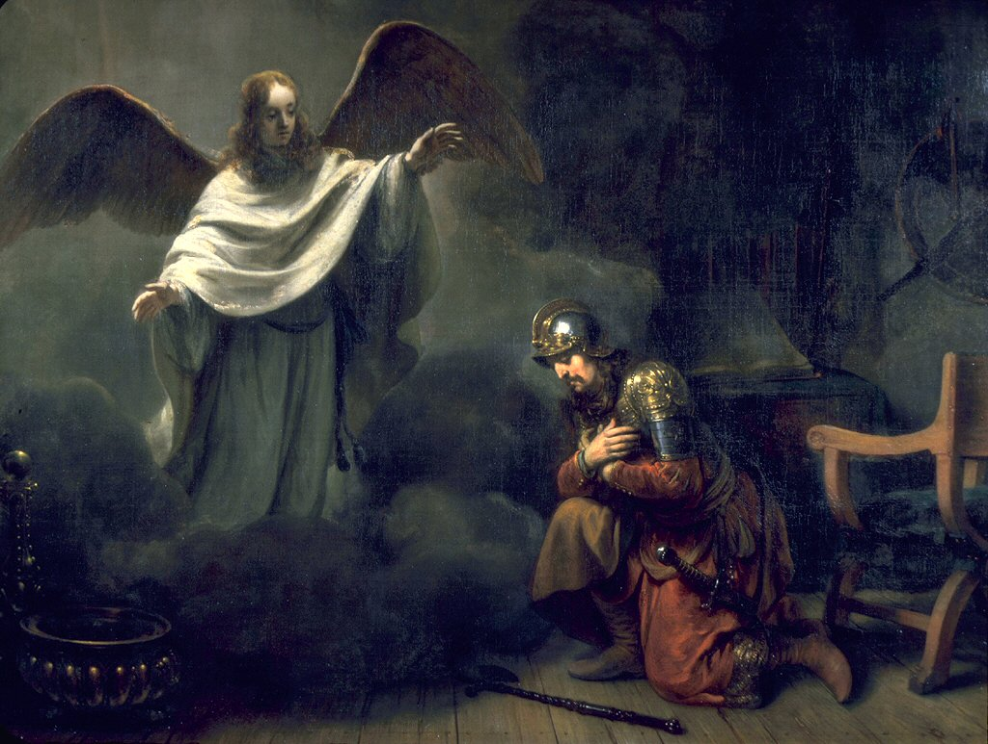
Acts 10:24-11:26
“Cornelius the Centurion”
by Gerbrand van den Eeckhout 1664

Peter and Cornelius: Part 2 – Meet and
Preach (10:24-48)
- Peter and Cornelius Meet (v24-33)
  - “Cornelius was expecting them and
had called together his relatives and
close friends.” (v24)
  - “Stand up; I too am a man.” (v26)

  - “you yourselves know how unlawful it is for a Jew to associate with or to visit anyone of another nation” (v28)
  - “I should not call any person common or unclean.” (v28)

  - “So I sent for you at once and you have been kind enough to come.” (v33)

- Peter Preaches the Gospel (v34-43)
  - “in every nation anyone who fears him and does what is right is acceptable to him.” (v36)
  - What parts of the gospel narrative does Peter mention? (v36-41)

  - “To him, all the prophets bear witness that everyone who believes in him receives forgiveness of sins through his name.” (v43)

- The Holy Spirit Confirms Belief (v44-48)
  - “The Holy Spirit fell on all who heard the word” (v44)
  - “were amazed because the gift of the Holy Spirit was poured out even on the Gentiles.” (v45)

  - “they were hearing them speaking in tongues and extolling God.” (v46)
  - “Who have received the Holy Spirit, just as we have?” (v47)

Peter Confronted (11:1-18)
- “heard that the Gentiles also had received the word of God.” (v1)
- “The circumcision party”: anyone who was circumcised. (cf. Gal 2, Titus 1:10-11, Acts 15) Likely a group within the church arguing that the Mosaic Law must continue to be followed in order to be Christian.

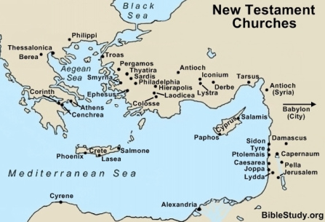

- “The Holy Spirit fell on them…” (v15)

- “…just as on us at the beginning.” (v15)

- “John Baptized with water…” (v16)
(cf. Luke 3:16, Acts 1:5)

- “If then God gave the same gift to them as he gave to use when we believed in the Lord Jesus Christ, who was I that I could stand in God’s way?” (v17)

- “to the gentiles also God has granted repentance that leads to life.” (v18)
  - Who says this?

Reforming… pun intended (11:19-26)
- And a great many people were added (v19-24)

  - “those scattered… speaking to only Jews.” (v19)
  - “But some… spoke to Hellenists in Antioch.” (v20)
  - “a great number believing, turned to the Lord.” (v21)

- They were called the Christians (v25-26)
  - Why does Barnabas bring Saul to Antioch and how long do they stay?

  - “And in Antioch the disciples were first called Christians” (v26)

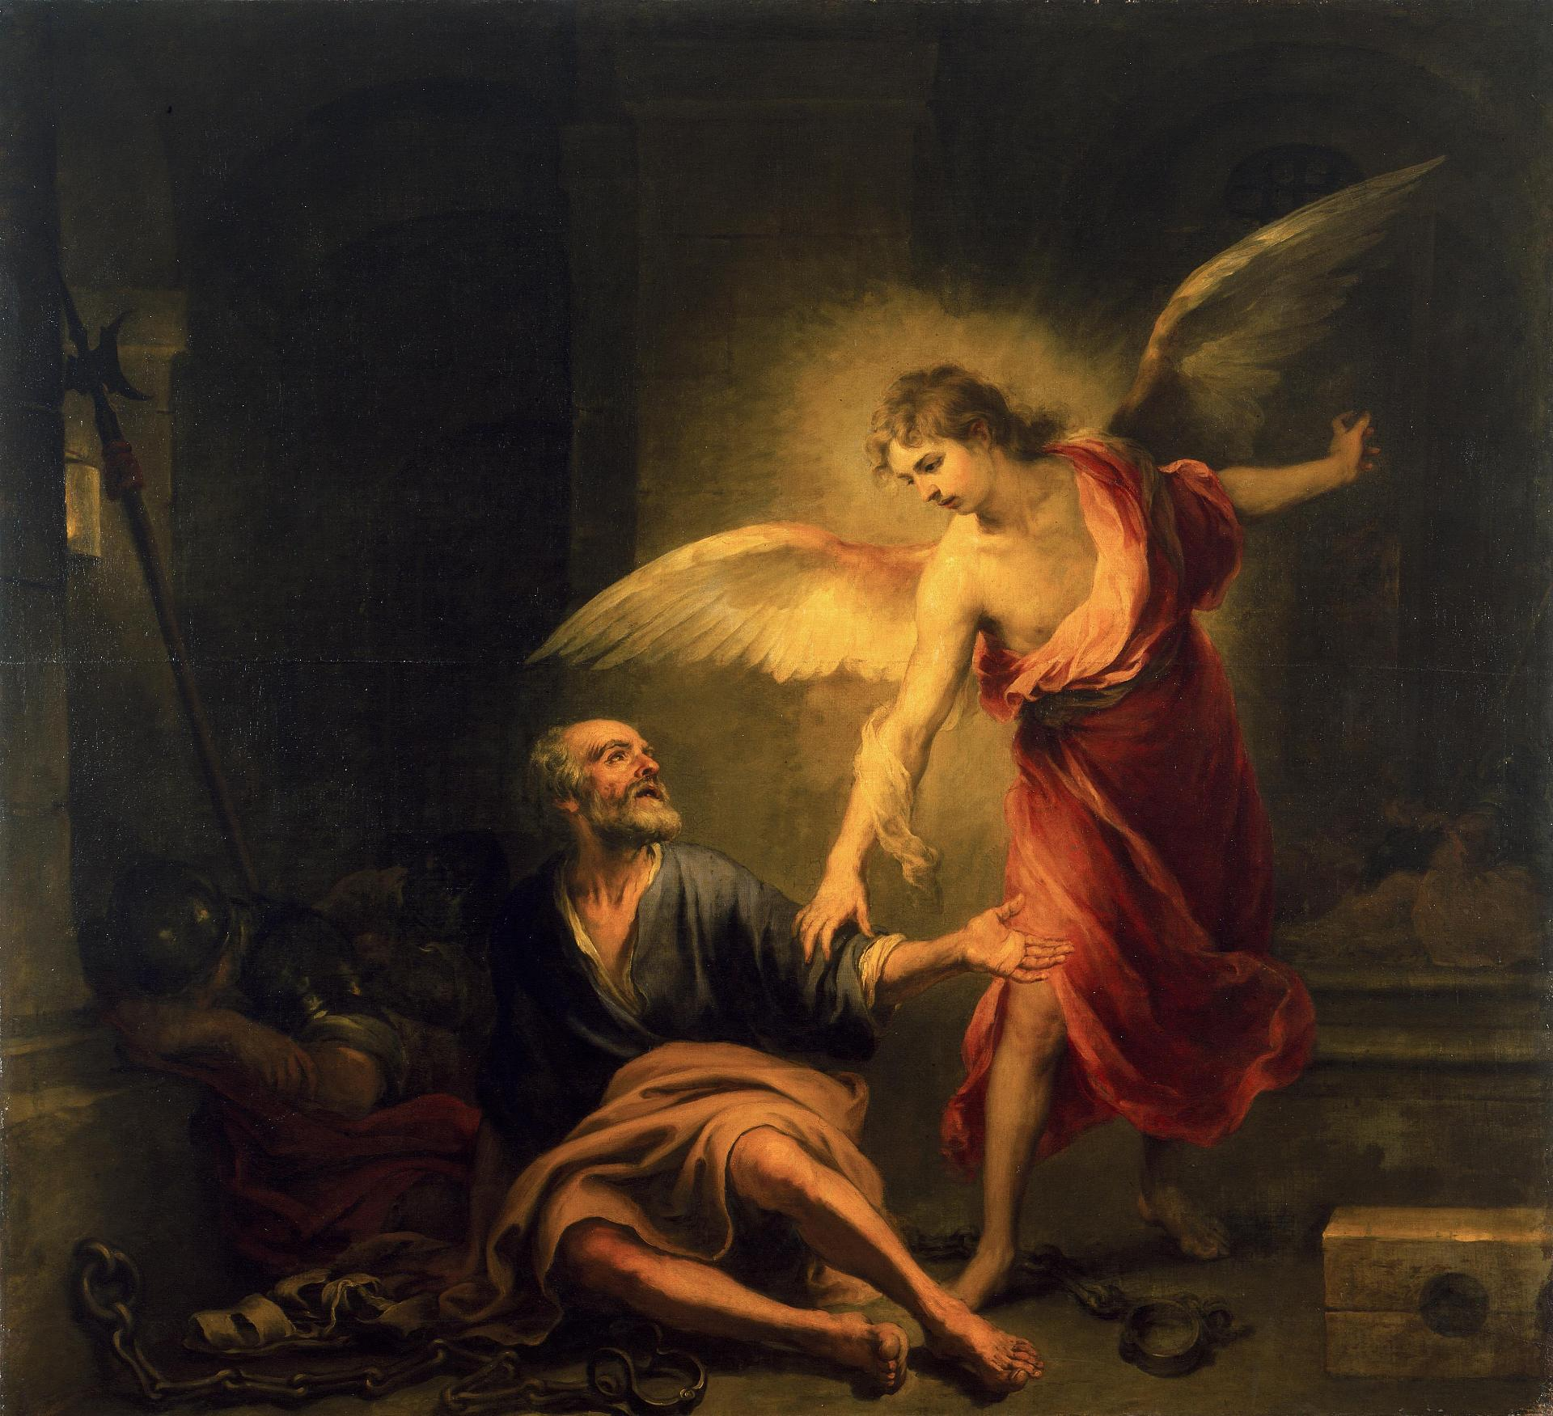
Acts 11:27-13:3
“The Liberation of St Peter”
Bartolome Esteban Murillo 1665-1667

Problems in Jerusalem (11:27-12:5)
- “Prophets came from Jerusalem
to Antioch” (v11:27)
  - What is a Prophet?

- “This took place in the days of Claudius” (v11:28)
  - This took place between 41and 54 AD.
  - Josephus attests Herod’s death in 44AD, the third year of Claudius’s reign. (Antiquities, 19.8.2)

- “”the disciples…sent relief to the brothers in Judea” (v11:29)

- “Herod the king… killed James the brother of John” (v12:1-2)

  - The 4 Herods in the Bible:

- Herod the Great
  - Matthew 2
  - Tried to kill Jesus at birth
  - Went insane
  - Ordered death of all 2yr olds in Bethlehem
  - Ruled from 37-4BC

- Herod Antipas I
  - Ruled from 4BC-39 AD
  - Luke 9&23
  - Killed JtheB
  - Tried Jesus Illegally
  - Ruled during Jesus life and ministry

- Herod Agrippa I
  - Ruled from 41-44 AD
  - Acts 12
  - Killed the Apostle James
  - Imprisoned Peter
  - Killed By an Angel

- Herod Agrippa II
  - Ruled during Apostle Paul’s ministry
  - Married his sister Bernice
  - Acts 25-26
  - Tried the Apostle Paul
  - Sent the Apostle Paul to Caesar at Paul’s request

- “When he saw that it pleased the Jews…” (v12:3)

- What are the days of Unleavened Bread? (Ex 12:14-20)

- “So Peter was kept in prison, but earnest prayer for him was made to God by the Church.” (v12:5)
The Effects of Prayer (12:6-17)
- “And behold, an angel of the Lord stood next to him…” (v7)
- “And he went out and followed him. He did not know that what was being done by the angel was real…” (v9)
- “When Peter came to himself…” (v11)
- “from all that the Jewish people were expecting.” (v11)

- “many were gathered together praying” (v12)
- “you are out of your mind!”… “It is his angel” (v15)
  - What views of prayer are displayed here and by whom?

- And he said, “Tell these things to James and the brothers” (v17)
  - Which James? (cf. 15:13)

The Word of the Lord Increasing (12:18-13:3)
- “Herod was angry with the people of Tyre and Sidon… [but] they asked for peace because their country depended on the King’s for food.” (v12:20)
- “The voice of a God and not of a man. Immediately an angel of the Lord struck him down.” (v12:23)
  - Why did the Lord strike him down?

- “But the word of God increased and multiplied.” (v.12:24)

- “And Barnabas and Saul returned (to Antioch) bringing John Mark.” (v12:25)

- “Now there were in the Church at Antioch, prophets and teachers.” (v13:1)
  - What’s the difference between a prophet and a teacher?

  - Can someone be both?

- “while worshipping and fasting, the Holy Spirit said…” (v13:2)
- “they sent them off.” (13:3)
  - Who now?

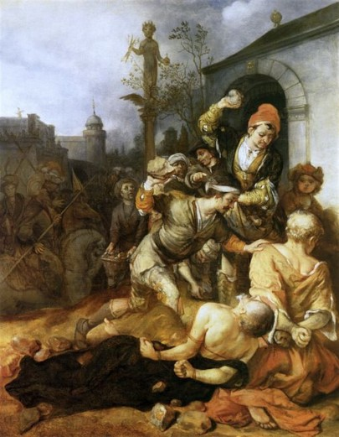
Acts 13:4-14:28

Barnabas, Paul, and John in Cyprus (13:4-12)
- “They proclaimed the word of God
in the synagogues” (v5)
- “a magician, a Jewish false prophet
named Bar-Jesus.” (v6)
  - Bar-jesus = Elymas
  - Saul=Paul

- “You son of the devil, you enemy of all righteousness,
full of all deceit and villainy, will you not stop making
crooked the straight paths of the Lord?” (v10)
  - What happened to Christian love?
“The Stoning of St Paul and St Barnabas at Lystra”
by Barent Fabritius 1672, Amsterdam

- Elymas struck blind… “Then the proconsul believed” (v12)
- “For he was astonished at the teaching of the Lord.” (v12)

Barnabas and Paul in Antioch Pisidia (13:13-50)
- Paul gives the background for the Messiah (v13-25)

  - “on the Sabbath, they went to the synagogue and sat” (v14)
  - “If you have any word of encouragement for the people, say it” (v15)
    - the synagogue rulers invite them to speak!

  - “Men of Israel and you who fear God, listen” (v16)
    - Who’s the audience?

  - Paul summarizes the story of the old testament (v17-22)
    - Would you be able to do that? Why or why not?

  - “Of this man’s offspring, God has brought to Israel a Savior, Jesus, as he promised.” (v23)
    - Where did he promise that? (cf. Acts 13:33-35; Ps 2; Is 55; Ps 16; Sam 7)

- Paul supports the resurrection with Scripture (v26-37)
  - “because they did not recognize him or understand the utterances of the prophets, which are read every Sabbath, fulfilled them by condemning him.” (v27)
  - “for David… fell asleep… and saw corruption, But he whom God raised up did not see corruption.” (v36-37)
- Paul gives an application (v38-41)
  - “Forgiveness of sins is proclaimed to you.” (v38)
  - “Everyone who believes is justified…” the way you couldn’t be with the law. (v39) (cf. Galatians, Romans arguments)

- The people want more, but the leaders don’t (v42-50)
  - “Many jews and devout converts to Judaism followed” (v430
  - “It was necessary for the word of God to be spoken first to you. Since you thrust it aside and judge yourselves unworthy of eternal life, behold, we are turning to the Gentiles.”(v46)
    - Why do they go to the Gentiles? (2 reasons)

  - Gentiles believe… “and as many as were appointed to eternal life believed. (v48)
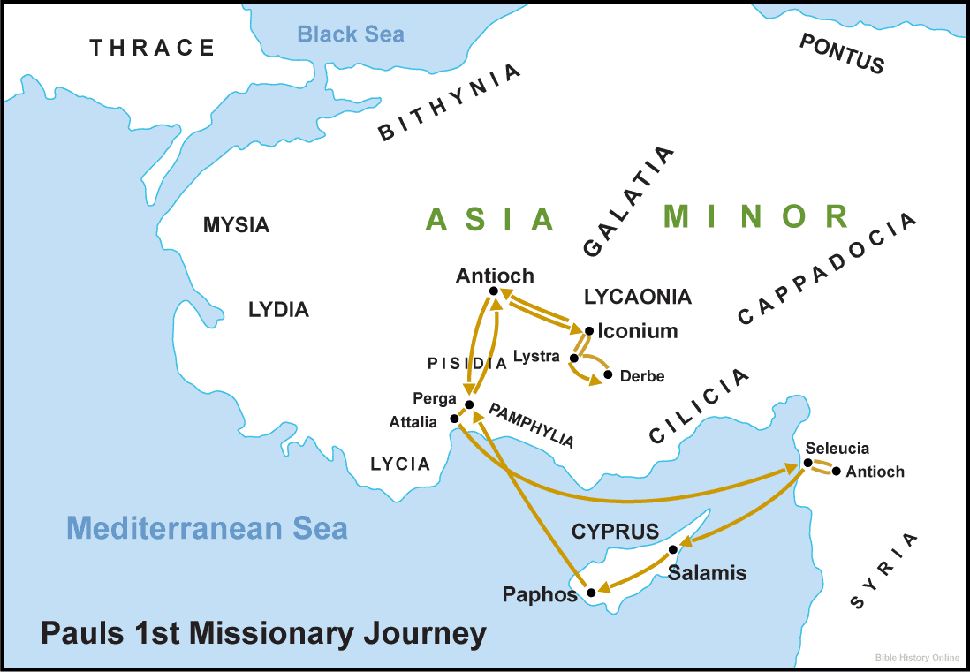
Barnabas and Paul in Iconium (13:51-14:7)
- “But they shook off the dust from their feet
against them and went to Iconium” (v13:51)
- “they remained a long time speaking boldly
for the Lord... grace… wonders” (v14:3)
- they fled to Lystra because they heard of an
attempted stoning. (v14:5-6)

Barnabas and Paul in Lystra (14:8-28)
- Paul heals a cripple (v8-10)
  - “seeing that he had faith to be saved” (v9)
  - he sprang up! (v10)

- The people praise them (v11-18)
  - “Barnabas they called Zeus and Paul Hermes” (v12)
  - “We also are men, of like nature with you… turn to a living God” (v15)
    - What “supports” do they give to persuade the people not to sacrifice to them?

- Paul stoned by previously-seen Jews (v19-23)
  - “Jews from Antioch and Iconium” (v19)
  - “he rose up and entered the city” (v20)
  - Went to Derbe, and then retraced their steps doing discipleship.
  - “through many tribulations we must enter the kingdom of God.” (v22)
  - they appointed elders in every church (v23)

- Paul and Barnabas return to Antioch (v24-28)
  - “They declared all that God had done with them and how he had opened a door of faith to the Gentiles.” (v27)
  - “And they remained no little time with the disciples.” (v28)
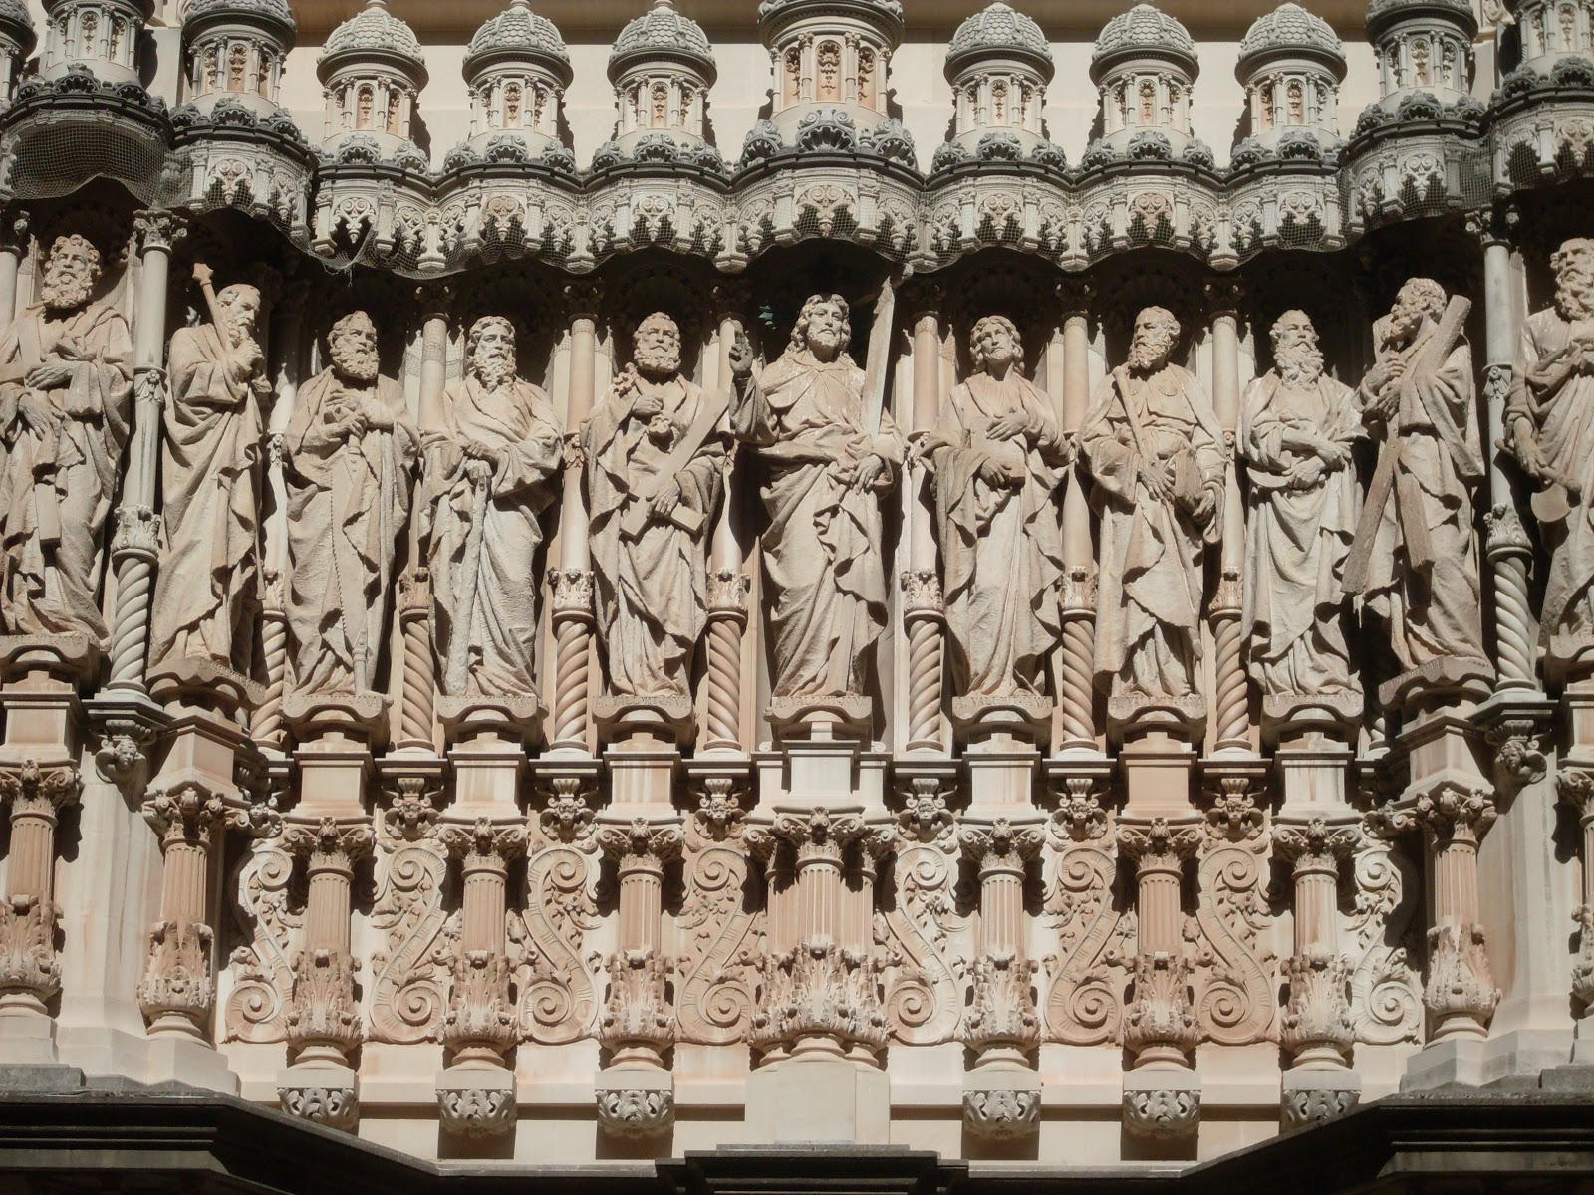
Acts 15:1-35

The Problem Arises (v1-6)
- “came down from Judea” (v1)

- “unless you are circumcised…” (v1)

- “…you cannot be saved.” (v1)

Atrium façade at the Basilica at the Montserrat Monastery. Barcelona, Spain. By Venanci and Agapit Vallmitjana 1900-1901.
- “no small debate with them” (v2)

- “appointed to go up to Jerusalem to the apostles and elders about this question.” (v2)

- “describing in detail the conversion of the gentiles” (v3)

- “some believers who were Pharisees rose up saying, ‘It is necessary to circumcise them and to order them to keep the law of Moses.’” (v5)

Peter’s Address (v7-11)
- “After there had been much debate” (v7)

- “In the early days God chose among you by my mouth that the gentiles would hear the word of the gospel and believe.” (v7)

- “God bore witness to them” … how? (v8)
  - “By giving them the Holy Spirit, just as he did to us.” (v8)

- “Why do you test God?” …how?(v10)
  - “By placing a yoke” .. that we can’t even bear.
  - What yoke? (cf. Gal 3:17-28; Rom 3:19-31; Mishnah, berakot 2.2)
    - Jewish custom of reciting the law and Shema.

- “But we believe we will be saved through the grace of the Lord Jesus, just as they will.” (v11)
  - GOSPEL!

Barnabas, Paul, and James’s Address (v8-21)
- Barnabas and Paul tell what’s happening among the gentiles. (v12)
- “Simeon has related how God first visited the Gentiles” (v14)
  - Simeon=Peter (cf. 2 Pet 1:1 Συμεων Πετρος)
- “With this word the prophets agree” (v15)
  - Amos 9:11ff

  - What is the context and the meaning of Amos 9?

  - “That the remnant of mankind may seek the Lord” (LXX) or “That they may possess the remnant of Edom” (MT)?

- “Therefore my judgment is that…” (v19)
  - Not trouble the gentile believers (19)
  - Abstain from idolatry (20)
  - Abstain from sexual immorality (20)
  - Abstain from what has been strangled (20)
  - Abstain from blood. (20)

- “For from ancient generations, Moses has had in every city, those who proclaim him, for he is read every Sabbath in the synagogues.” (v21)
  - Idolatry, fornication, and murder are considered the 3 cardinal sins to the Jews, for which the whole world would be accountable.

Four are sent to Antioch with a Letter (v22-35)
- “They sent Judas called Barsabbas and Silas…” with a letter. (v22)

- “Some persons have gone out… and troubled you” (v24)
  - Who? (cf. v1)

- “And Judas and Silas encouraged and strengthened the brothers.” (v32)

- “Paul and Barnabas remained in Antioch teaching and preaching the word of the Lord” (v35)

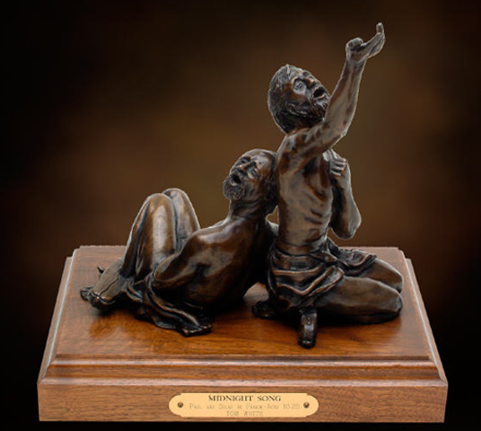
Acts 15:36-17:14

A Disagreement (15:36-41)
- “Paul said to Barnabas…” (v36)

- “But Paul thought best not to take with them
one who had withdrawn from them in Pamphylia
and had not gone with them to the work.”(v38)

- “There arose a sharp disagreement” (v39)

“Midnight Song” bronze, tabletop sculpture by Tom White

The Guiding of the Spirit to Convert of Lydia (16:1-15)
- Timothy:
  - Son of a Jewish woman, Greek man (v1)
  - Well-spoken of (v2)
  - Circumcised by Paul (v3)
    - Why did Paul circumcise Timothy?

- “they delivered the decisions that had been reached by the apostles” (v4)
  - What decision? (v ____)

- The Spirit “forbids them to speak in Asia, Mysia, and Bithynia (v6-8)

- “A vision appeared to Paul” (v9)

- “Immediately we sought to go on into Macedonia” (v10)
  - Why? (v10b)

  - First person plural?
    - 16:10-16:18; 20:4-21:19; 27:1-28:30
- “We went outside the gate… where we supposed there was a place of prayer” (v13)

- Lydia:
  - From Thyatira (v14)
  - Seller of purple goods (v14)
  - Worshipper of YHWH (v14)

- “The lord opened her heart to take heed of what was said by Paul.” (v14)

Paul and Silas in Prison (16:16-40)
- “as we were going to the place of prayer” (v16) (cf. v13)
- “a slave girl who had a spirit of divination” (v16)

- “These men are slaves of the Most High God, who proclaim to you the way of salvation.”(v17)

- “Paul, having become greatly annoyed, turned…” (v18)

- “These men are Jews and are disturbing our city.” (v20)
- “…ordering the jailer to keep them safely.” (v23)

- “Paul and Silas were praying hymns sung to God and the prisoners were listening to them, and suddenly there was a great earthquake” (v25-26)

- “What must I do to be saved?” (v30)

- They have beaten us publicly, uncondemned… do they now throw us our secretly?”(v37)

- “They came and apologized” (v39)

Thessalonica and Berea (17:1-14)
- “Paul went [to the synagogue] and reasoned with them from the scriptures explaining and proving that it was necessary for the Christ to suffer and to rise from the dead” (v2-3)

- “some were persuaded” (v4)

- “But the Jews were jealous… and formed a mob.” (v5)

- “And when they had taken considerable money from Jason and the rest, they let them go.” (v9)
  - Where were Paul and Silas in verse 6?

- In Berea “these Jews were more noble than those in Thessalonica; they received the word with all eagerness, examining the Scriptures daily to see if these things were so. Many of them therefore believed” (v11-12)

- The mob follows them and Paul leaves, but Timothy and Silas stay. (v13-14)

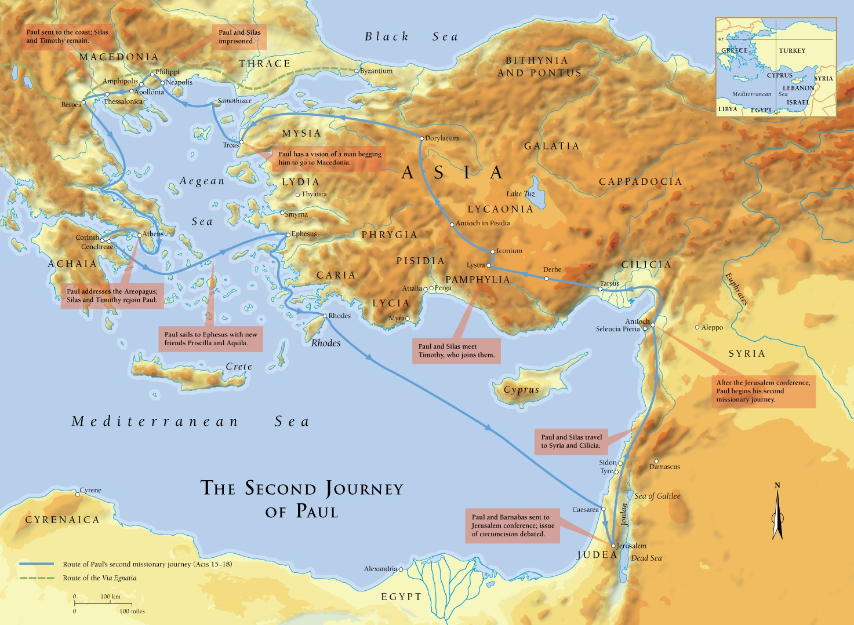

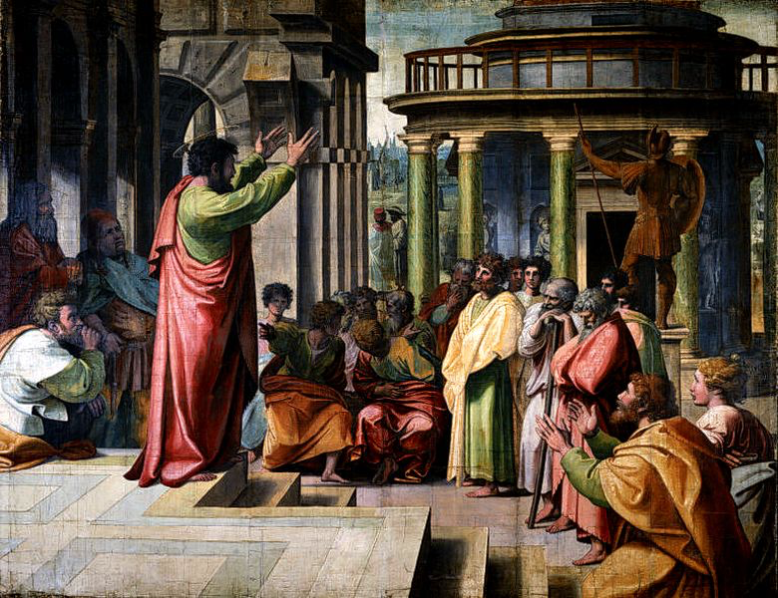
Acts 17:15-18:22

Paul in Athens (17:15-34)
- What is Paul doing while in Athens?
  - Waiting for Timothy and Silas. (v15-16)
  - Reasoning in the synagogue and
marketplace (v17)
- Epicurean Philosophers: the purpose of life is
to seek pleasure.
- Stoic Philosophers: self-control, self-denial,
and fortitude are the keys to good living.
“Areopagus Sermon” by Raphael 1515. Cartoon for tapestries in Sistine Chapel.

- What was Paul preaching?
  - “Jesus and the resurrection.” (v18)

- “And taking him, they led him to the Areopagus.” (v19)
- Paul’s message:
  - “You are very religious.” (v22)
  - “You have an alter to an unknown God.” (v23)

  - That God is the uncreated creator of everything. (v24-25)
  - “He gives life and breath and everything to men.” (v25)

  - and from one man… “appointing and commanding the times and boundaries of their dwelling places to seek God, if then indeed they would only reach out and grasp for him, and indeed he is not far from each of us…” (v27)

  - Your own poets see some of this truth. (v28-29)
  - “The times of ignorance God overlooked, but now…” (v30)

  - “repent because...” a man is going to judge the world, and that man came back from the dead. (v31)

- 2 Reactions: mocking and curiosity. (v32)
  - What point solicited those reactions?

- “Some men joined and believed.” (v34)

Paul in Corinth (18:1-17)
- Paul meets Aquila and Priscilla. (v2)
- Paul stays with them in Corinth (v3)
- “he reasoned in the synagogue every Sabbath… Jews and Greeks.” (v4)
- “witnessing to Jews the Christ to be Jesus.” (v5)

- “From now on, I will go to the Gentiles.” (v6)

- “Do not be afraid but go on speaking.” (v9)
- “no one will attach you to harm you.” (v10)
- “He stayed a year and 6 months teaching the word of God among them.” (v11)

- The Jews attempt to have Paul taken out by Gallio. (v12-15)

- “…see to it yourselves. I refuse to be a judge of these things.” (v15)
- “he drove them from the tribunal.” (v16)

- “They seized Sosthenes… and beat him in front of the tribunal. But Gallio paid no attention.”(v17)
  - Why are they beating Sosthenes? (cf. 1 Cor 1:1)

Return to Antioch (18:18-22)
- Paul went to Syria with Priscilla and Aquila. (v18)
- “He cut his hair, for he was under a vow.” (v18)

- “They came to Ephesus and he left them there, but he went into the synagogue and reasoned with the Jews.” (v19)

- He set sail from Ephesus, greeted the church in Caesarea, and went down to Antioch. (v22)

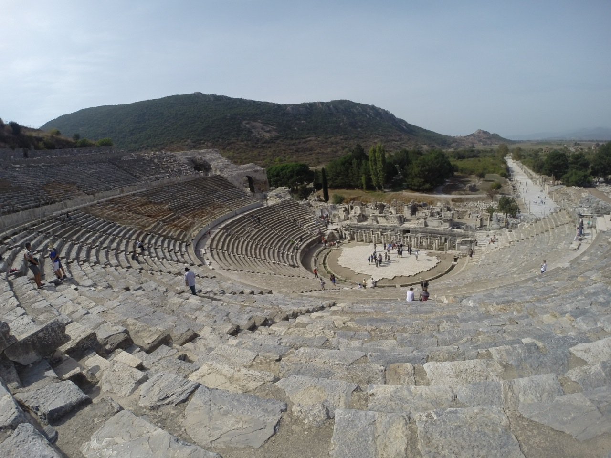
Acts 18:23-20:12

Paul and Apollos’s Ministry (18:23-19:7)
- he “went from one place to another” (v23)
- “strengthening all the disciples” (v23)

- Apollos:
  - Jew from Alexandria (v24)
  - Eloquent man (v24)
  - Competent in the Scriptures (v24)
  - fervent in Spirit (v25)
  - taught Jesus accurately (v25)

- “When Priscilla and Aquilla heard him, they took him aside and explained to him the way of God more accurately.” (v26)
- “Showing by the scriptures that the Christ was Jesus.” (v28)

- “Did you receive the Holy Spirit when you believed?” (v2) (cf. Acts 2:4; 8:14-17; 10:44)

- “John baptized with the baptism of repentance, telling people to believe in the one who was to come after him, that is, Jesus.” (v4)

  - Were these twelve men Christians before Paul showed up?
    - called “disciples” (v1) and “When you believed” (v2)
    - “We have not even heard that there is a Holy Spirit.” (v2)

  - Soteriology (Study of Salvation)
    - the one condition: Belief (trust) that Christ’s death burial and resurrection procure salvation for you, given to you by grace through faith. (cf. John 3:16; 5:24; 6:47; 20:30-31; Acts 16:30-31; Rom 1:16; Eph 2:8-9 1 Cor 15)
    - Saved from the penalty of sin: death, brought about by the fall, deserved by all humanity. (Gen 3:19; Ezek 18:20; Rom 3:23; 5:12; 6:23; John 3:36; Eph 2:1)

- “When Paul lad laid his hands on them, the Holy Spirit came” (v6) (cf. Eph 1:11-14)

Ministry in Ephesus (19:8-20)
- “entered the synagogue and for three months spoke boldly,” (v8)
- “persuading them about the kingdom of God.” (v8) (cf. Acts 1:3-7)

- “And God was doing extraordinary Miracles by the hands of Paul” (v11)
- Some Jews try exorcising in Jesus’s name without faith in Jesus. (v13-14)
- “The man with the evil Spirit overpowered them… and this became known to all in Ephesus, both Jews and Greeks.” (v16-17)

- Many converted and there was evidence of their repentance. (v17-20)
  - What evidence?

Riot in Ephesus (19:21-20:1)
- “Paul resolved in the Spirit to pass through Macedonia and Achaia (Greece) and Go to Jerusalem”… and then to Rome. (v21)

- “…there arose no little disturbance concerning the way.” (v23)
  - What is “the way”?

- “Demetrius, a silversmith, made silver shrines for Artemis” (v24)
- How and why does Demitrius incite the riot?

- “They rushed together into the theater, dragging Gaius and Aristarchus” (v29)
- Paul wishes to go in but… “the disciples would not let him.” (v30)
- “the assembly was in confusion, and most did not know why they had come” (v23)

- Alexander tries to calm them “But when they recognized he was a Jew, for about two hours they all cried out with one voice ‘Great is Artemis of the Ephesians!’” (v34)

- How does the Town clerk calm them?

- “After the uproar ceased Paul sent for the disciples... encouraging them.” (20:1)

Eutychus Raised (20:2-12)
- “we sailed away from Philippi after the days of Unleavened Bread” (v6)
  - What happens after the feast of Unleavened bread and what is the significance for Christians?

- “On the first day of the week” (v7)

- “we gathered together to break bread…he prolonged his speech until midnight” (v7)

- Eutychus dies and is raised from the dead (not Resurrected.)
  - Theological difference between “raised” and “resurrected”?

- “he conversed with them a long while, until daybreak” (v11)

- “And they took the youth away alive and were not a little comforted.” (v12)

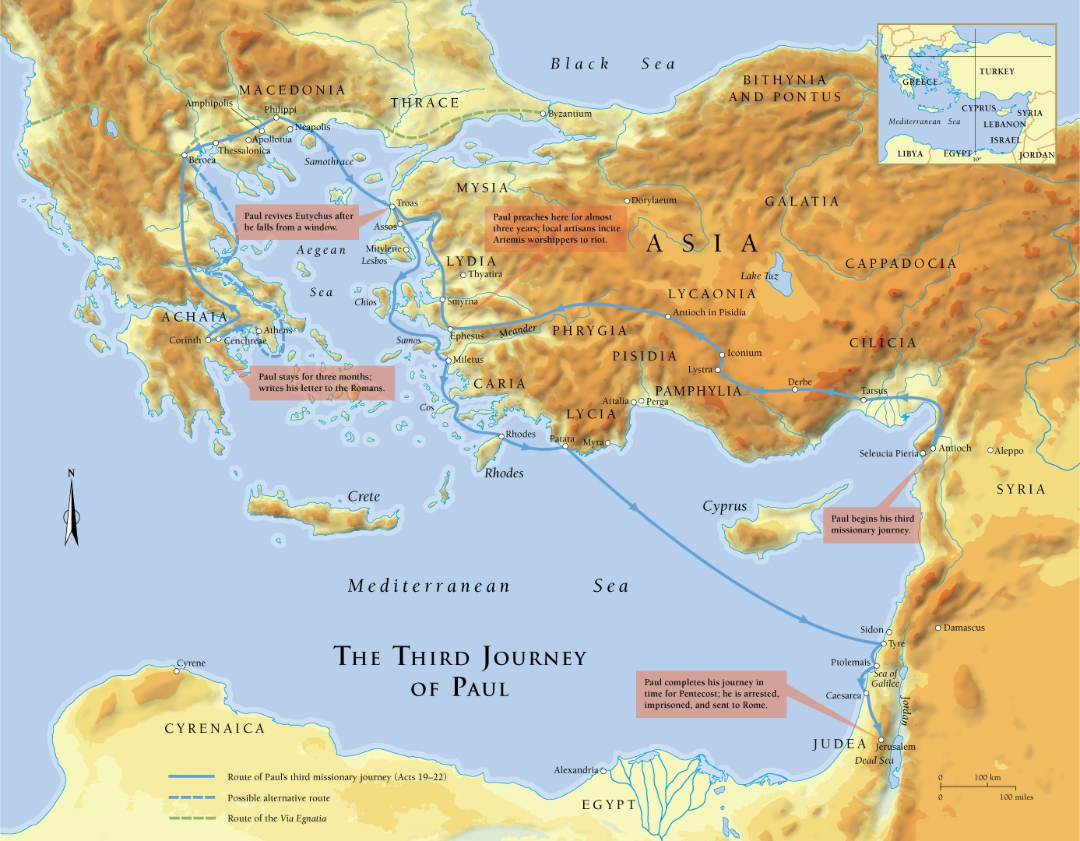

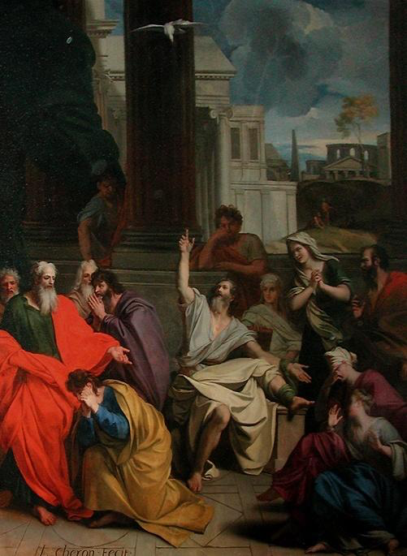
Acts 20:13-21:40a

Final Words to Ephesian Elders (20:13-38)
- the travel plans to avoid Ephesus. (v13-16)

- Paul’s speech to the Ephesian elders:
  - You know me and my character. (v18-19a)
  - I taught through persecution (v19b-20)
  - I preached the gospel (v21)
  - I’m going to be put in jail (v22-23)
  - If I die, so what. I preach the gospel. (v24)
  - This is the last time you’ll see me, and wolves
and false teachers are coming (v25-30)
  - So be alert and admonish with tears (v31)
  - You’re in God’s hands now. (v32)
“The Prophecy of Abagus” by Louis Cheron 1686
  - Work hard for what you need and give the rest away. (v33-35a)
  - “It is more blessed to give than to receive.” (v35b)
- “There was much weeping on the part of all… that they would not see his face again.” (v37-38)

Prophecies of Jerusalem (21:1-14)
- “landed at Tyre… we stayed there for seven days.” (v3-4)
- “Through the Spirit they were telling Paul not to go to Jerusalem” (v4)
- “we came to Caesarea and entered the house of Philip the evangelist” (v8)

- “A prophet named Agabus came down from Judea.” (v10)
- “Thus says the Holy Spirit, ‘This is how the Jews at Jerusalem will bind the man who owns this belt and deliver him into the hands of the Gentiles.’” (v11)
  - What does this say about prophecy?

- “We and the people there urged him not to go up to Jerusalem.” (V12)
- “I am ready not only to be imprisoned but even to die in Jerusalem for the name of the Lord Jesus.” (v13)

- “Let the will of the Lord be done.” (v14)

All Things to All People (21:15-26)
- “Paul went in with us to James and all the elders were present.” (v18)
  - What’s the first thing Paul relates and how do the elders react?

- “you see how many thousands there are among the Jews who have believed.” (v20)
  - “They are all zealous for the law.” (v20)
  - They’ve been told that you teach Jews who are among Gentiles not to follow the law.
  - “What then is to be done?” (v22)

- The Plan for Peace: (cf. Rom 15:25-27; Num 6:13-17)
  - purify yourselves with these four men under a vow
  - pay their expenses
  - “Thus all will know that there is nothing in what they have been told about you.”
    - Is this true?

    - Is Paul wrong for participating in this? (cf. 1 Cor 9:20; Acts 24:17-18; 23:1)

Another Angry Mob (21:27-40a)
- “The Jews from Asia… stirred up the whole crowd and laid hands on him.” (v27)

- Two false charges: (v28)
  - “Teaching everyone everywhere against the people and the law of [the temple]” (cf. Rom Gal 3:19-25 Rom 3:19-20; 7:7)
  - “brought Greeks into the temple” (cf. Acts 21:29)

- “They seized Paul and dragged him out of the temple.” (v30)
- “When they saw the tribune and the soldiers they stopped beating Paul.” (v32)

- “The tribune arrested him and ordered him be bound with two chains.” (v33) (cf. 21:11)

- “he was actually carried by the soldiers because of the violence of the crowd.” (v35)
- “I am a Jew from Tarsus in Cilicia, a citizen of no obscure city.” (v39)
- “When there was a great hush, he addressed them in Hebrew…” (v40)

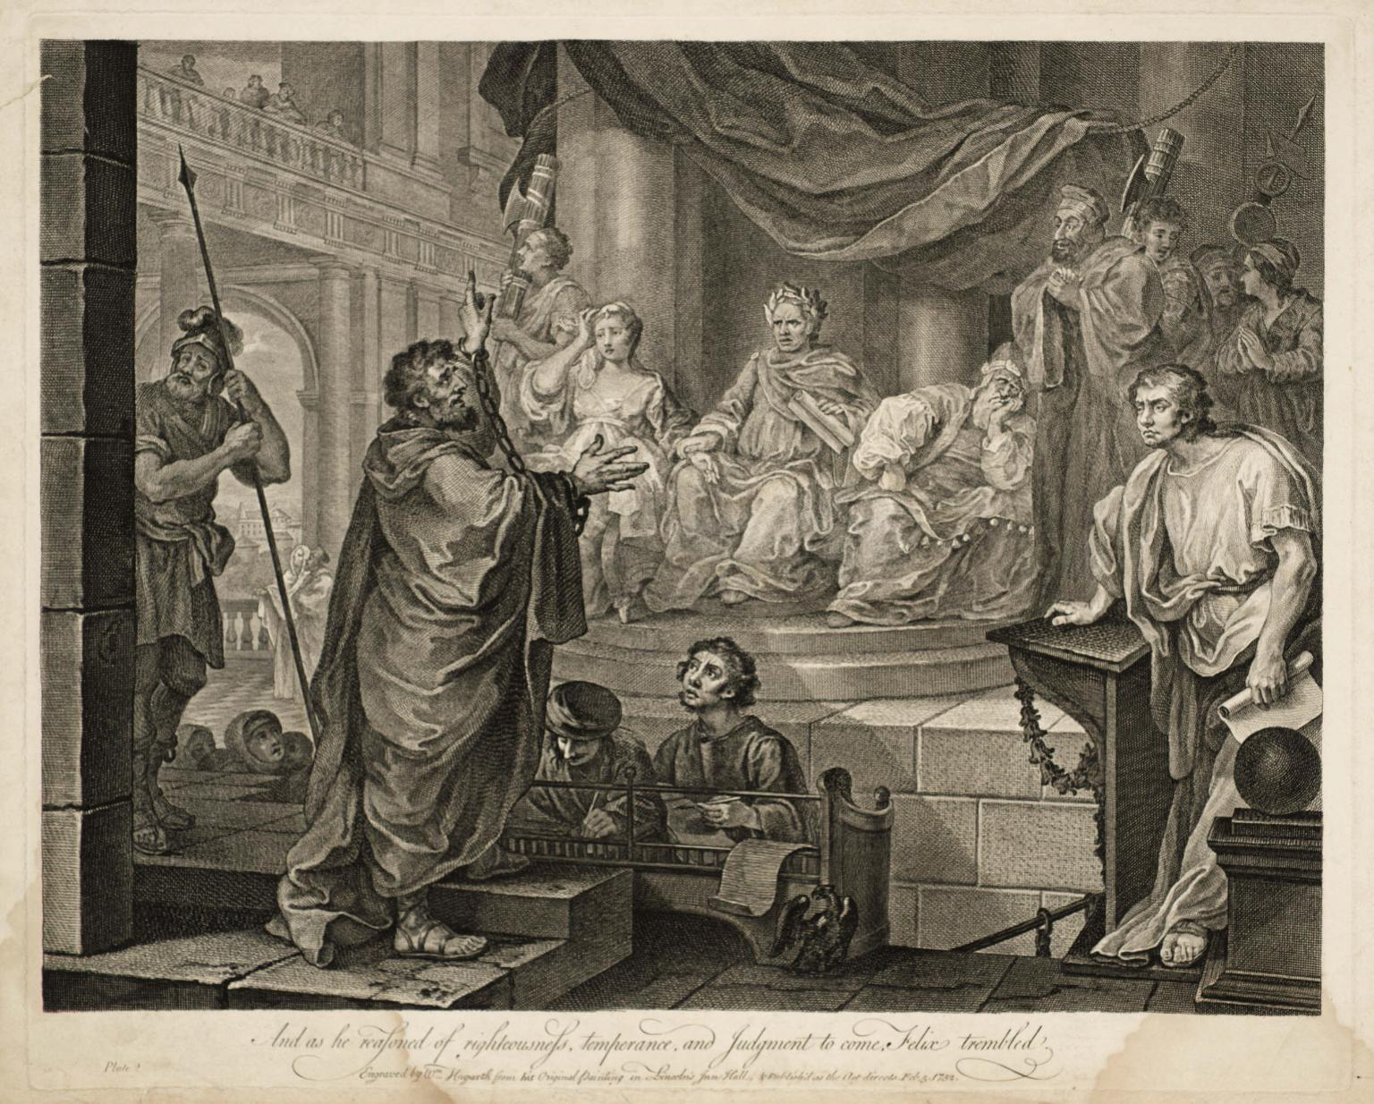
Acts 21:40b-24:27

Paul Speaks as He is being Arrested (21:40b-22:22)
- “I am a Jew” (v3)
- “Brought up in this city” (v3)
- “educated at the feet of Gamaliel” (v3)
- “I persecuted this Way to the death” (v4)
- Tells his conversion story (cf. Ch9)

- “I fell into a trance” (v17)
- “Go, for I will send you far away to the
“Paul Before Felix” etching by William Hogarth 1752
Gentiles.” (v21)

- “Away with such a fellow from the earth for he should not be allowed to live.” (v22)
  - What statement caused this reaction?

  - Why such a strong reaction?

Paul Before the Tribune and Council (22:23-23:11)
- “the tribune (Claudius Lysias [cf. 23:26])… said he should be examined by flogging to find out why they were shouting against him like this.” (v24)
- “Is it lawful for you to flog” an un-condemned Roman citizen? (v25)
- “The tribune answered, ‘I bought this citizenship for a large sum.’” (v28)
  - What does he mean by saying this?

- “I am a citizen by birth.” (v28)
- “the tribune (and centurions) were afraid” (v29)
  - Why?

- The tribune calls in a council.
  - Who all is here? (hint: 23:2, 6)

- After being struck, does Paul apologize or justify himself? (v23:1-5)
  - “I do not doubt that this is a taunting excuse [….] Paul purges himself of this crime; yet so, that he denies that Ananias is to be counted a priest of God, who has corrupted and perverted all the order of the Church.” –John Calvin

- How does Paul stir up the council? (v6-9)
- some Pharisee scribes stood and said “we find nothing wrong in this man.” (v9)
- “Take courage for as you have testified to the facts about me in Jerusalem, so you must testify also in Rome.” (v11)

An Unsuccessful Assassination Attempt (23:12-24:27)
- The Plot and its Undoing (23:12-22)
- “The Jews made a plot and bound themselves by an oath neither to eat nor drink till they had killed Paul.” (v12)
- Paul’s nephew goes to the tribune. “Do not be persuaded by them for more than forty of their men are lying in ambush for him.” (v21)

- The Escort to Caesarea (23:23-35)
- “Get two hundred soldiers with seventy horsemen and two hundred spearmen to go as far as Caesarea.” (v23)

- The Letter to Felix
  - “I found that he was being accused about questions of their law, but charged with nothing deserving death or imprisonment.” (v29)
- Felix: “I will give you a hearing when your accusers arrive.” (v35)

- The Defense in Caesarea (24:1-27)
- Tertullus (a ῥητορος rhetoros – rhetorician)
- Felix – a governor who was a slave, won his freedom, and was known for his violent self-advancement. “He exercised royal power with the mind of a slave.” – Tacitus

- Tertullus’s Address:
  - Flattery for 3 verses (v2-4)
  - accusations: (v5-8)
    - stirs up riots throughout the world (v5) (cf. Ch19 Riot in Ephesus)
    - ringleader of Nazarene sect (v5) (Jesus of Nazareth. cf. v14)
    - tried to profane the temple (v6)
    - Is there a verse 7?

- Paul’s Reply:
  - I’ve been in Jerusalem for only 12 days (v11)
  - I wasn’t found starting a riot (v12)
  - They have no proof of any of this (v13)
  - I haven’t even broken their law! (v14-16)
  - I was presenting offerings when some jews from Asia (started the riot) (v17-20)
  - The only thing that I did was proclaim the resurrection of the dead. (v21)
- Felix hears Paul speak for two years about Christ, but leaves him in prison. (v24-27)

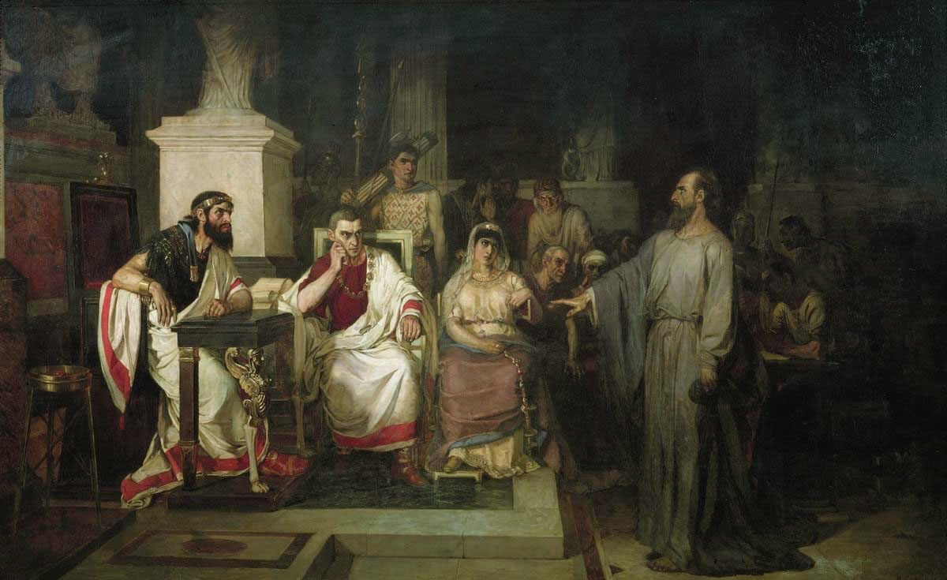
Acts 25:1-26:32

Paul Before Festus (25:1-12)
- Festus Goes to Jerusalem (v1)
- the chief priests plan to kill
Paul in Jerusalem (v3)
- “let the men of authority among
you go down with me… and bring
charges against him.” (v5)

“The Apostle Paul Explains The Tenets Of Faith In The Presence Of King Agrippa, His Sister Berenice, And The Proconsul Festus” by Vasily Surikoz 1875

- “the Jews also [brought] many
serious charges against him that they could not prove.” (v7)

- “Neither against the law of the Jews, nor against the temple, nor against Caesar have I committed any offense.” (8)
- “Festus, wishing to do the Jews a favor…” (v9)

- “I appeal to Caesar.” (v11)

Agrippa Comes to Town (25:13-22)
- The 4 Herods in the Bible:

- Herod the Great
  - Matthew 2
  - Tried to kill Jesus at birth
  - Went insane
  - Ordered death of all 2yr olds in Bethlehem
  - Ruled from 37-4BC

- Herod Antipas I
  - Ruled from 4BC-39 AD
  - Luke 9&23
  - Killed JtheB
  - Tried Jesus Illegally
  - Ruled during Jesus life and ministry

- Herod Agrippa I
  - Ruled from 41-44 AD
  - Acts 12
  - Killed the Apostle James
  - Imprisoned Peter
  - Killed By an Angel

- Herod Agrippa II
  - Ruled during Apostle Paul’s ministry
  - Married his sister Bernice
  - Acts 25-26
  - Tried the Apostle Paul
  - Sent the Apostle Paul to Caesar at Paul’s request

- “Festus laid Paul’s case before the king” (v14)
  - a man left by Felix (v14)
  - Jews are accusing him (v15)
  - They only have points about their own religion and a certain Jesus (v19)
  - He appealed to Caesar and I’m holding him til I can send him (v21)

Paul Before Agrippa (25:23-26:32)
- Festus’s Problem (25:23-27)
  - “I found that he had done nothing deserving of death.” (v25)
  - “I have brought him before you… that I may have something to write!” (v26)

- Paul’s Testimony (26:1-18)
  - “…because you are familiar with all the customs and controversies of the Jews.” (v3)
    - Agrippa may have been a practicing Jew (cf. 26:27) an appointed many high priests.

  - “they have known for a long time… that I have lived as a Pharisee.” (v5)
  - “And now I stand here on trial because of my hope in the promise made by God to our fathers”
    - What Promise? (cf. Gen 3:15; Job 19:25-27; Ps 16:9-11; Is 25:8; Ez 16; 37:1-14; Hos 6:2; Dan 12:2; Amos 9:11-15; Hab 2:4; Jonah 2:5-9; Acts 22:6; 24:21)

  - He again tells his conversion story (v9-18)
    - Compare this to his story before crowd in 22:3-21. What’s different this time?

- Paul’s Defense (26:19-23)
  - “… that they should repent and turn to God, practicing works worthy of repentance.”(v20)
    - Repentance literally means “change of mind.” What about this idea do you think made the Jews seize and try to kill Paul?

  - “That the Christ must suffer and that by being the first to rise from the dead, he would proclaim light both to our people and to the Gentiles.” (v23)

- The Final Deliberations (26:24-32)
  - “I am speaking true and rational words.” (25)
  - “King Agrippa, do you believe the prophets? I know that you believe.” (27)

  - “This man is doing nothing to deserve death or imprisonment…. This man could have been set free if he had not appealed to Caesar.” (v31-32)
    - Something to ponder: could this have happened any other way? Consider 19:21 and 23:11.

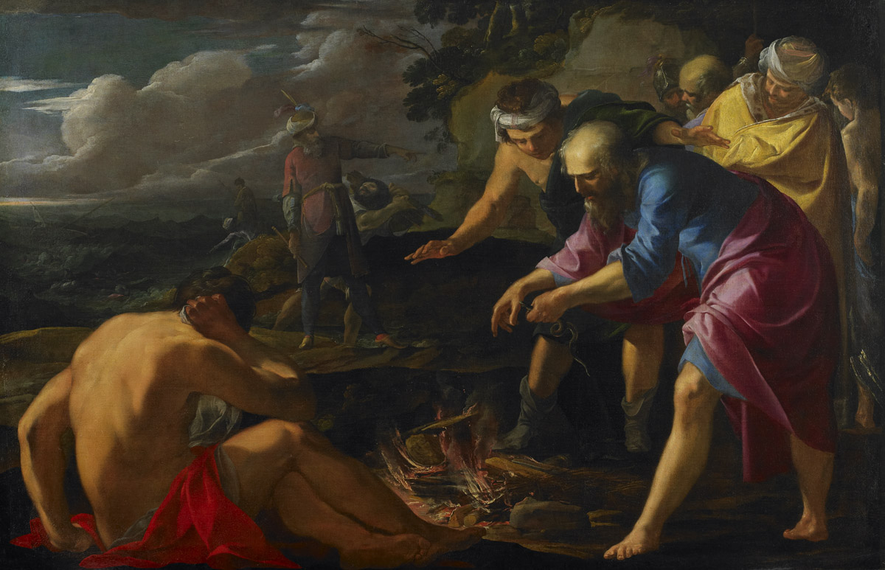
Acts 27:1-28:31

Departure for Rome (27:1-12)
- “They delivered Paul to… Julius” (v1)
  - centurion of Augustan Cohort

- “accompanied by Aristarchus” (v2)
  - cf. Acts 19:29; 20:4; Phm 24;
Col 4:10-11
  - according to tradition, martyred
“Saint Paul Shipwrecked on Malta” by Laurent de La Hyre, 1629
in Rome under Nero

- “we put in at Sidon and Julius treated Paul kindly…” (v3)
- difficult journey up the Asia minor coast (v4-8)

- “the voyage was now dangerous because even the Fast was already over” (v9)
  - “The Fast”=Yom Kippur = Day of Atonement= End of September
  - Sea traffic stops between October and February

- “Paul advised them… but the centurion paid more attention to the captain and ship owner.” (v10-11)

Stormy Seas (27:13-26)
- “but soon a tempestuous wind called the northeaster struck” (v14)
- “we gave way to it and were driven along” (v15)
- “we managed with difficulty to secure the ship’s boat” (v16)
  - a life boat was often dragged behind Mediterranean ships in the 1st century

- “They used supports to undergird the ship” (v17)
  - They ran ropes under the ship to keep it from breaking apart

- “All hope of our being saved was abandoned.” (20)

- “Paul stood up saying ‘…take heard for there will be no loss of life among you.’” (v21-22)
- “Do not be afraid, Paul; you must stand before Caesar.” (v24)

Paul Preserves Life (27:27-38)
- “Fearing that we might run on the rocks, they let down four anchors.” (v29)
- Some sailors try to escape, and Paul gets the soldiers to stop them. (v30-32)
- “I urge you to take some food… not a hair is to perish from the head of any of you.” (v34)
- “he took bread, and giving thanks to God in the presence of all, he broke it and began to eat.” (v35)
- “They lightened the ship, throwing out the wheat into the sea.” (v38)
Shipwreck (27:39-44)
- “they ran the vessel aground.” (v41)
- “the soldiers’ plan was to kill the prisoners, lest any should swim away and escape, but the centurion wishing to save Paul, kept them from carrying out their plan.” (v43)
- “all were brought safely to land.”(v44) (cf. v22)

Paul on Malta (28:1-10)
- “The natives showed us unusual kindness” (v2)
- “a viper came out because of the heat and fastened on his hand.” (v3)
- “No doubt this man is a murderer. Though he has escaped from the sea, Justice has not allowed him to live.” (v4)
- “He suffered no harm” (v5)
- Paul heals many on the island and they supply their needs for the voyage in gratitude. (v6-10)

Paul in Rome 28:11-31)
- “We set sail… in a ship with twin gods as figureheads”(v11)
  - Castor and Pollux, said to give good fortune to mariners in Greek mythology
  - Why might Luke include this?

- They stop at Syracuse and Rhegium before coming to Rome. (v12-14)

- “Paul was allowed to stay by himself, with the soldier guarding him.” (v16)
  - Possibly Julius?

- “After three days he called together the local leaders of the Jews.” (v17)
- Paul explains how he got to Rome (v18-20)

- “For this reason, I have asked to see you and speak with you since it is because of the hope of Israel that I am wearing this chain.” (v20)

- “But we desire to hear from you what your views are, for with regard to this sect we know that everywhere it is spoken against.” (v22)
- “he expounded to them testifying:
  - to the kingdom of God and
  - trying to convince them about Jesus
  - both from the Law of Moses and the prophets.” (v23)

- “The Holy Spirit was right in saying…” (v25)
  - Isaiah 6

- “Therefore let it be known that this salvation of God has been sent to the Gentiles.” (v28)

- “preaching the kingdom of God and teaching about the Lord Jesus Christ with all boldness and unhindered.” (v31)



