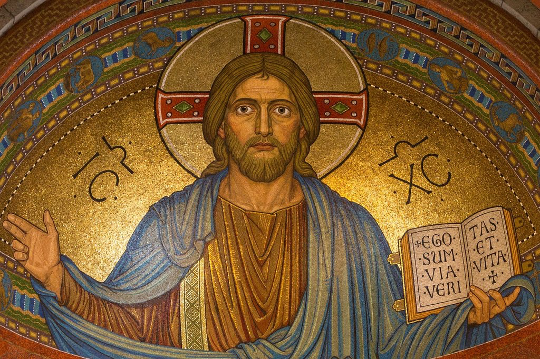
Christology – Handout
“Words about the Anointed One”

INCARNATION
Definition
- in – in ; carno – flesh
- the taking on of flesh
- God’s incarnation occurred in Bethlehem in about 5 BC

Passages
- Isaiah 9:6 – A child called God

- Isaiah 7:14 – Virgin birth prophesied

- Matt 1; Luke 3 – Genealogies

“Guilt can be extinguished only by a penal offering to justice. But it would contradict the idea of justice, if for the sin of a rational being like man; the death of an irrational animal should be accepted as a sufficient atonement. Hence, a man must be offered as the sacrifice for man; so that a rational victim may be slain for a rational criminal. But how could a man, himself stained with sin, be an offering for sin? “Hence a sinless man must be offered. But what man descending in the ordinary course would be free from sin? Hence, the Son of God must be born of a virgin, and become man for us. He assumed our nature without our corruption. He made himself a sacrifice for us, and set forth for sinners his own body, a victim without sin, and able both to die by virtue of his humanity, and to cleanse the guilty, upon grounds of justice. “ Gregory the Great, Moralia

ROLES/TITLES
- Son of God (Mk 15:39) [Priest]

- Son of Man (Dan 7:13; Mk 14:62) [Prophet]

- Son of David (Lk 18:38) [King]

- Christ (Messiah) (Matt 16:16)

- The Seed (Gen 3:15; Gal 3:16)
HYPOSTATIC UNION

Definition
- ὑπο hypo – “under”; στασις stasis – “standing”
- Christ (the son) is one person in the triune Godhead.
- Christ has two complete natures, divine and human.
- These two natures fully exist in harmony within the person of Christ.

Deity
- Matt 28:18 – All authority
- Mark 5:11-15 – power over demons
- John 1:1 – The word was God
- John 10:30 – I and the Father are one
- John 11:38-44 – Raises others from the dead

Humanity
- Luke 2:52 – body
- John 19:28 – thirst
- Matt 4:2 – hunger
- Heb 2:16-17 – like his brethren in every way
- Luke 23:46 – death

History
- Arianism
  - Jesus was not fully God.
  - Condemned at Nicaea (325) and Constantinople (381)

- Apollinarianism
  - Jesus was not fully man.
  - Condemned at Constantinople (381)

- Nestorianism
  - Denied the unity of person.
  - Condemned at Ephesus (431)

- Eutychianism
  - Denied the distinction of natures.
  - Condemned at Chalcedon (451)
Definition of Chalcedon:
“Therefore, following the holy fathers, we all with one accord teach men to acknowledge one and the same Son, our Lord Jesus Christ, at once complete in Godhead and complete in manhood, truly God and truly man, consisting also of a reasonable soul and body; of one substance with the Father as regards his Godhead, and at the same time of one substance with us as regards his manhood; like us in all respects, apart from sin; as regards his Godhead, begotten of the Father before the ages, but yet as regards his manhood begotten, for us men and for our salvation, of Mary the Virgin, the God-bearer; one and the same Christ, Son, Lord, Only-begotten, recognized in two natures, without confusion, without change, without division, without separation; the distinction of natures being in no way annulled by the union, but rather the characteristics of each nature being preserved and coming together to form one person and subsistence, not as parted or separated into two persons, but one and the same Son and Only-begotten God the Word, Lord Jesus Christ; even as the prophets from earliest times spoke of him, and our Lord Jesus Christ himself taught us, and the creed of the fathers has handed down to us.”

KENOSIS
Definition and Question
- Kenosis from κενοω kenao – “I empty”
- What is meant by Christ’s “self-emptying”?

Philippians 2:5-8
“Think this way in yourselves which was also in Christ Jesus, who, being in the form of God, did not consider clinging to be equal to God, but emptied Himself, receiving the form of a slave, and being made in the image of men. Being found in shape as a man, He lowered Himself by becoming obedient to the point of death, even death on a cross.” SET (Stephen’s English Translation)

- Genre: Poetry (Hymn?)
  - couplets
  - word-choice

- You cannot cling to, empty yourself, or lower yourself from something you did not already hold onto, were full of or on the level of.

- What is the point/instruction Paul is making/giving?
  - “Think this way in yourselves…”
  - i.e. consider obedience, self-surrender of your greatest qualities in order to obey God, a good thing.

RESURRECTION
Definition and Importance
- ἀναστασις anastasis “standing again”
- Returning permanently from the dead
- 1 Corinthians 15(:13-26)
  - First-fruits
  - Most to be pitied
  - in Adam vs in Christ
Complete list of Roles and Titles

- Son of God (Mk 15:39)
- Son of Man (Dan 7:13; Mk 14:62)
- Son of David (Lk 18:38)
- Christ (Messiah) (Matt 16:16)
- Lamb of God (Jn 1:29)
- the Word (Jn 1:1)
- Lord (Ac 2:25)
- Prophet (Deut 18:18)
- Priest (Heb 4:14)
- Light of the World (Jn 8:12)
- the Gate (Jn 10:7-10)
- the Good Shepherd (Jn:10:11-14)
- Alpha and Omega (Rev 22:13)
- the last Adam (1 Cor 15:45)
- the Morning Star (Rev 22:16)
- the way, the truth, and the life (Jn 14:6)
- the true vine (Jn 15:1-5)
- the Lion of Judah (Rev 5:5)
- King (Mt 2:1-2)
- the Seed (Gen 3:15; Gal 3:16)
- Immanuel (Matt 1:23)
- the head of the Church (Eph 1:22-23)
- the Mediator (1 Tim 2:25)
- Savior
- The exact image of God (Heb 1:3)
- the bread of life (Jn 6:35)

Stephen’s Incomplete List of Passages that show Jesus is God

Matthew 1:21-23 “she will bear a son… this took place to fulfill what the Lord had spoken by the prophet… his name is called Immanuel, which means God with us.”12:8 “The son of Man is Lord of the Sabbath.” (Who created the Sabbath? and why? Ex 20:8-11; Lev 23:3) Jesus’s argument for the trinity comes most clearly in the great commission Matt 28“baptizing in the name of the father, and the son, and the Holy Spirit.”
Mark 1:1-3 “…I send my messenger… prepare the way of the Lord” – John was preparing for the Lord, and Lord here is clearly a reference to God (It’s YHWH in Is 40). Who was John preparing for? Jesus.
Luke 20:41-44 The Christ is David’s Lord.
John - The entire book, and argument, of John.
(chapter 1 – The word was with God and the word was God; 5:18ff – “This is why the Jews were seeking all the more to kill him, because not only was he breaking the Sabbath, but he was even calling God his own Father, making himself equal with God”; 8:19ff “If you knew me, you would know my father also.” 8:58 - “before Abraham was, I AM” he uses the covenant name of God for himself; 10:30 – “I and the father are one.”; 20:31 “These are written that you may believe Jesus is the Christ, the Son of God…” Any claim that Jesus is the Son of God, or that God was Jesus’s father, is secondary support for Jesus’s deity. (As Stephen Colbert would say, “What’s the son of a duck? It’s a duck.”))
Acts 9 :5, again, Jesus uses God’s covenant name for himself (ego eimi) “I am, Jesus, whom you are persecuting.” If he just wanted to say “I’m Jesus, he could have just said eimi. He makes a clear reference to the covenant name of God, I AM.
1 Cor 15:47 – “the first man was from the earth, a man of dust, the second man is from heaven”
2 Cor 4:4 – “… of Christ, who is the image of God.”
Gal 1:12ff - “for I did not receive it from any man… but I received it through a Jesus Christ’s revelation…. I persecuted the church of God violently.” (He must be talking about Jesus’s church here… but calls it the church of God. He also says Jesus is not “any man”. What is he?)
Philippians 2:6 “Jesus, who though he was in the form of God, did not count equality with God a thing to be clung to, but emptied himself by taking the form of a servant, being born in the likeness of men.”
Col 1:15 “He is the image of the invisible God, the firstborn of all creation.”
Rev 5 – Jesus is worshipped because he’s able to open the scroll.

