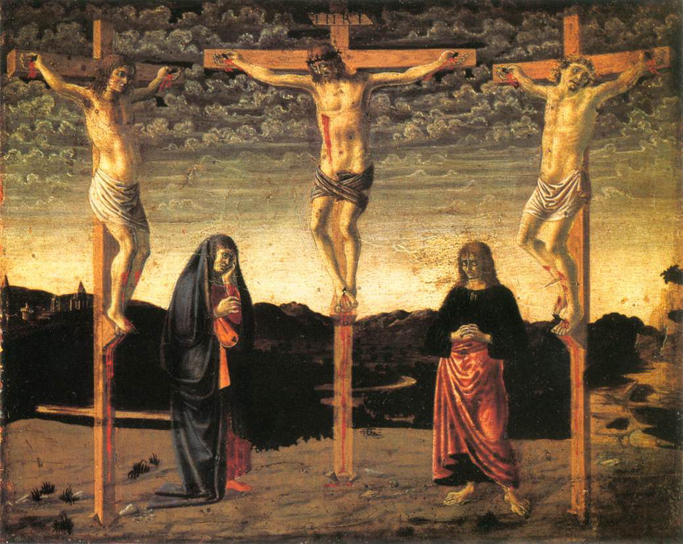
Galatians Introduction and 1:1-12

Author: Paul (virtually uncontested)

Date: Northern View or Southern View?

- Southern View: Written to the southern
region known as Galatia after Paul’s First
Missionary Journey, just before the
Jerusalem Council in Approx 48AD

- Norther View: written to the northern region known as Galatia after Paul’s Second Missionary Journey in approx. 53AD

Purpose: To Rebuke Christians who had been tricked by Judaizers into thinking they must follow the Mosaic Law in order to be saved.

Message: We are saved from the penalty of sin by grace alone through faith alone and not by works. THIS IS THE GOSPEL.

Key Verse: 2:16b “…we have believed in Christ Jesus, so that we may be justified by faith in Christ and not by the works of the Law; since by the works of the Law no flesh will be justified.”

Background: Acts 10-15
- Acts 10: First Gentiles are saved (Cornelius and Peter’s Visions)
- Acts 11: Peter Defends his Actions against the circumcision party

- Acts 12: Peter’s Arrest, Miraculous Release, and Herod’s Death
- Acts 13: First Missionary Journey, Paul Preaching at Antioch, Paul Turns to Gentiles

- Acts 14: Paul Heals a Cripple, Mistaken for a Pagan God
- Acts 15: The Jerusalem Council

Outline Of Riggins Galatians Meetings
- Intro and 1:1-12 (May 7)
- 1:13-2:10 (May 14)
- 2:11-2:21 AND VBS Prep (May 21)
- 3:1-29 (June 4)
- 4:1-5:1 (June 11)
- VBS Prep (June 18)
- 5:2-14 (June 25)
- 5:15-26 (July 2)
- 6:1-18 (July 9)
- VBS Final Touches (July 16)

Galatians 1:1-12

Greeting (v 1-5)
- “Paul, an apostle – not from men nor through man, but through Jesus Christ and God the father who raised him from the dead – …” (v1)
  - Unique opening for a unique letter
  - This aside is the summary of his argument: this gospel is from God! (cf. v10-12)

- “…who gave himself for our sins to deliver us from the present evil age...” (v4)
  - What is this a summary of?
    - (cf. 1 Cor 15:1-14)

  - what is “the present evil age”?

- “…according to the will of our God and Father…” (v4)
  - Who’s will was it that Christ would die?

  - Does it seem contrary that God would “will” such evil?

- “… to whom be the glory forever and ever.”
  - Dispensationalism rears its ugly head.

The purpose for Writing: the Gospel (v6-9)
- “I’m astonished that you are so quickly deserting him who called… and are turning to a different gospel” (v6)
  - “so quickly” support for Southern view

  - What different gospel are they turning to?

  - How do you know?

- “…in the grace of Christ...” (v6)
  - Paul is setting up his rant for later. How are we ACTUALLY saved?

- “not that there is another gospel…” (v7)
  - Truth doesn’t change by popular opinion.

- “Even if we or an angel from heaven should preach to you a gospel contrary… let him be accursed” (v8, x2 v9)
  - “accursed” anathema : i.e. condemned to hell.
  - What question should immediately be of importance to the reader?

  - What is the answer to that question?

The Source of “Paul’s” Gospel (v10-12)
- “For now do I persuade men or God? Or do I desire to please men? If I still desire men, I would not be a slave of Christ.”
  - What specifically is he saying?
    - I have no idea.
  - What’s his point?
    - see verses 11-12

- “The gospel that was preached by me is not according to man... I received it through a revelation of Jesus Christ.” (v11-12)

- This statement serves 2 purposes:
  - Sums up the point of the preceding section: This is a unique gospel.
  - Transitions to his supporting argument: Paul’s testimony.


