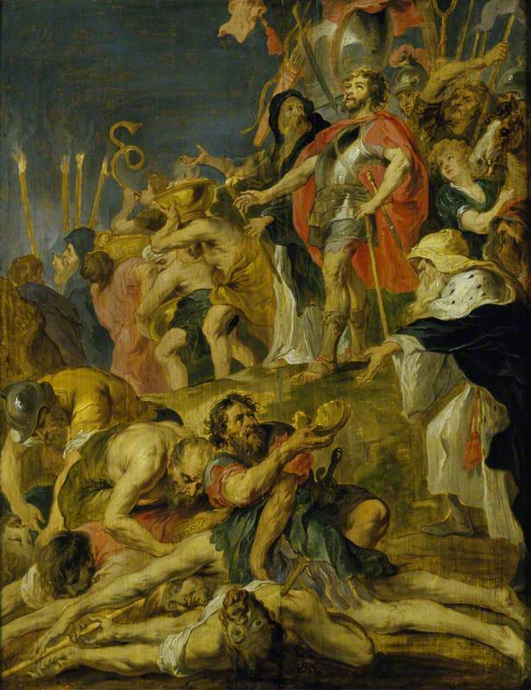
The Intertestamental Period:
A Survey

The Intertestamental Period
- Definition: The historical period between the
end of the Old Testament and the beginning
of the New Testament.
- Most of it prophesied by Daniel in
chapters 2, 7, 8, and 11
- Time covered: 400’s-5 BC

Extra-Biblical Sources for Intertestamental Period
- 1 & 2 Maccabees (in apocrypha)
- Josephus Antiquities and Wars of the Jews
“The Triumph of Judas Maccabeus” by Peter Paul Rubens 1635
- The major Persian and Roman historians

The Biblical Texts

Daniel 2: (~600-580’s BC)
- Nebuchadnezzar’s dream of a statue
- Head of Gold (Babylon), Chest of Silver (Persia), Belly of Bronze (Greece), Legs Iron (Rome) Feet Mixed Iron and Clay (Revived Roman Empire), Rock (Christ’s Kingdom)

Daniel 7: (~550 BC)
- Daniel’s dream of four beasts
- Lion with wings (Babylon), Lopsided Bear (Persia), Four-headed-four-winged Leopard (Greece), Beast with 10 horns (Rome)

Daniel 8: (~546 BC)
- Daniel’s dream of the goat and ram
- Ram with uneven horns (Persia), Goat with one horn (Greece under AtG), four horns replace one horn (Divided Greece)

Daniel 11: (~552 BC or 424 BC)
- Gabriel’s explanation of intertestamental history
- Mighty king who rules with great dominion rises (AtG) and his kingdom is broken toward the four winds (AtG’s Generals, Divided Greece, tetrarchs) alliances and wars (Ptolemies and Seleucids fighting) and one profanes the temple and sets up an abomination that makes desolate (Antiochus IV)

BROAD OVERVIEW OF MAJOR EVENTS

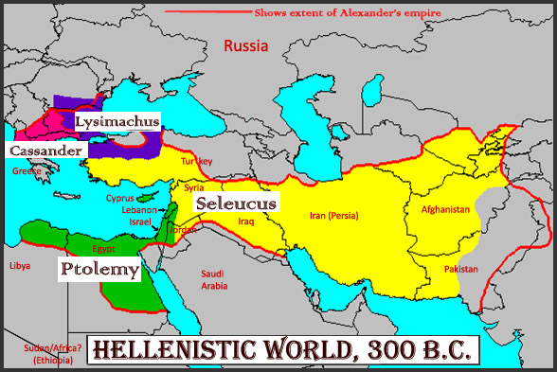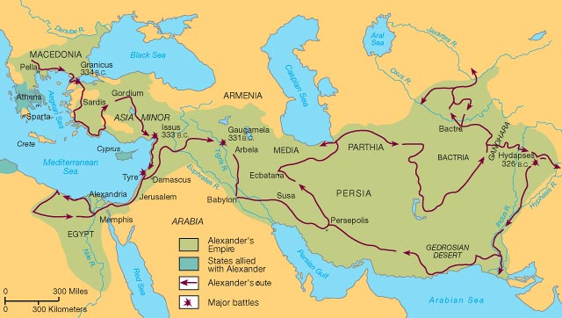

.:NOTE TAKING GUDE:.
PERSIAN ERA: (560BC-330BC)
Persian Kings-
Cyrus the Great – 559-530BC
…

Darius I – 522-486BC

Xerxes (Ahasuerus) – 486-465BC

Artaxerxes – 464-424BC
…

Darius III – 336-330BC

GREEK ERA: (330BC-130’sBC)
Alexander the Great-

Divided Kingdom of AtG-
Cassander
Lysimachus
Ptolemy

Seleucus

…
Pharisees, Sadducees, Essenes begin developing…
…

Antiochus IV Epiphanes-

(HASMONEAN/MACCABEAN ERA): (166-63BC)
Mattathias Maccabeus-

Judas Maccabeus-

Jonathan Maccabeus-
Simon Maccabeus-
John Hyrcanus-
…

Hillel vs Shammai (110BC-70AD)

ROMAN ERA: (146BC-330AD)
Pompey-

Antipater-

Herod-

Octavian (Augustus)-

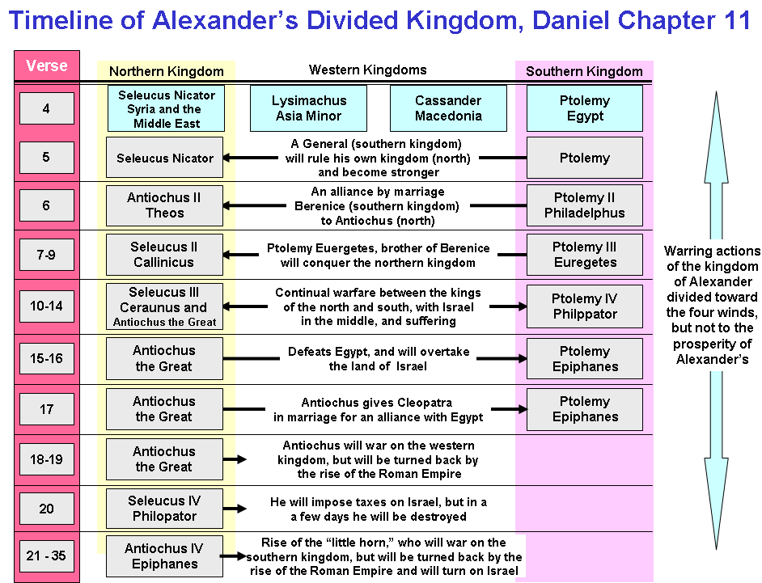

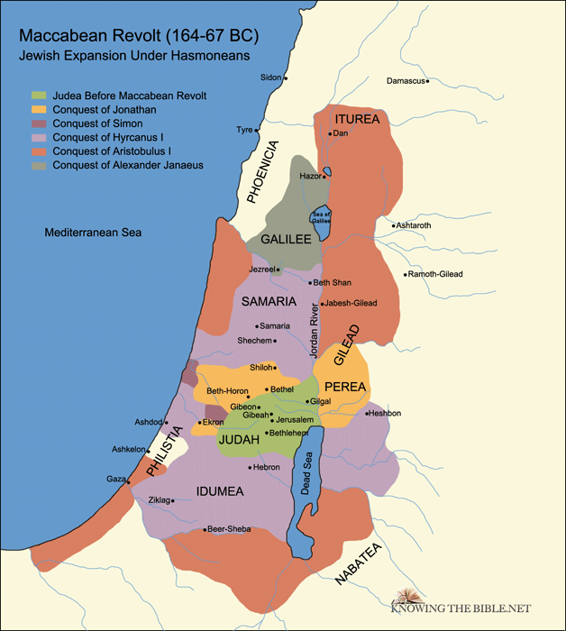

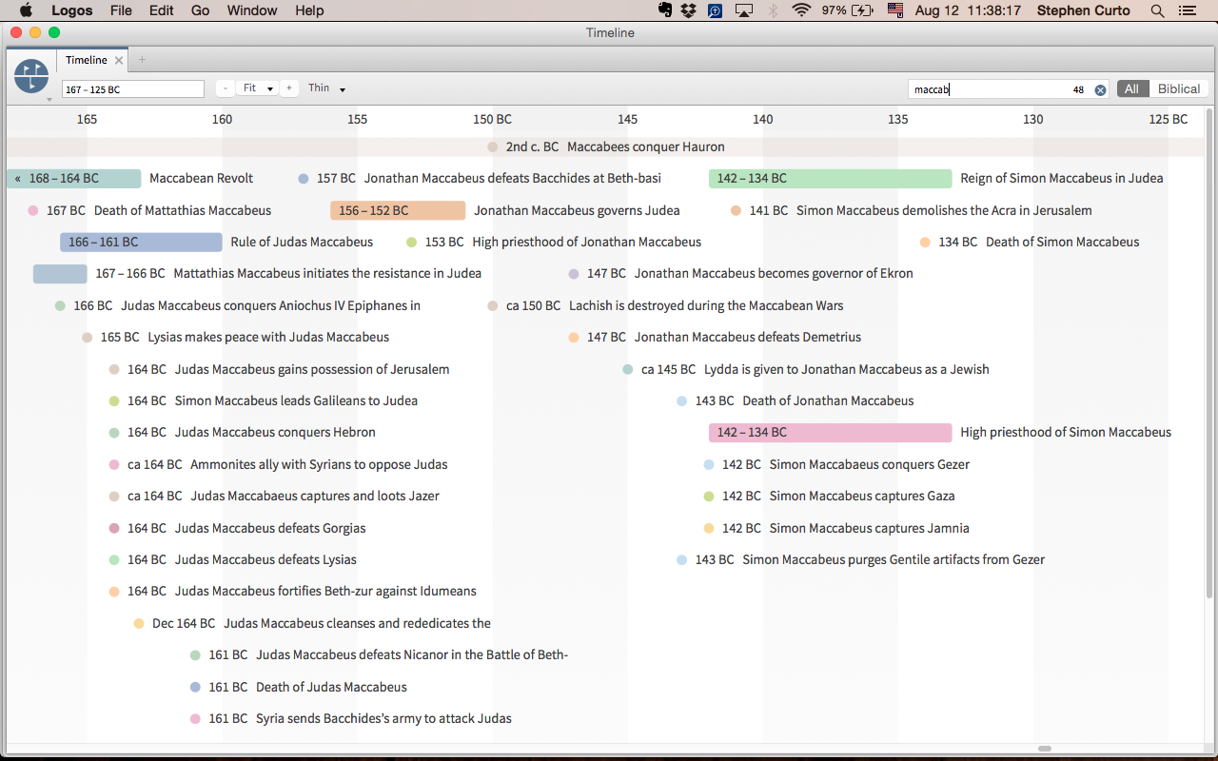
TIMELINE OF MACCABEAN REVOLT

