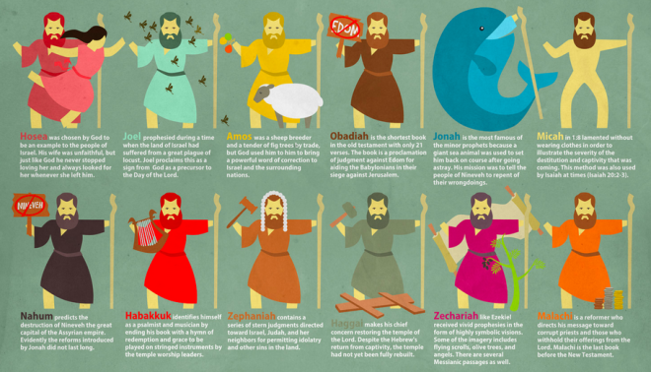
Minor Prophets: Introduction

Why study the Prophets?
- Make up approx. 29% of the
OT and 22% of the bible.
(the whole NT is 23% of the bible)
- Teach us about God and how He
interacts with Israel

- Often timeless messages:
  - Hosea’s appeal for purity and God’s indestructible love
  - Amos’ call for justice in his society
  - Obadiah’s condemnation of pride
  - Micah’ rebuke of ungodly leadership
  - Habakkuk’s quest for divine retribution and reconciling God’s sovereignty
  - Haggai’s discourse on misplaced priorities
  - Malachi’s censure of religious orthodoxy

- Tell us much about the Messiah

- Teach us more about the future than the NT. (If you don’t know a little eschatology you won’t get the prophets)

- They serve as our examples. (Hebrews 11:32-38)

- Stress the judgment and mercy of God who always does what he says he will.

Why we neglect the prophets:
- Difficult to understand
- Some think they are “Out of date” and “irrelevant"

- Requires effort and skill to exegete them
- Some believe they are already fulfilled or will never be fulfilled so why bother with them?

- Modern church doesn’t like the message of the prophets: A sovereign God whose righteous judgment and holy discipline is presented.

History:
- Genesis
  - Abraham, Isaac, Jacob - > Egypt

- Exodus
  - Moses and the Law

- Joshua
  - Conquering the land

- Judges
  - “Everyone did what was right in their own eyes.”

- Samuel
  - the last judge, the first prophet since Moses (Joshua?)

- Saul

- David

- Solomon

- Divided Kingdom
- Rehoboam (Judah/South) and Jeroboam (Israel/North) Conflict
- All the kings of Israel and Judah



