Moses Through David

Review:
- Seed Promised (Gen 3:15)
- Noah
- Babel
- Abraham

  - Abrahamic Covenant (Gen 12, 13, 15) UNCONDITIONAL
    - Land – “To your offspring I will give this land” (12:7) “From the Nile to the Euphrates” (15:18-20)
    - Seed – “Make you a great nation” (12:2) numerous as “dust” (13:16) and “stars” (15:5)
    - Blessing – “Bless those who bless you… in you, all the families of the earth shall be blessed.” (12:3)

- Isaac
  - Abrahamic Covenant reiterated to Isaac (26:3-5)
- Jacob
  - Abrahamic Covenant reiterated to Jacob (28:13-15)

Moses
- Burning bush (Ex 3:6, 13-15))(ref Gen 32:22-32) The Name of God!
- Return to Egypt and the ten Plagues (Ex 4-12)
  - The 10 Plagues
    - *SEE SUPPLEMENT CHART #1

  - The Passover (Ex 12)
    - Take a lamb and keep it four days
    - Congregation kills their lambs together at twilight
    - Blood on doorpost
    - Roast and eat lamb, quickly
    - The Lord will see the blood and pass over you.

- The Exodus (Ex 12-15) *SEE SUPPLEMENT CHART #2
Giving the Law and the Law (Ex 19-31, Leviticus)
- 10 Commandments (Ex 20)
- 613 Commandments (Exodus-Deuteronomy)
- Theme/point of the law? Lev 19:2 “Be ye holy for I the Lord your God am Holy.”

Mosaic Covenant (Ex 19-Deut 34) CONDITIONAL
- Exodus 19:5-6
  - “IF you will… keep my covenant…”
  - “A kingdom of priests and a holy nation”
- Exodus 24:7-18
  - “All that YHWH has spoken we will do, and we will be obedient”
- Compare Galatians and Hebrews…

Rebellion at Kadesh Barnea (Num 13-14)
- 12 spies go in
- 2 spies come out optimistic (Caleb and Joshua)
- The people rebel
- “How long will this people despise me?” (Num 14:11)
- Moses intercedes (Num 14:13-19)
- God’s Judgment (Num 14:20-45)
  - 14:28-35

40 Years Wandering (Num 15-36)
- Korah’s Rebellion (Num 16)
- Aaron’s staff buds (Num 17)
- Moses Strikes Rock (Num 20)
- Bronze Serpent (Num 21)
- Balaam’s oracles (22-24)

Deuteronomy (Second Law)
- Recounts History
- Recounts laws
- Predicts future
  - Deut 17:14-20 (“When you have a king…” ????)
  - Deut 28 (Blessings AND Curses)

  - Deut 30:2-6 (land and circumcision)

  - Deut 32 (The whole story)

Major Shifts in the Story
- From single characters to nation
- From Abrahamic Covenant to Mosaic Covenant
- From broad rule to specific law
- Why?

Conquest of Joshua
- Joshua begins conquering land (starting with Jericho) (1-6)
  - Rahab and the spies (2)
  - *SEE SUPPLEMENT CHART #4
- Josh 8:30-35 (Covenant renewal)
- Josh 13 (Lands not conquered)
  - “You are old and there remains very much land to possess.)
- Josh 24:14-28 (Covenant renewal)

Period of Judges
- Judges 2:11 (It takes 2 chapters for them to forget their promises)
- Theme of Judges: 21:25 “In those days there was no king in Israel. Everyone did what was right in his own eyes.”
- The cycle of the judges
- The Judges *SEE SUPPLEMENT CHART #3

Ruth
- during the period of the judges
- a Moabite
- grafted into Israel
- mother of Obed, father of Jesse, Father of David…

Samuel
- during the period of the judges
- Hannah prays for son (1 Sam 2)
- The Lord Calls Samuel (1 Sam 3)
- Samuel Judges Israel (1 Sam 7)

- Israel Demands a king (1 Sam 8)
  - Refer to Deut 17:14-20
  - 8:4-9 (Israel rejects God)
  - 8:19-22 “That we may be like all the other nations” (Refer to theme of the law)

Saul, the First King
- Chosen and anointed by Samuel (1 Sam 9-10)
- Saul as a successful leader (1 Sam 11-13)
- Saul as an unsuccessful leader (1 Sam 13-31)
- 1 Sam 13:14 “the Lord has sought out a man after his own heart…”

Major Shifts in the Story? Discuss.

SUPPLEMENT CHART #1

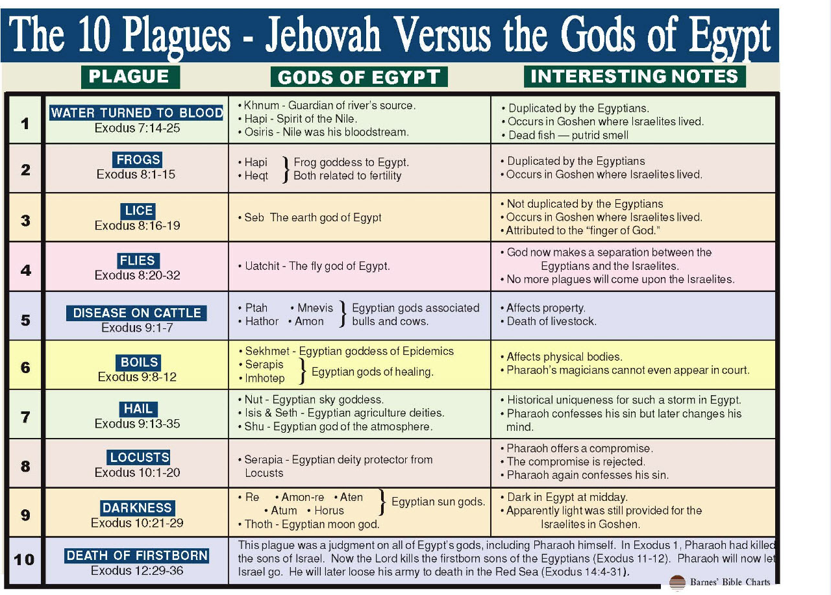

SUPPLEMENT CHART #2
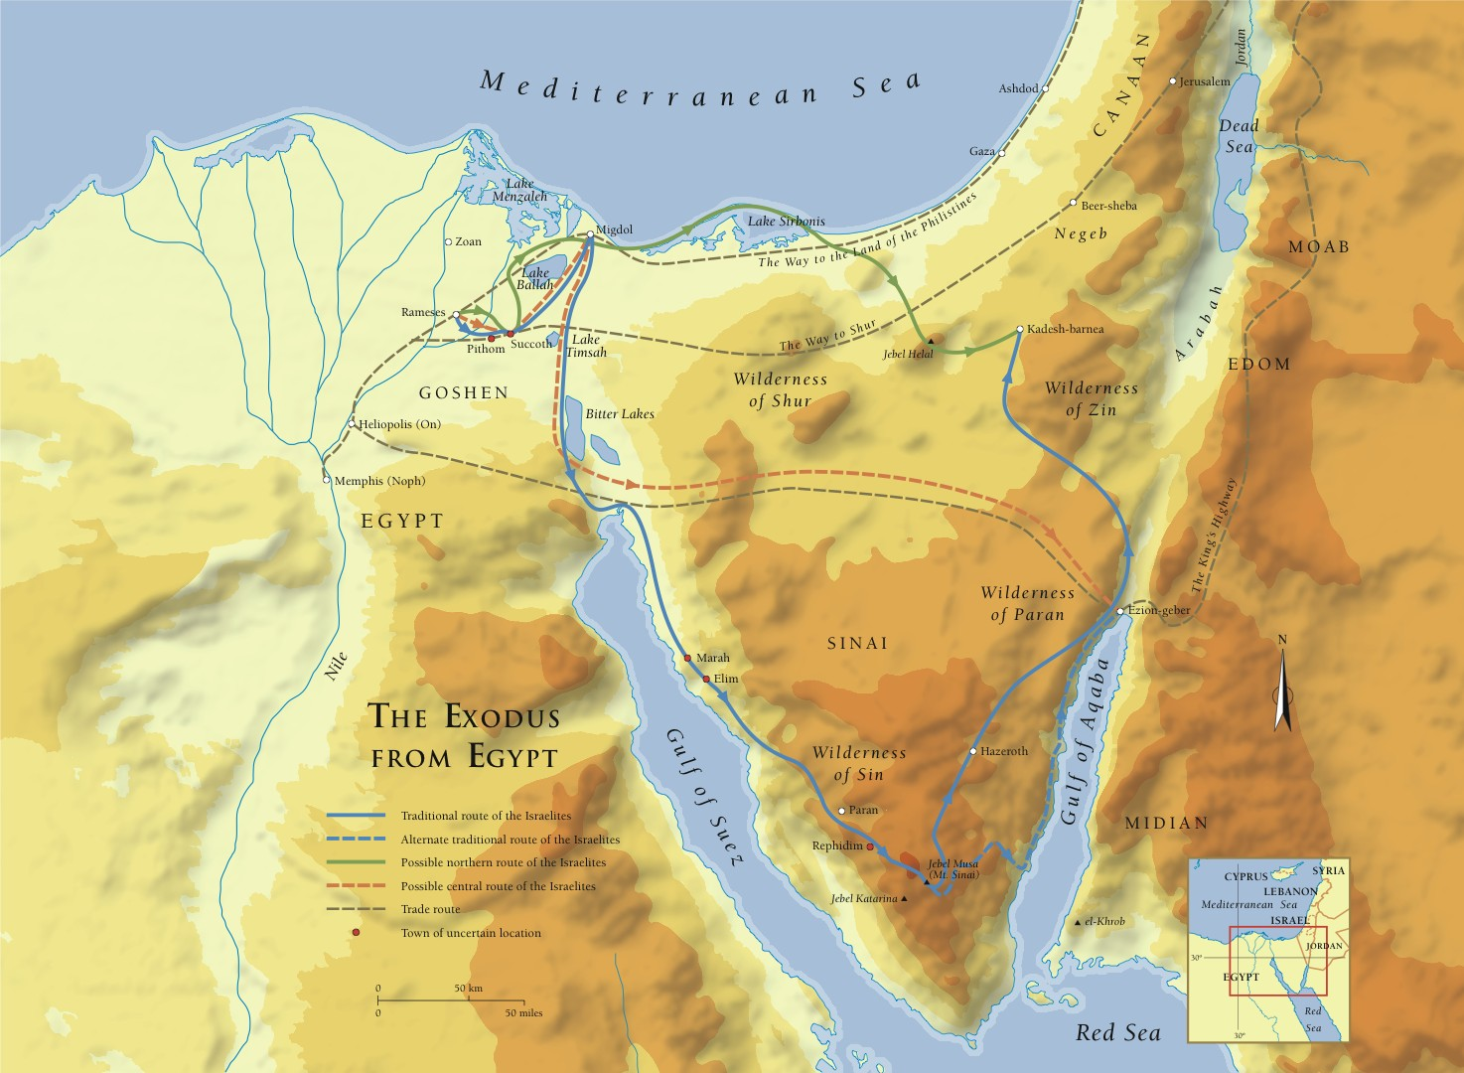

SUPPLEMET CHART #3
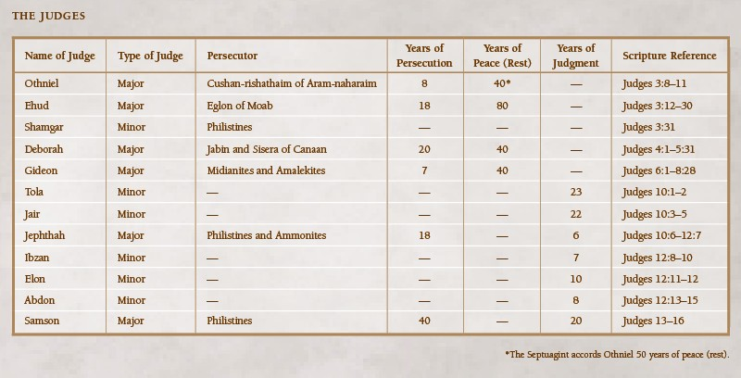

SUPPLEMENT CHART #4
