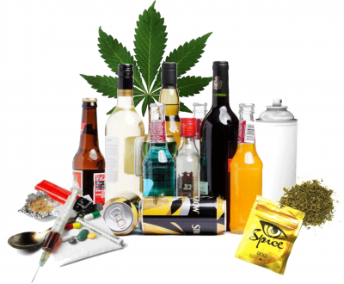
The Biblical View of Drugs and Alcohol

DRUGS
Definition: Any substance used to alter state of mind,
perception of reality, or physical performance when
ingested or otherwise introduced to the body.

By this definition, any of the following are “drugs”:

heroine
cocaine
vicodin
coffee
alcohol
excedrin
tobacco

marijuana
steroids
aloe vera cream

Relevant Biblical Passages:

- 1 Peter 4:1-3; 5:8

- Titus 2:1-8

- 2 Timothy 4:3-5

- Gal 5:22-23

- 1 Tim 5:23

- Matt 9:12

- Luke 10:34

- Colossians 4:14

- Rom 13:1ff

Systematic Theology:
Medicinal Drug Use-
- God controls the effectiveness of healing in all situations.
- Medicinal use of drugs (from Asprin, to coffee, to chemotherapy) is permissible as long as God’s sovereignty in healing is recognized.

Recreational Drug Use-
- The Christian pursues self-control and sober-mindedness
- Recreational drug use not prohibited by law is acceptable in moderation, but must not be used to the point of a loss of self-control or sober-mindedness.
Marijuana Use:
- Marijuana is currently illegal in all forms in the state of Texas, therefore it is wrong for Christians to use it in this state.
- If legalized, Christians should ask themselves these questions about using Marijuana:
  - Does this activity…
    - … weaken my reason.
    - … Impair the tenderness of my conscience.
    - … Obscure my sight of God.
    - … Diminish my thirst for spiritual things.
    - … Increase the authority of my body over my mind.
ALCOHOL
Relevant Biblical Passages:
Stories (Descriptive texts):

- Noah (Gen 9)
- Lot and his daughters (Gen 19)
- Jacob marries Leah (Gen 29)
- Samson’s mother (Judges 13)
- Absolom kills Amnon (2 Sam 13)
- Ahasuaras banashes Vashti (Esther 1)
- Belshazzar loses Babylonian Empire (Daniel 5)
- The wedding at Cana (John 2)
- Jesus came “eating and drinking” Matt 11:19
- Passover/Final supper (Matt 26, and parallels)

Instructions (Prescriptive Texts):

- Proverbs 23:20-21

- Leviticus 10:9 (and Numbers 6)

- Proverbs 9:1-6, 16-18

- 1 Tim 5:23

- 1 Tim 3:1-3 (and Titus 2)

- Paul’s Lists (1 Cor 6:9-11; Gal 5:19-21; Rom 13)

Systematic Theology:
- Because Jesus came “eating and drinking,” and Jesus is God in flesh, and God can’t sin, merely ingesting alcohol cannot be innately sinful.
- Because of the myriad warnings and direct classifications, drunkenness is expressly sinful.

Stephen’s Four Rules for Drinking Biblically:

- You can drink, but don’t get drunk.
- Don’t drink if you can’t stop drinking.
- Don’t drink if your friends can’t stop drinking.
- Don’t drink for the wrong reasons.

