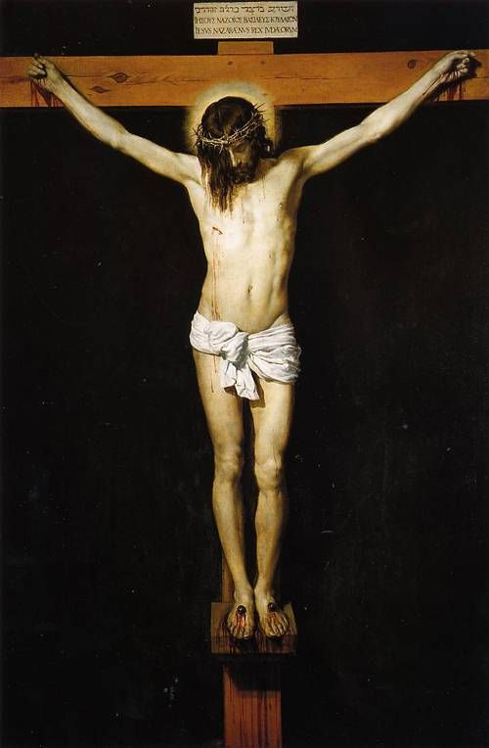
The New Testament:
A Survey

Overview:
- Historical Books
  - The Four Gospels and Acts
- Pauline Epistles
  - Romans - Philemon
- General Epistles
  - Hebrews-Jude
- Prophetic Book
  - Revelation

Historical Books

The Gospels: (gospel= “good news”)
- Forget not…
  - Their Context
    - Their Jewishness
    - Their Time (1st Century)
    - Their genre (history)
  - Their Point
“Christ Crucified” by Diego Velazquez 1632
    - To record their first coming
    - Not to tell the whole story

- Major Themes
  - The Kingdom of God
  - The rejection of the Messiah
  - The striking of the heel (Gen 3:15) (the Crucifixion)

- Matthew: The gospel of the kingdom and the king.
  - Records more teachings about the kingdom of heaven than any other
  - Likely written to a Jewish audience
  - Key emphasis on showing the proofs from the OT of Jesus’s claim to be Messiah

- Mark: The gospel of action.
  - Punchy writing style (euthus immediately)
  - The shortest
  - Records Jesus’s actions without much interpretation of the meaning

- Luke: The gospel of order.
  - Likely written to a largely Hellenistic audience
  - High-level Greek vocabulary
  - Was written “to present an orderly account”
- John: The gospel of love.
  - The most unique material/stories.
  - Written to get you to “believe that Jesus is the Christ, the Son of God, and that by believing you may have life in his name.”
  - Records 7 major miracles

Acts: (The Acts of the Apostles)
- Written as a second volume to Luke’s Gospel to record the events after the resurrection.
- Shows the going out of the gospel to Judea, and Samaria, and the ends of the earth.
- 1st half: The Apostles in Jerusalem
- 2nd Half: Paul travelling the world

Pauline Epistles (for a great overview of all: https://bible.org/seriespage/4-pauline-epistles)
Book | Year Written | Written From | Theme
Romans | 57 | Corinth (3rd Journey) | The Gospel of righteousness from God.
1 Corinthians | 56 | Ephesus (3rd Journey) | The Spirit of God working in a worldly local Church.
2 Corinthians | 56 | Macedonia (3rd Journey) | A personal appeal from Paul to reject false teachers.
Galatians | 40-49 | Antioch of Syria (After 1st Journey) | The grace of God which is better than the law.
Ephesians | 60 | Rome (Captivity) | The church of God, a mystery.
Philippians | 60-61 | Rome (Captivity) | A letter of encouragement and thanks.
Colossians | 60-61 | Rome (Captivity) | A defense of the deity of Christ in the face of heresy.
1 Thessalonians | 50-54 | Corinth (2nd Journey) | A letter of encouragement in the face of persecution.
2 Thessalonians | 50-54 | Corinth (2nd Journey) | a commendation of growth and instruction on "the Day of the Lord."
1 Timothy | 63-66 | Macedonia? (Before 2nd captivity?) | An encouragement to a young pastor on how to lead his church.
2 Timothy | 67 | Rome (2nd Captivity) | An encouragement to a young pastor to persevere in the face of hardship.
Titus | 63-66 | Macedonia? (Before 2nd captivity?) | An encouragement to a young pastor on how grace promotes good works.
Philemon | 60-62 | Rome (Captivity) | An appeal to view Christian slaves as brothers and forgive those who wrong you.

General Epistles

Book | Year Written | Author | Theme
Hebrews | ? | Paul? Luke? Apollos? Barnabas? | The superiority of Christ to all previous revelation.
James | 45-48 | James (Brother of Jesus) | The practical holiness brought by the Spirit.
1 Peter | 64 | Peter | Daily living as an alien in a foreign land.
2 Peter | 68 | Peter | A warning against false teachers.
1 John | 60-65 | John | How to love each other while rejecting false teachers.
2 John | 60-65 | John | a short encouragement to right belief and practice.
3 John | 60-65 | John | a short note on resolving church quarrels.
Jude | ? | Jude (Brother of Jesus) | A warning against false teachers.

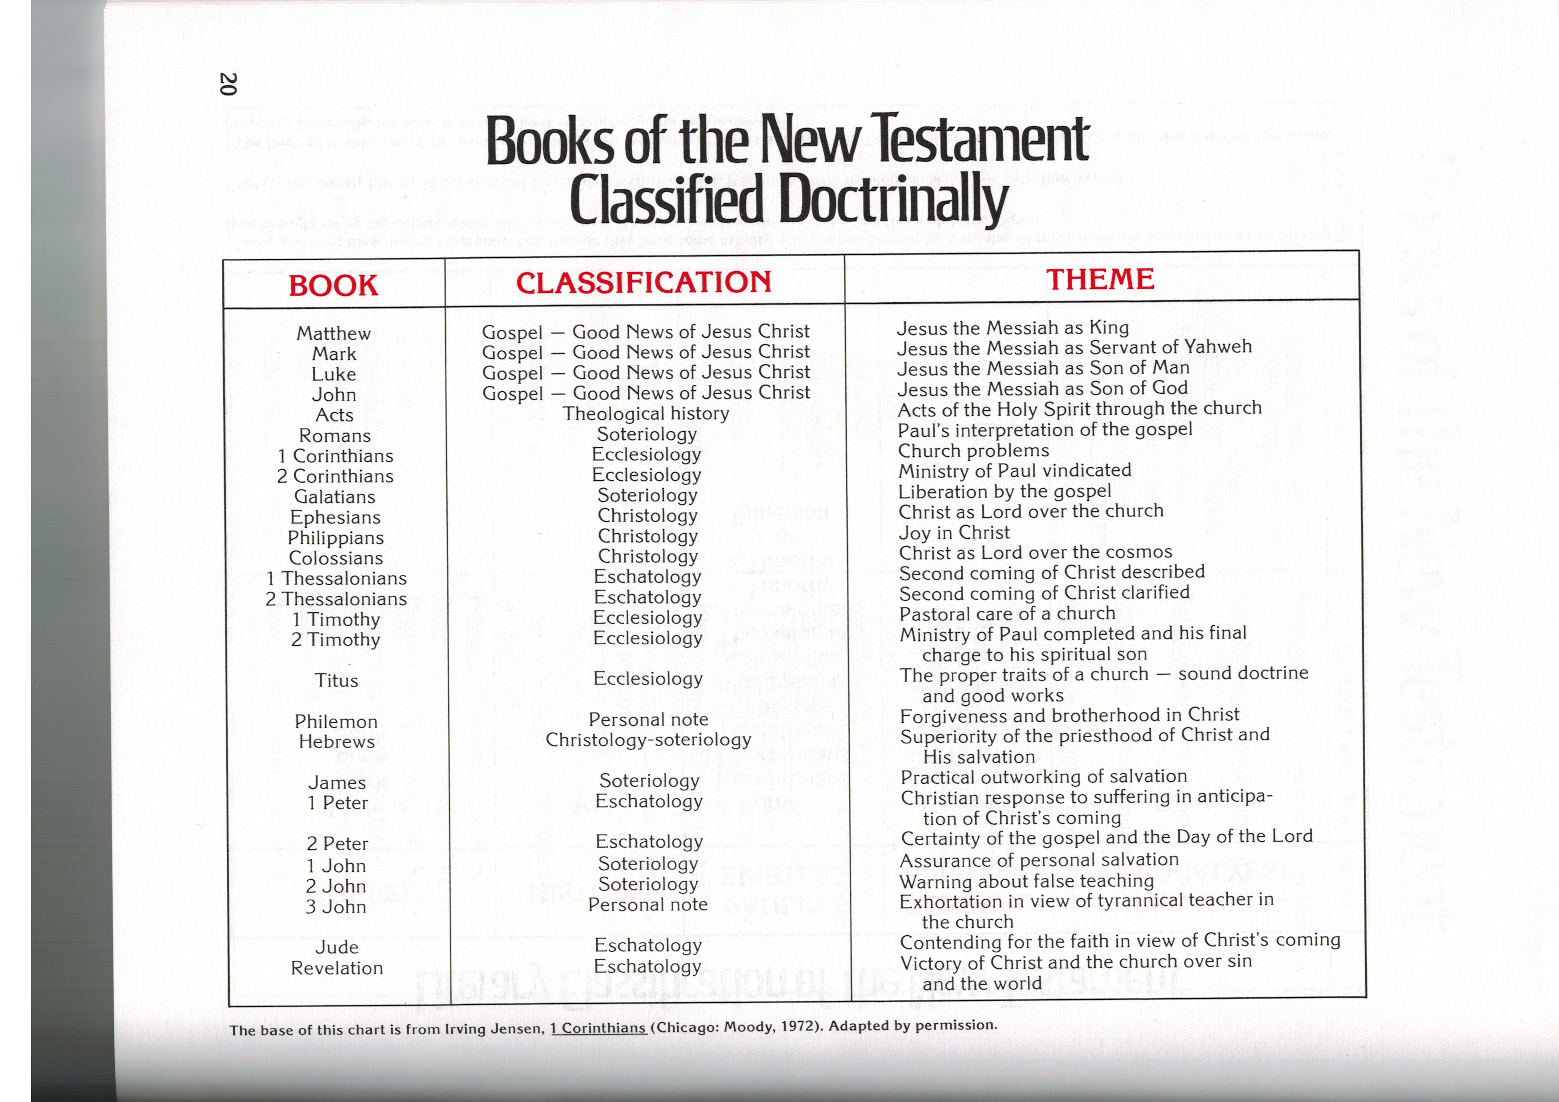
Prophetic Book
- Revelation
- Tells the end of the story that began in Genesis 3
- Major theme: the worship of God for his holiness and justice.

