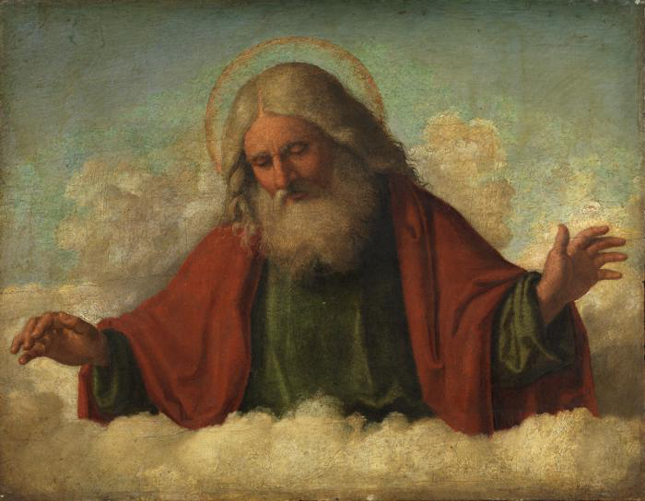
Trinity – A Review of Past Lessons
“God the Father” by Cima da Conegliano, 1510-1517

History and Heresies
The Major Heresies about Jesus – An Overview:
- Arius (d.336) – Jesus was a created being. God like, but not the same essence as God.
- Apollonarius (310-390) – Jesus wasn’t fully human, just fully God.
- Nestorius (370’s-452) – Jesus had two warring natures, and the divine overpowered the human.
- Eutyches (378-454) – Jesus wasn’t fully God or fully man. He was 50-50. He had a mixed nature. (Modern equivalent: Mormons)

Early Church Fathers (100-150AD)
- Weren’t concerned with defining trinity
- Fighting Gnosticism
- Affirmed “Jesus is Lord.”
- Followed Apostles Creed

  - “Creed” credo (lat) “I believe”

Gnosticism
- Secret knowledge
- Matter is evil, spirit is good
- Dualistic philosophy
- Jesus wasn’t really a historical human

The Apologists (150-300AD)
- Development of language, but not concepts
  - Tertullian coins “trinity” “person” “substance”
- Fighting Modalism
- Setting the stage for the theologians

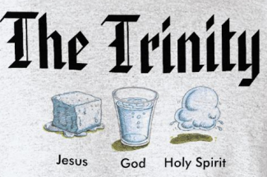
Modalism
- God is only one person
- The one person of god appears in three forms
- When God is the Father, he’s not the son or the Spirit, etc.

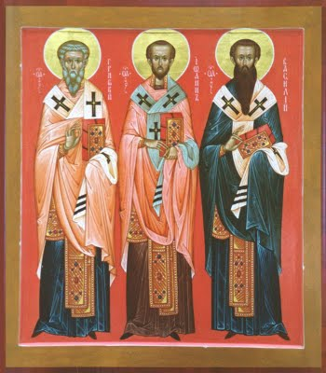

The Theologians (300-600AD)
- Nailing down concepts
- Fighting Arianism and Tri-theism
- Council of Nicaea (325AD)
- Nicene Creed

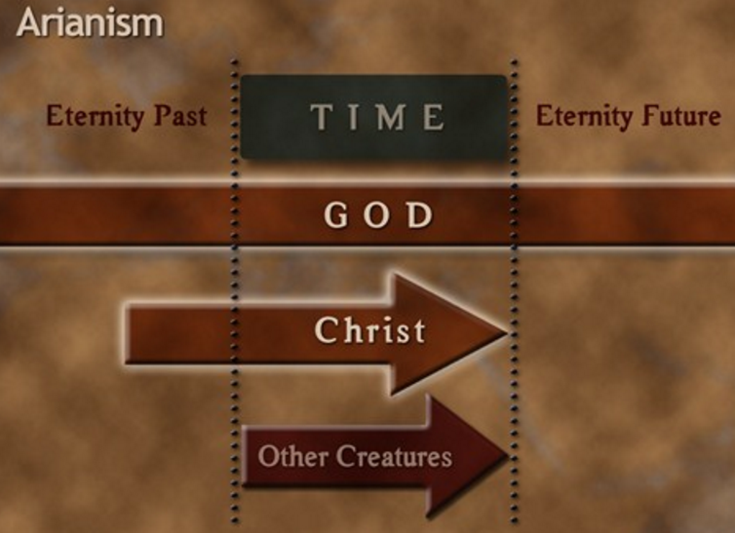
Arianism
- Jesus wasn’t always the son of God
- Jesus didn’t have full divinity
- Jesus was “God-like”
- Jesus was the first thing God created (Col 1:15)

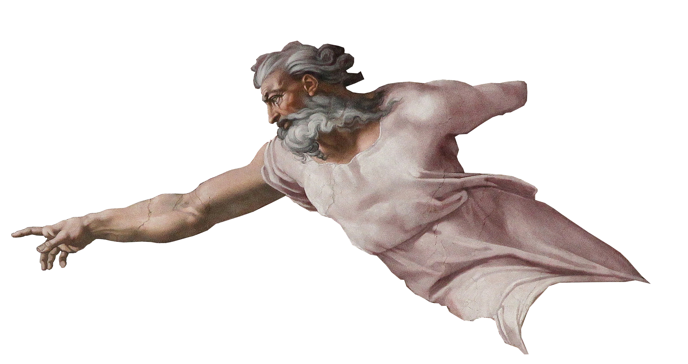
Tri-theism
- There are three different Gods, with three different essences

The Theologians cont’d (300-600AD)
- Weaknesses of Nicene council
- Creed of Constantinople (381AD)
- The three Cappadocians work on definitions
- Athansius’s Creed

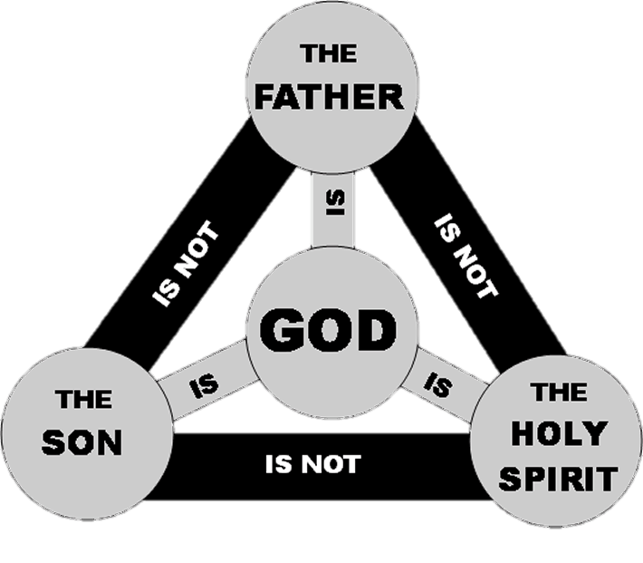
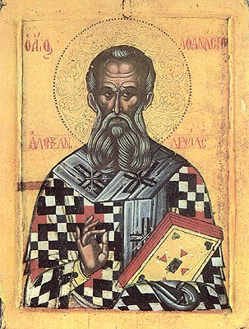
Creeds and Councils for Clarity
Athanasius (297-373)
- Athanasian Creed
- Very influential against Arianism and defending Trinity
- Bishop of Alexandria (reluctantly)
- “Athanasius against the world”

Councils
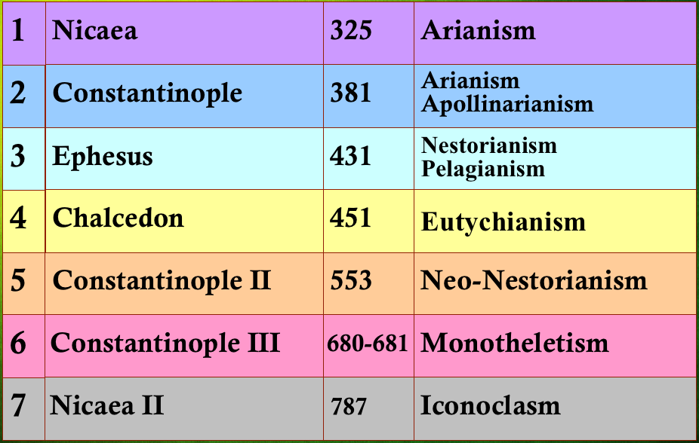

Creeds
- Nicene Creed (325AD)
- Nicene Constantinople Creed (381AD)
- Athanasius Creed
*See Handout “Creeds Appendix”

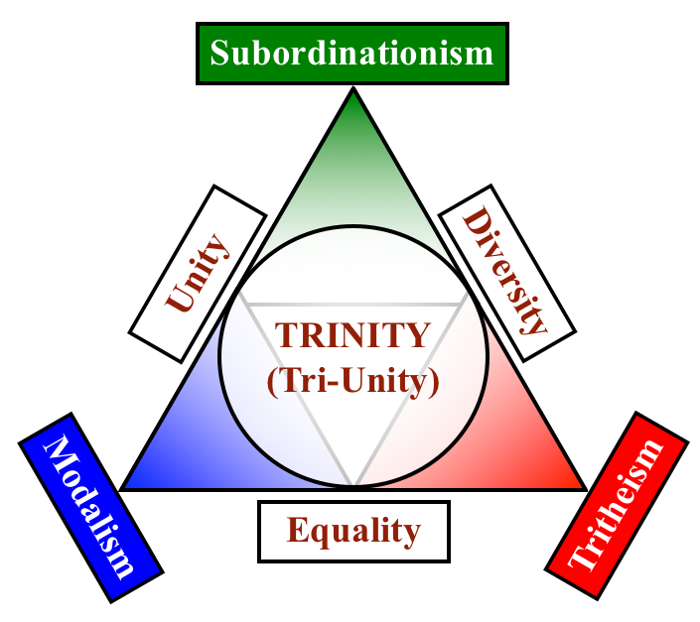
Coming to Conclusions

Conclusion 1:
- 3 qualities to affirm
- 3 heresies to deny

Conclusion 2:
- 3 persons
- 1 essence

