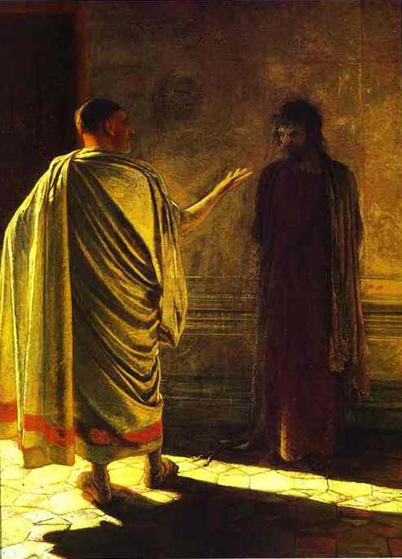
Truth and Morality: Objective and Knowable
“What is Truth. Christ and Pilate” by Nikolai Ge, 1890
What is Truth?

Common Answers
- Pragmatism (Truth is what works)
- Relativism (Truth is up to the individual)
- Correspondence Theory (Truth is what corresponds to reality)
- Consensus Theory (Truth is what the most people agree on)

Biblical Answers

- Psalm 119:142, 160

- Proverbs 16:13

- John 1:14, 17

- Titus 1:1-2

- Ephesians 1:13-14; 6:14
- 2 Timothy 2:15

- 1 John 1:8; 3:18

- 3 John 3-4

- John 14-18

Biblical Answers
- Truth comes from GOD.
- Truth is the gospel.
- Truth is what corresponds to reality.
- Truth is intrinsically moral.

“Truth is that which corresponds with reality, identifies things as they actually are, can never fail diminish change or be extinguished, must be able to be expressed in logical propositions, sourced in the God of the Bible, the author of all truth.” – Paul R. Shockley
What is Morality?

Common Answers
- Moral Pragmatism (What’s right is what works)
- Moral Relativism (What’s right is what I believe is right)
- Moral Utilitarianism (What’s right is what benefits the most people)
- Moral Hedonism (What’s right is what brings the most pleasure)
- Moral Deontology (What’s right is what a God says is right)

  - Moral Absolutism (What the deity says is absolutely right)
    - Unqualified

    - Conflicting

    - Graded

Biblical Answers
- Man was created in the image of God
  - (Gen 1:27)
- Man was created very good
  - (Gen 1:31; Rom 1:18-20)
- Man became corrupted and sinful
  - (Gen 3; Romans 1:21-32; 5:12-21)
- Natural desires untrustworthy, but God’s word is trustworthy
  - (Gal 5:cf16, 2 Tim 3:16-17)

Logical Answers
- God determines what is Good.
- Morality is learned, though it is objective.
- Men are basically selfish.
- God enables men to live morally.

“ Human beings, all over the earth, have this curious idea that they ought to behave in a certain way, and they cannot really get rid of it, but they do not in fact behave in that way. They know the Law of Nature (Morality); they break it. These two facts are the foundation of all clear thinking about ourselves and the universe in which we live.” - C.S. Lewis, Mere Christianity

