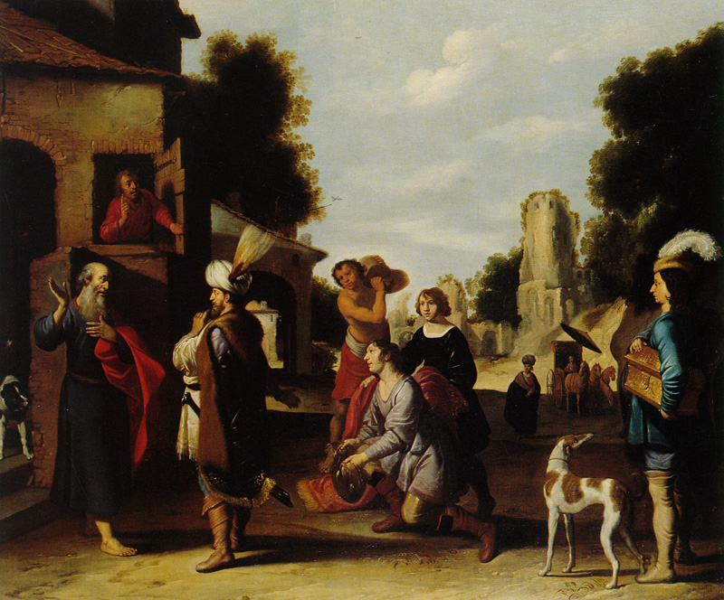
2 Kings 5:1-14 Handout

Context (Gen 1-2 Kings 4)
- Creation, Noah, Abraham-Jacob, Joseph, Family> Egypt, Exodus, Law, Golden Calf, 12 Spies, 40 Years Wandering, Moses Dies, Joshua and his conquest, Period of the judges, Saul, David, Solomon, Divided Kingdom, Israel: Jeroboam>Omri, Ahab>Joram, Elijah>Elisha
The Prophet Elisha and Naaman” by Lambert Jacobsz, 1598-1636

- 2 Kings 2-6:7: Series of Elisha Miracle Stories:

  - parts Jordan river
  - purifies drinking water
  - sics bears on youths
  - sends water for Jehosaphat and Joram in battle
  - Widow with Oil
  - Revives Shunnamite woman’s son
  - Makes poisoned stew safe to eat
  - feeds a 100 men with 20 loaves, and leftovers
  - Heals Naaman (Our Story)
  - Floating Axe-head

In Aram (v1-5)
- “Naaman, captain of the army of the king of Aram” (v1)
  - What is Aram and where did it come from? (cf. Gen 10)

- “…was a great man with his master... because YHWH had given victory to Aram, by him.” (v1)

- “...but he was a leper.” (v1)
  - What is “a leper”?

- “the Arameans had taken captive a girl from Israel’s land.” (v2)
- “I wish that my master were before the prophet in Samaria” (v3)

- The King of Aram said, “Go and I will send a letter to the king of Israel” (v5)
  - What did the king send with Naaman?

Joram’s House in Israel (v6-8)
- “behold, I have sent Naaman my servant to you, that you may cure him of his leprosy.” (v6)
  - Who did the king send Naaman to, and why? (cf v5-6)

- “he tore his clothes” (v7)
  - What does this mean in the context of the story?
- “Am I God, to kill and make alive…” (v7)
  - Describe Joram’s faith.

- “Why have you torn your clothes?”
  - What does Elisha’s response tell us about Joram?

- “… and he shall know that there is a prophet in Israel.” (v8)

Elisha’s House in Israel (v9-12)
- “Elisha sent a messenger saying, ‘Go and wash in the Jordan seven times’” (v10)

- “I thought surely he would come out to me and stand and call on the name of YHWH his God, and wave his hand over the place and sure the leper.’” (v11)

- “Are not… the rivers of Damascus better than all the waters of Israel?” (v12)
- “So he turned and went away in a rage” (v12)

The Jordan (v13-14)
- “His servant came near…” (v13)

- “Had the prophet told you some great thing, would you not have done?” (v13)

- “So he went and dipped seven times… and his flest was restored, and he was clean.” (v14)

The Fallout (v15-27)
- Naaman’s offer and Elisha’s Refusal
- Naaman’s faith
- Gehazi’s greed/treachery
- Gehazi’s comeuppance

Application/Contribution to the Story
- How does this contribute to the story? What is it doing in the flow of the narrative?

- What does this teach us about God? About Elisha?

- What truths about reality/morality are here, but aren’t the point of this story?

