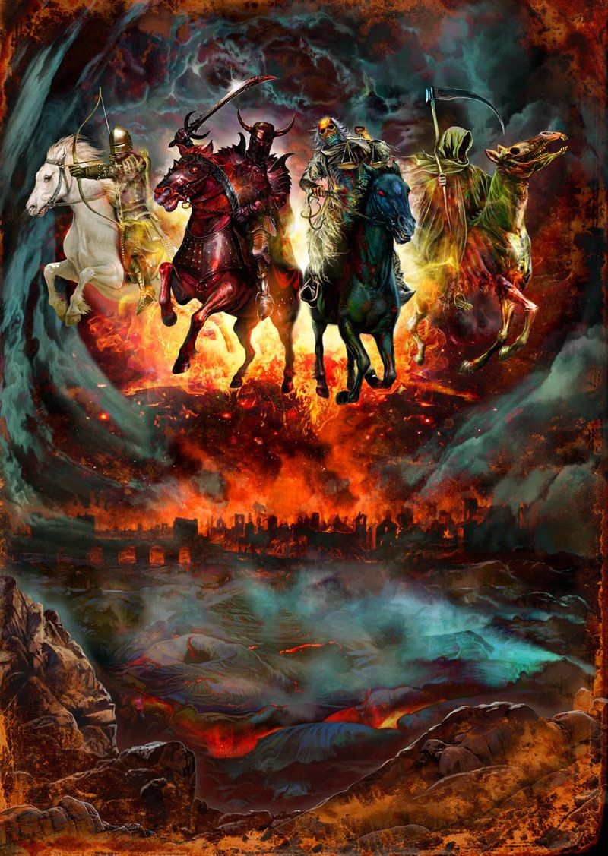
Revelation Seal Judgments & Lunch Break #1 Handout

Structure of the Judgments: 3 Options?
- Backbone structure of Revelation 6-17
- 7 Seal Judgments, 7 Trumpet Judgments, 7 Bowl Judgments
- All 3 sets have a Lunch Break between 6 and 7
  - 1 2 3 4 5 6 (Lunch Break) 7
- In what order do these 3 sets actually unfold in real time, on earth?

- Option 1: Telescoping
1 2 3 4 5 6 7
1 2 3 4 5 6 7
1234567

- Option 2: Successive (Chronological)
Seals Trumpets Bowls
1 2 3 4 5 6 7 1 2 3 4 5 6 7 1 2 3 4 5 6 7

- Option 3: Concurrent (Recapitulation)
Seals: 1 2 3 4 5 6 7
Trumpets: 1 2 3 4 5 6 7
Bowls: 1 2 3 4 5 6 7

First 6 Seal Judgments (Ch 6)
- Seal 1: White horse; Bow; Crown; “Went out conquering and to conquer…”

- Seal 2: Red horse; Sword; “to take peace from the earth that men would slay one another…”; I.e. WAR

- Seal 3: Black horse; Scales; “A quart of wheat for a denarius, 3 quarts of barley for a denarius, and do not damage the oil and the wine!”

- Seal 4: Green horse (sickly/pale); Rider named Death; Hades with him; Authority to kill ¼ of the earth with famine/pests/beasts

- Seal 5:
  - Souls of martyrs crying “How long, holy and true ruler, will you not judge and avenge our blood because of those who dwell on the earth?”
  - Given white robes and told to “cease” a little while longer until the number of their fellow martyrs was completed

- Seal 6:
  - Earthquake, black sun, red moon, stars fall, sky split
  - All men hide in the caves saying to the rocks “Fall on us and hide us from the presence of Him who sits on the throne, and from the wrath of the Lamb, for the great day of their wrath has come, and who is able to stand?”

1st Lunch Break (((The 144,000 and The Multitude))) (Ch 7)
- 4 Angels
  - “Holding back the four winds of the earth” (7:1) – i.e. preventing destruction
  - About to unleash the winds, thus bringing destruction
  - Stopped by a fifth angel who “has the seal of the living God” (7:2)
  - Cf. Zech 6:1-8 “The four winds of heaven”

- The 144,000
  - Those “sealed” prior to the destruction brought by the 4 angels
  - 12,000 from each tribe of Israel
    - Are there not non-Israelite “slaves of God” (7:3) on earth at the time? If not, why not? If so, why aren’t they sealed?

  - List of tribes: omits Dan, and Ephraim; Includes Levi, Manasseh, and Joseph (cf. Gen 48:17-22; 49:16-18)

- The Multitude
  - From every tribe, nation, people and tongue (7:9)
  - Clothed in white with palm branches (7:9)
  - Worshipping with the angels in the throne room (7:10-11)
  - “The ones coming from the great tribulation…” (7:14)
    - i.e. the Raptured Church, destined for the new earth (cf. description in 7:15-17)

7th Seal Judgment (8:1-5)
- 30 min silence
- 7 angels with 7 trumpets
- 1 angel
  - Golden censure
  - Adds incense to prayers of saints
  - Throws fire from altar on earth

