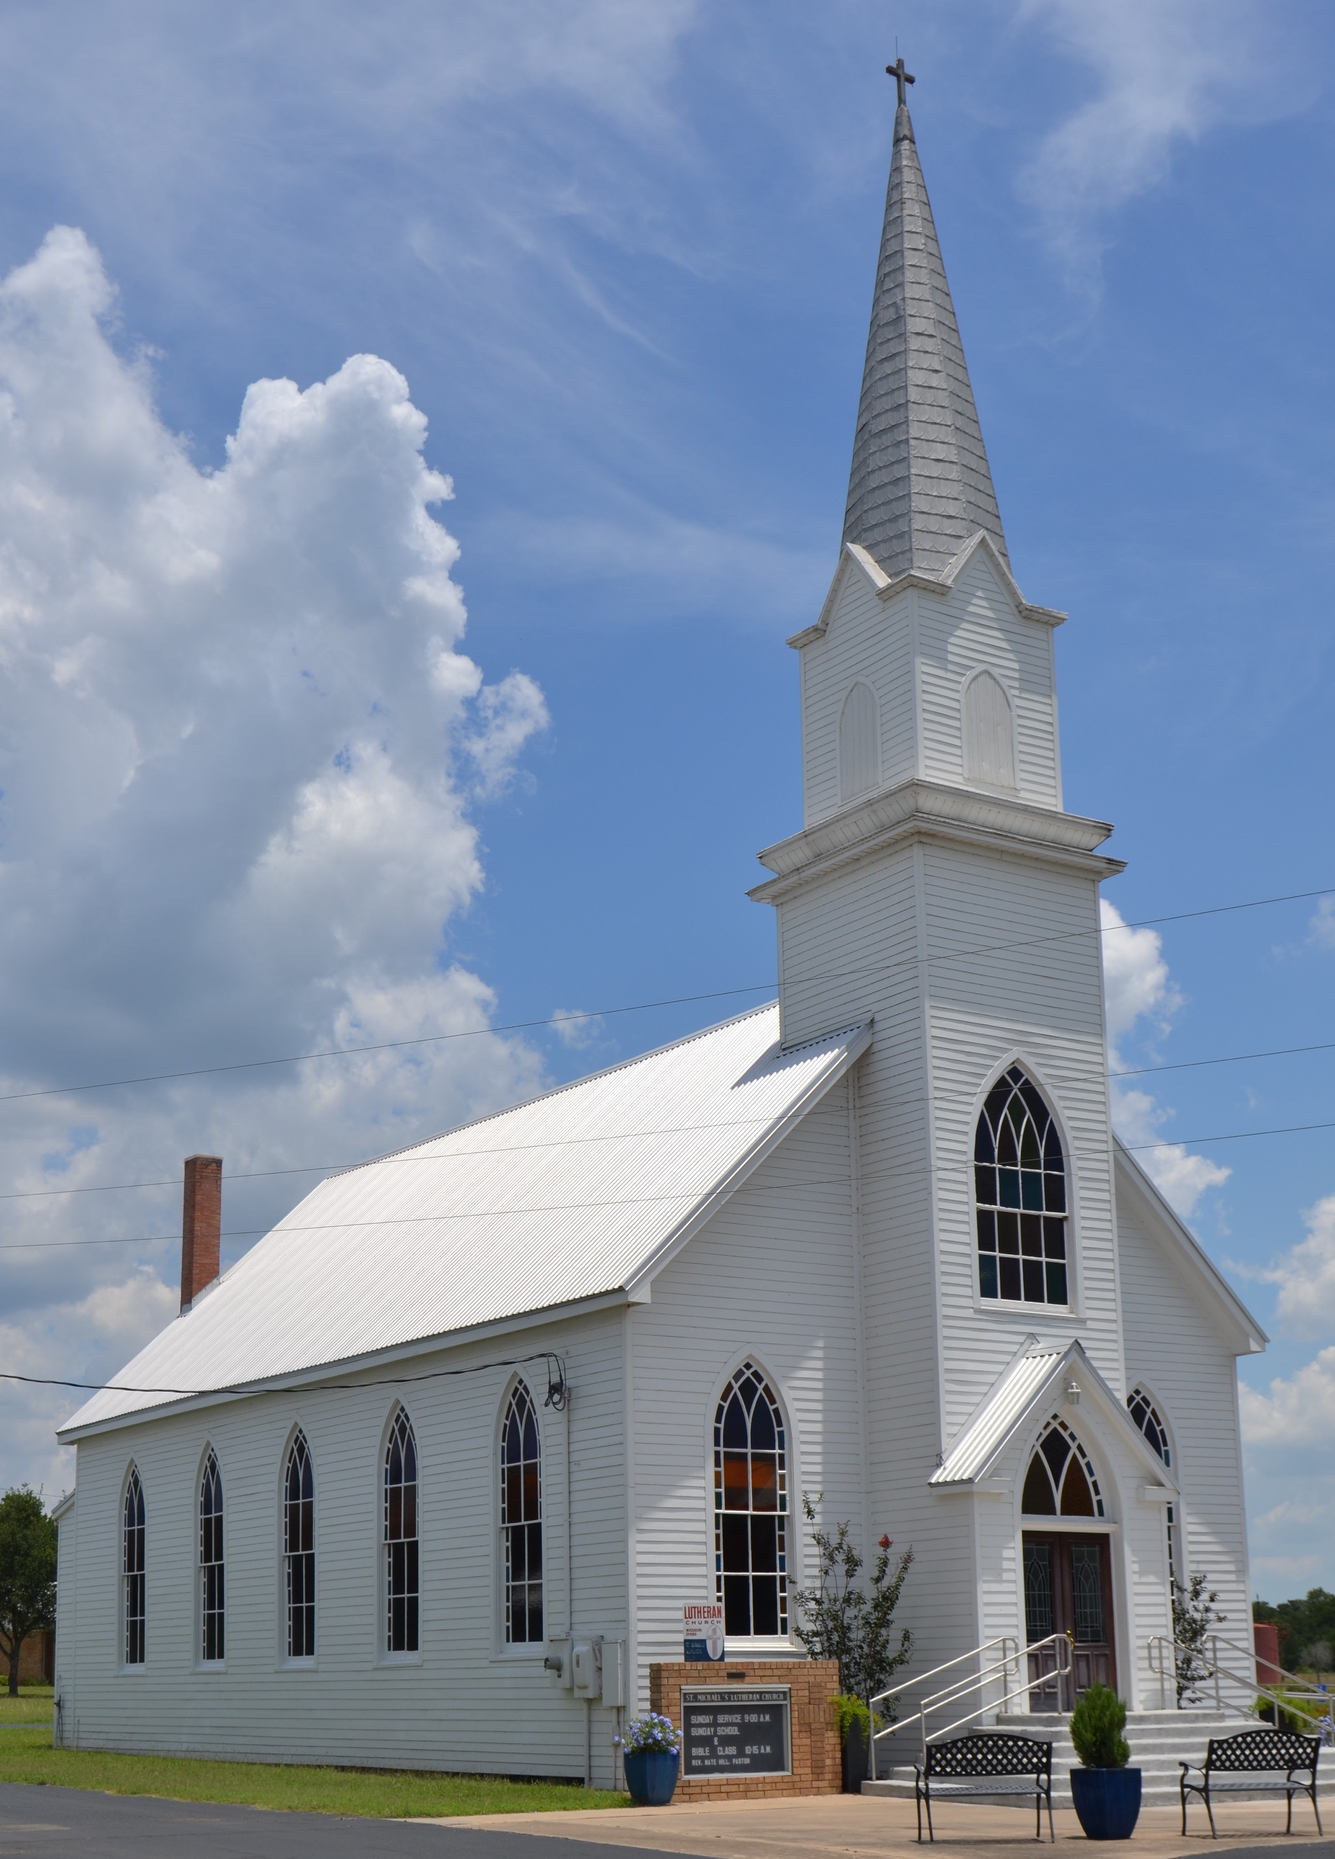
The Sunday Worship Service; Part 1

Defining the Topic:

- Brief Review
The nature of the universal church:
Invisible membership united solely by belief in Christ; his “sheep” his “followers” his “disciples” (John 10; 20:31; Eph 2-3; 1 Pet 2)
Body of Christ (1 Cor 6; 12; 15; Ephesians; Colossians)
Consists of those who are “descendants of Abraham by faith” (Rom 9-11)
Gathers in local geographic assemblies (Heb 10:25; Every Epistle in the NT; Rev 2-3)

The nature of the local church:
A geographic gathering, ἐκκλησία, or “church” of people united and submitting to a local group of elders (1 Tim 2-3; Titus; Acts 14:23; 15; 20:17; Phil 1:1; 1 Pet 5)
Local gathering contains believers and un-believers/false converts (1 John 2:19; 1 Cor 6; Matt 7:15-23; 18:15-17; 2 Pet 2)

Biblical Definition of Worship:

- “Worship” προσκυνέω or σέβω
proskuneo: “to worship” from root words meaning “as a dog” meaning in some contexts “to kiss like a dog licks its master’s hand”
Sebo: “to revere” or “to adore”

- When the church gathers for a “worship service” its primary function must be to “adore” and “revere” the triune God as someone and something wholly higher than those gathered.

- Rom 12:1; 1 Cor 14:25
Worship is a way of life and it is characterized by repentance and contrition.

Insufficient Definitions:

- Music sung in a worship service.
- Praying to God.
- Teaching or reading the Bible.
- Giving to the poor.
- Living according to Jesus’s teaching without submission to a local body of elders.

“Let’s be clear. A Bible study is not a church. It’s a Bible study. Getting together in the home for prayer is not a church. It’s a prayer meeting. A herd of Christians with a guitar and tambourine is not a church. It’s a sing-along. A man or woman opening the Bible and preaching at a willing crowd is not a church. It’s an exercise of free speech. A gathering of saints for eating and gossiping (often misconstrued as “fellowship”) is not a church. It’s a party. The church is not just any gathering of a few believers.” – Michael Svigel Retro Christianity, 155.

Where it Came From:

- The Synagogue
συναγογη “gather together”
System of meeting developed during Babylonian captivity and throughout first 3 centuries as designated meeting places for schools, hostels, court meetings, charity centers, and worship (Josephus Antiquities 14.214ff; 16.43)

Basic service Officers (minimum of 11 people):
Prayer sheliach tsibbuer ”messenger of the congregation”
Readers of the law (7 people in succession)
Reader of the prophets
Interpreter (for those who did not speak Hebrew)
Preacher (often selected from the congregation)

Order of Service of Sabbath Synagogue
Benedictions, Shema, Prayers, and Eulogies
Reading of the law
Reading of the prophets
Sermon
Benediction

- The Temple
Sacrifices and rituals (liturgy/traditions) = Lord’s supper and rituals (see Leviticus)

- The Didache
“The Teaching” (of the twelve apostles)
Extremely early Christian document (approx. 90AD) with a summary of the teaching the apostles approved of and instructions on conducting “sabbath” worship services.

Instructions included:
Baptism (ch 7)
Fasting and Prayer (ch 8)
The Lord’s Supper (ch 9)
Prayer after the Lord’s Supper (ch 10)
How to treat visiting teachers/prophets (ch 11)
How to treat visiting Christians (ch 12)
Providing the needs of teachers and prophets (ch 13)
Instructions on “the Lord’s Day” (ch 14)
Leadership (ch 15)

The Didache, Chapter 14: “As for the day for the Lord, when you gather, break bread and have the good gift [I.e. Lord’s supper/communion] after confessing your transgressions; this is how your sacrifice is pure. But any having a quarrel with his friend may not come together with you, until they are reconciled, in order that you will not make the sacrifice common [unclean]. This is what was spoken by the Lord, “In every place and time offer to me a pure sacrifice. Because I am a great king, says the Lord, and my name is wonderful among the nations.””

- Pattern of Gathering as Exemplified in Acts 4:32ff; 11:26; 12; 14; 15; 20
  - Gathered in a house
  - The apostles and/or elders taught
  - Ate together
  - Prayed together
  - Collected money to meet needs of the poor

- Progress of History
  - Early Church > Medieval Church > Protestant Church > Modern Church

Tradition vs. Prescription:

- All denominations practice traditions (liturgy)
Order of service
“Script” with which people are comfortable
Accepted songs
Length of service

- All Christians have certain prescriptions for their gathering and daily life

E.g.: Teaching (Preaching?); Singing; Prayer; Confession; Giving charity; Loving/serving one another

